Unit 4 Sharing Assessing Your Progress 教案
课程基本信息
学科 | 英语 | 年级 | 高三 | 学期 | 秋季
课题 | Unit 4 Sharing Assessing Your Progress
教科书 | 书 名：普通高中英语教科书（选择性必修四）  出版社：人民教育出版社
教学目标
1. review and consolidate vocabulary learnt in this unit.
2. review and consolidate the grammar learnt in this unit.
3. reflect on the content of this unit by drawing a mind map.
教学内容
教学重点：
1. review and consolidate vocabulary learnt in this unit.
2. review and consolidate the grammar learnt in this unit.
教学难点：
1. reflect on the content of this unit by drawing a mind map.
教学过程
Lead-in
Activity 1: Teacher asks students the following two questions to activate their knowledge about the unit theme.

1. What kind of volunteer work have you learnt in this unit?

2. What kind of volunteer work would you like to do?

Reviewing Vocabulary
Activity 2：Read the following words learnt in this unit and classify them into different categories.
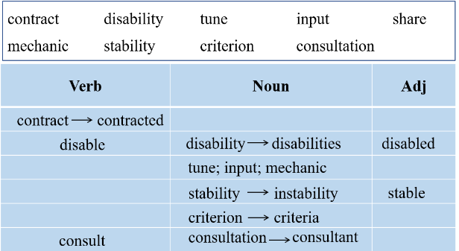
Activity 3：complete a news report using the correct forms of the words in the box.

Many of us have worked as volunteers before. Some have experience as _________ repairing and maintaining machines. Others are experienced medical workers who have volunteered to help those with _________. This summer, one Chinese volunteer, Liu Fei will serve as a management _________ for AIDS projects in an African country. Liu has never been there, and his impression of the country is that it is developing rapidly, but suffers from much _________ and violence. Many people there have _________ AIDS. Liu will work with a local organisation engaging in AIDS prevention. Liu’s path to Africa was long and bumpy. Although he had met the _________ for the volunteer application, his family was opposed to his choice at first. It took Liu some time to explain the importance of building a _________ future for mankind. Ultimately, his family decided to sing the same_________ as Liu and respected his right to choose his own path. Liu is looking forward to sharing his knowledge and skills with needly communities. He hopes his _________ can make a difference in distant Africa.
(Answers: mechanics; disabilities; consultation; instability; contracted; criteria; shared; tune; input)

Activity 4: Make a news headline for the news report
Teacher leads the students to review the key elements of a news report and the features of a headline.

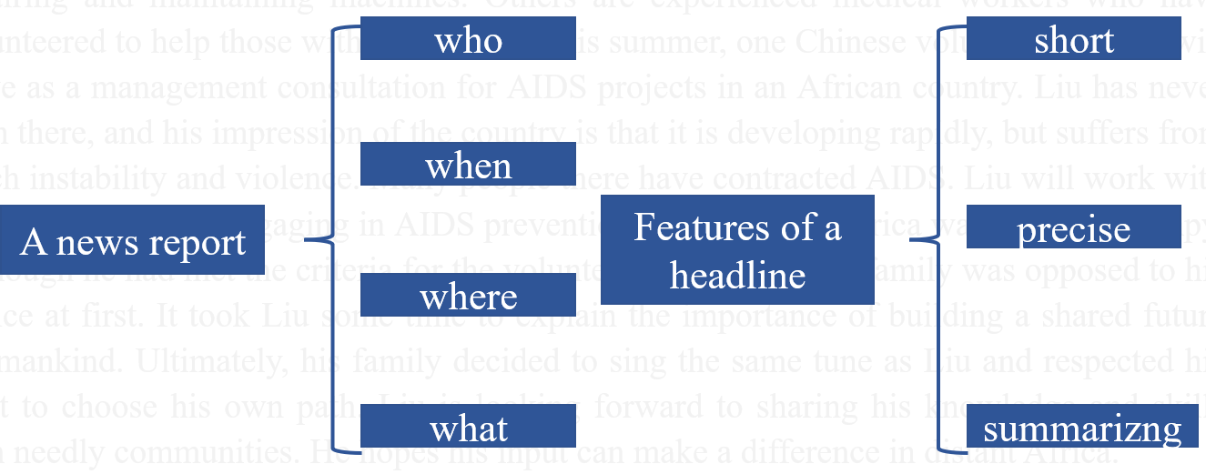

Then the teacher asks students to find the key information in the news report.
(This summer, one Chinese volunteer, Liu Fei will serve as a management consultation for AIDS projects in an African country)

Finally, students share their idea about the best headline. (A Chinese volunteer in Africa)
Review Grammar— Group work
Teacher asks students to think about what kind of phrase the headline is. (A NP)

Activity 5: Students work in groups to talk about the phrases they have learnt in the unit and their functions in a sentence.
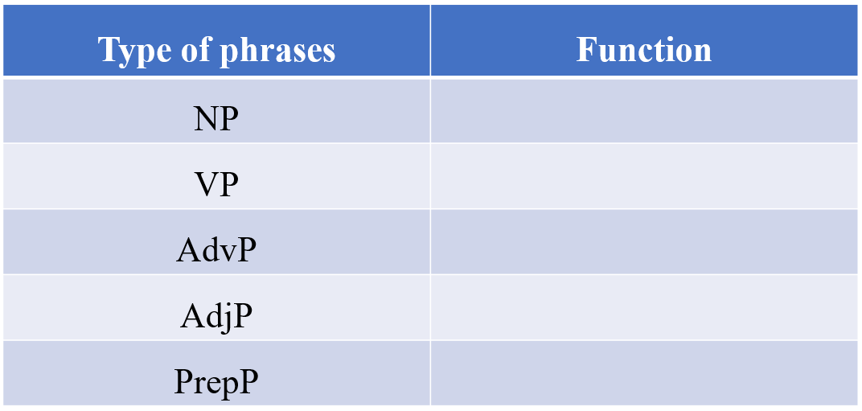

The following form is the answer
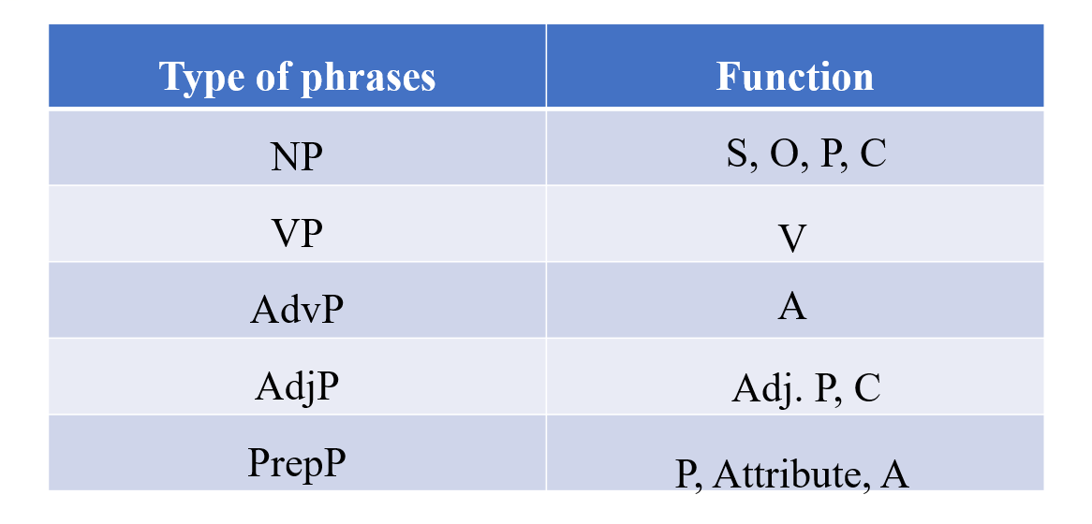

Activity 6 Find different types of phrases in the news report
Many of us have worked as volunteers before. Some have experience as mechanics, repairing and maintaining machines. Others are experienced medical workers who have volunteered to help those with disabilities. This summer, one Chinese volunteer, Liu Fei will serve as a management consultation for AIDS projects in an African country. Liu has never been there, and his impression of the country is that it is developing rapidly, but suffers from much instability and violence. Many people there have contracted AIDS. Liu will work with a local organization engaging in AIDS prevention. Liu’s path to Africa was long and bumpy. Although he had met the criteria for the volunteer application, his family was opposed to his choice at first. It took Liu some time to explain the importance of building a shared future for mankind. Ultimately, his family decided to sing the same tune as Liu and respected his right to choose his own path. Liu is looking forward to sharing his knowledge and skills with needly communities. He hopes his input can make a difference in distant Africa.

Activity 7: Expanding writing
Expand the following sentences by adding different phrases. Try to make these sentences more vivid.
Eg. The chemist is doing an experiment.→The chemist from Harvard University is doing an experiment on lab rats to see their reactions on a sinking ship.

1. A rat is chasing a cat.

2. A train is crossing a bridge.

3. Susan placed the cup on the saucer and swallowed the capsule.

4. I drag myself off the bed.

5. A tree shades the farmer.

6. The president is relaying his ambition to the audience.

Possible answers:

1. A big and hungry rat is crazily chasing a little cat.

2. A train full of passengers bound for Moscow is crossing a beautiful bridge.

3. Susan, quite ill and weak, placed the cup of hot water on the saucer with

trembling hands and swallowed the capsule to save her life.

4. After trying to stand up only to feel dizzy, I dragged myself off the bed and

into the chair next to the phone and then called for an ambulance.

5. A fabulous maple tree shades the exhausted farmer sitting down to eat his lunch.

6. The young president of the book club is relaying his ambition to be a writer to the

audience.

Reflecting — Mind map

Activity 8: Think about the following questions and reflect on the whole unit by drawing a mind map.
1 What kind of volunteer work have you heard about before? What kind
of volunteer work in this unit impressed you the most?
2 What story can you tell about China’s contribution to the development
of the world? What are the improvements?
3 What do you think you can contribute to the cause of building a shared
future for mankind?
4 What can you do to improve your public speaking skills?
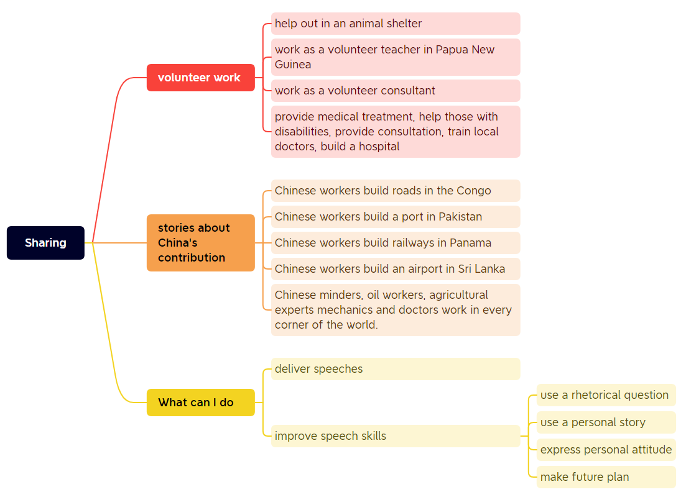

Assignment
1. Improve your mind map in groups.
2. Report the news report in class.

