教学设计
课程基本信息
学科 | 高中英语 | 年级 | 高一 | 学期 | 春季
课题 | Opening Page & Listening and Speaking（Pronunciation)
教学目标
1. Ss can identify the stylistic features of news report.
2. Ss can grasp the skills of making inferences in a discussion of the listening.
3. Ss can understand and practise the use of intonation to convey meaning.
4. Ss can better understand the role of money in your own lives.
教学内容
教学重点：
1. Help Ss know well about the stylistic features of news report to retrieve the key information effectively.
2. Guide Ss to understand the given information, use background knowledge and the speakers’ tone and intonation to make inferences.
教学难点：
1. Guide Ss to use the speakers’ tone and intonation to make inferences and have conversations.
2. Help Ss understand the value of money and share their ideas in daily conversations.
教学过程
I. Lead-in(2 mins)
Activity 1. Talk about the opening page
Ss observe the picture and talk about their knowledge of money. Then Ss discuss the meaning of Francis Bacon’s saying and the value of money.

Purpose: Ss activate their background knowledge of money, and get interested in the topic of this unit.

II. Pre-Listening (2 mins)
Activity 1. Making predictions
Ss say the names of festivals as soon as possible when they see the pictures.

Purpose: Ss grasp the stylistic knowledge of news reports, using wh-questions to help predict the content.

Activity 2. Complete the leading paragraph
According to the leading paragraph, Ss acquire the most newsworthy information and answer the questions raised before.

Purpose: By raising questions and trying to find the respective answers, Ss can analyze the text with a clear objective. It also helps Ss understand the content’s structure and identify the important information.

III. While-Listening (10 mins)
Activity 1. Listen and put the events in the correct order
Ss listen again and put these events in the correct order after pre-treating the given information.

Purpose: To help Ss quickly identify the key information by using the strategy and catch development of the whole story.

Activity 2. Listen for further details
Ss Listen again and decide if the following statements are true (T) or false (F).

Purpose: To help Ss practise the strategy to listen for the details and correct the wrong statements.

Activity 3. Map relationships between people

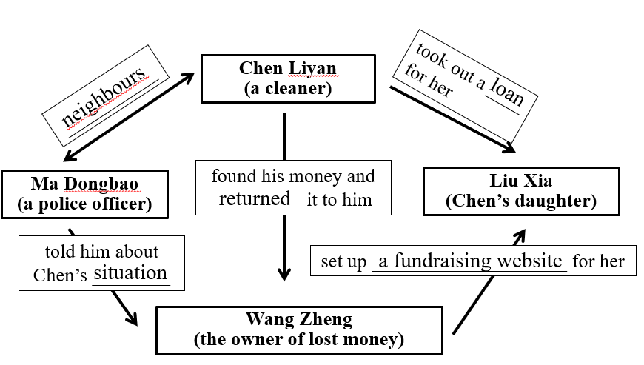

Further questions:
Q1: What kind of person do you think Chen Liyan is?
Q2: Did Chen return the money because she didn’t need it?
Q3: Is it common for people to do what Chen did?
Q4: How does the writer support the topic sentence?
Q5: How did Wang Zheng feel about the return of his money?
Q6: Why did Ma Dongbao tell Wang about Chen’s family?
Q7: How did the news reporter feel about Chen’s actions?

Purpose: By mapping the relationships between the people, Ss can quickly get the main ideas to comprehend the whole story and make inferences based on the given information, background knowledge and the speakers’ tone and intonation.

IV. Post-Listening (2 mins)
Activity 1. Discuss the good deed of returning lost money
Q1: Do you agree with Chen Liyan?
What would you do if you were in her situation?
Q2: When we help someone, should we expect to get something in return?
Q3: What do you think is the best way to get money?
Q4: Should we judge people based on how much money they have?

Purpose: Based on the above questions, Ss may design a conversation and practise the conversation intonation when speaking.

V. Assignment
1. Practise the intonation of the text.

2. Share the story of the listening with your family and get to know their attitudes towards money.
Purpose: By doing the practice, Ss can better understand the value of money and communicate with others more logically and fluently with different intonations.

