**【分层训练】五年级下册英语一课一练-**

**Unit 1 My day 课时（5） 人教PEP版**

**一、单选题**

1．Tom and his mother often to a park.

A．goes B．go C．going

2．Let's play football the weekend.

A．on B．of C．to

3． We often ____ after dinner.

A．go for walk B．go for a walk C．go walk

4． I ____ dinner at home.

A．eat always B．always eat C．always eating

5． I'm ____ today.

A．shop B．shops C．shopping

6．—What do you do the weekend?

—I often take a dancing class.

A．in B．on C．of

7．I play sports at 4:30 in the afternoon.

A．usually B．am C．are

8．选出不同类的一项（　　）

A．usually B．often C．morning

9．I often piano.

A．am playing B．play C．play the

10．I get up early _______.

A．Monday B．Tuesday C．every day

11．My friends and I go _________ on Sundays.

A．shop B．shops C．shopping

12．I read books _______ weekend.

A．on the B．on C．in

13．找出不同类的单词（　　）

A．always B．often C．usually D．sports

14．_______ I go to the park after dinner.

A．Sometimes B．Sometime C．Some time

15．找出不同类的单词（　　）

A．dinner B．breakfast C．sometimes D．lunch

16．My parents _______a walk in the park after dinner.

A．go for always B．go always C．always go for

17．I sometimes take a _______ class on Saturdays.

A．dance B．dancing C．sing

18． Friday I have a music class.

A．On B．At C．In

19．I go shopping with my mother on Sundays.

A．sometime B．sometimes C．some time

20．I often ___ my homework ___ 7:00 p.m.（　　）

A．do; in B．does; at C．do; at

21．I always ____class at 8 o'clock.（　　）

A．get B．start C．do

**二、判断题**

22．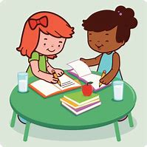

go for a walk

23．go shopping

24．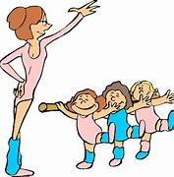

take a dancing class

25．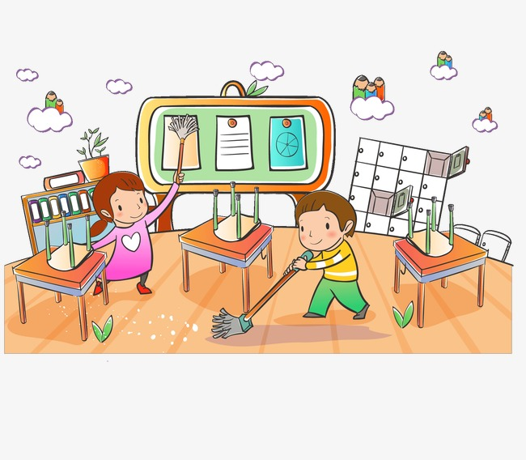clean the classroom

26．go swimming

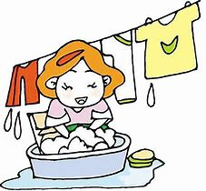

**三、选词填空**

27． I get up early 　 　 (every day/everyday).

28． Robinson always 　 　 (play/plays) sports with Friday.

29．What do you do on　 　(weekend/the weekend)?

30．I often go　 　(shop/shopping) on the weekend.

31．Every weekend I take a　 　(dancing/dance) class.

32． Lisa often goes 　 　 (swims/swimming) on the weekend.

**四、连词成句**

33． walk, for, I, go, a, class, after, usually(. )

_______________________________________

34． sometimes, I, watch, with, TV, Tina(. )

_______________________________________

35． often, I, the, on, clean, Saturdays, rooms(. )

_______________________________________

**五、阅读理解**

A

阅读短文，判断下列句子的正误。

Mike is a doctor. He usually works at night. He goes to work at 6:00 in the evening. Then he has dinner at 10:00. And he goes home at 6:00 in the morning. He always has breakfast at 7:00. After breakfast, he goes for a walk. Then he goes to bed at 9:00.

36．Mike usually works at night.

37．Mike has dinner at 7:00.

38．Mike goes home at 6:00 in the morning.

39．Mike goes shopping after breakfast.

B

阅读短文，判断下列句子正误。

Hi, I'm a rabbit. I usually visit my grandparents on the weekend. I have a good friend. He is a panda. He often plays football. Sometimes he plays the piano. We like climbing mountains. We always climb mountains together after school.

40．The rabbit usually visits her grandparents on the weekend.

41．The panda often plays football.

42．The rabbit sometimes plays the piano.

43．The rabbit and the panda like climbing mountains.

44．The rabbit and the panda don't climb mountains together after school.

**答案部分**

1．B

2．A

3．B

4．B

5．C

6．B

7．A

8．C

9．C

10．C

11．C

12．A

13．D

14．A

15．C

16．C

17．B

18．A

19．B

20．C

21．B

22．（1）F

23．（1）T

24．（1）T

25．（1）T

26．（1）F

27．every day

28．plays

29．the weekend

30．shopping

31．dancing

32．swimming

33．I usually go for a walk after class.

34．I sometimes watch TV with Tina.

35．I often clean the rooms on Saturdays.

36. T

37. F

38. T

39. F

40. T

41. T

42. F

43. T

44. F