Unit 2 Using language 1

listening and speaking教案
教学  目标 |  | - Students can understand the characteristics of New Zealand and expand their cultural horizons;  - Students can pay attention to the relationship between the identity characteristics of the speakers and their views;  - Students can use the key sentence patterns to introduce the iconic attractions in China.
重点  难点 |  | - Help students identify the job of the speakers.  - Enable students to express their own ideas on the given topics about what best represents a place.
教学  策略 |  | Audiovisual teaching technique.
课时  安排 |  |  | 课型 | Listening and speaking
Teaching procedures:
Step1 Lead-in
1.What do you know about New Zealand?
2.With so many natural landscapes, which one can best represent New Zealand?
Let’s listen to a radio programme: Amazing New Zealand
Step2 Listening
1.(P18 E2) Three speakers are talking about what they believe to best represent New Zealand. Match the speakers with their jobs and their choices.

2.(P18 E3) Listen again and take notes. List the reasons given by the speakers why these three things best represent New Zealand.
Presenters 1: Dave Edmonds (business journalist)
Choice: the Bay of Islands
Reasons:
- _________ cruises or _________ tours to _________ the _________ and their ____________, as well as tours to _________ and ___________ Maori __________
- be astonished to ___________ the haka on site
- ________ and _______ activities make it a popular tourist destination
- plenty of great ___________
Presenters 2: Felicity James (editor of World Nature magazine)
Choice: the geothermal parks
Which of the following make geothermal parks the most amazing place you’ll ever see?
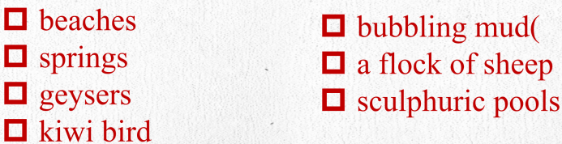
Presenter 3: Jane Smith (writer of the Fantastic Life blog)
Choice: the New Zealand experience
1.我认为如果人们离开新西兰前没有见过几维鸟或羊群，那他就不算真正体验过这个国家。
I think that___________________________ without ___________________,
______________they haven’t _______________.
2.我想说的是，最能代表新西兰的不一定是一个地方，而是你在那里的经历。
What_______________is that ________________________________, ___________________but rather _______________________.
3.尝一尝麦卢卡蜂蜜，看一看哈卡舞，去蹦极吧！
____________________________________________________
Step3 Thinking
How do our careers affect our thinking and talking?
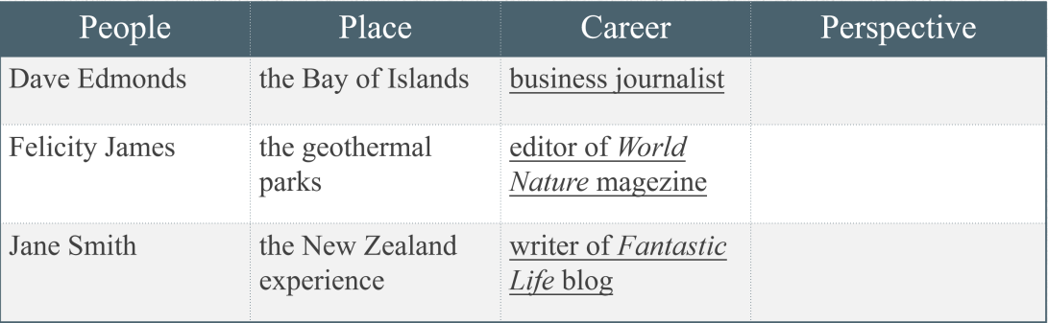
Step4 Speaking
你所在的社区举办面向外国友人的文化活动，需要请社区不同职业代表为社区出介绍中国的双语海报.
课后练习 | Students use the expressions to make a dialogue to change the topic.
教学反思

