**Unit 1 Science Fiction**

**Using Language 1**

**Voice your opinions on robots and AI教案**

**Teaching aims:**

By the end of this period, students will be able to:

1. make predictions based on given pictures and words.

2. voice your opinions on robots and AI based on your knowledge.

3. organise words by using correct discourse markers.

4. reflect future on the development of science and the fate of mankind.

**Teaching key points:**

1. Enable students to predict the content of the dialogue.
2. Help students to learn the related expressions about opinions on future techniques.

**Teaching difficult points:**

1. Encourage students to voice opinions on robots and AI.

**Teaching procedures:**

**StepⅠLead-in**

**Look** **at** **the** **pictures** **and** **discuss** **the** **questions** **in** **pairs**

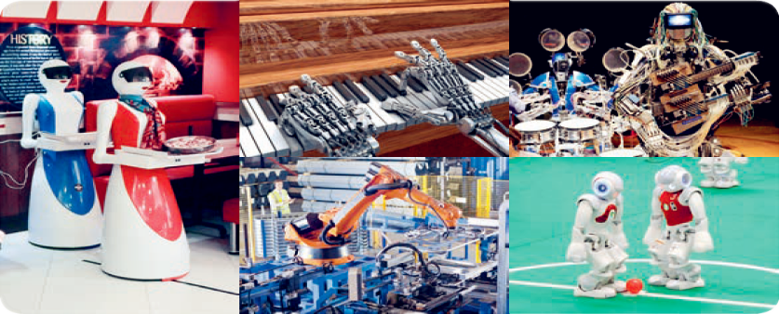

1. What jobs are these robots doing?
2. What are the pros and cons of robots doing these jobs?

Suggested answers:

1. Serving food,playing the piano,doing experiments,playing the instruments and playing football.
2. (1)Pros: May be cheaper and faster; Cons: Communication difficulty; No human touch.

(2)Pros: The robot can play anything perfectly; Cons: No creativity or emotion involved.

(3)Pros: Simple, repetitive tasks are done at higher speed more cheaply and accurately; Cons: Humans end up out of work; No added skill or creativity.

(4)Pros: More live music will be available more cheaply; Playlists will be limitless; Cons: It really isn’t live music; It is more like listening to a record, without any of the excitement and emotion of watching humans perform.

(5)Pros: Promote learning and enjoyment of AI and robotics to a wider audience; Cons: The robot players don’t even know they are in a contest and have no desire to win, so there is no emotional content to the match;No physical skill or talent is involved either.

**StepⅡBefore Listening**

**Watch** **a** **video**《机器人公民索菲亚》—**Hanson** **Robotics’** **most** **advanced** **human** **robot** **and** **answer** **some** **questions**

1. What impressed you most in the video?
2. What kinds of robots or AI developments do you hope for?

Suggested answers:

1. The robot is so human. She can communicate with the host without any barrier, and she can even imitate human feelings.It is amazing!
2. I hope for an educating robot because I can ask any questions when I have trouble in learning.

**StepⅢ Listening**

**Activity** **1** **Listen** **to** **an** **interview** **and** **put** **these** **statements** **in** **the** **correct** **order.**

　1　 The host introduces the guest, a sci-fi expert.

　The expert has robots in his home.

　As robots become more intelligent, they may also become more dangerous.

　The host mentions Asimov’s Three Laws of Robotics.

　The expert says robots will have occupations such as teaching and nursing.

　The line between humans and robots will be more blurred in the future.

　The host asks about benefits and problems.

　The host asks if there are robots in the expert’s home.

　In sci-fi stories, robots often become superior and take over.

Suggested answers:

194527386

**Activity** **2** **Listen** **to** **the** **interview** **again** **and** **write** **down** **the** **discourse** **markers** **that** **you** **hear.** **Make** **a** **note** **of** **how** **each** **discourse** **marker** **is** **used** **in** **the** **interview.** **Then** **compare** **your** **answers** **with** **a** **partner.**

The discourse markers:

Discourse markers are used to organise a text by making sequence, contrast,opinion,purpose, and so on. Listening for discourse markers can help you understand a text more easily.For example, first, however , above all, in order to,etc.

Suggested answers:

just now, so, well, however, above all

**StepⅣSpeaking**

**Activity** **1** **Think** **and** **answer** **these** **questions.**

1. What do you know about robot technology? What can robots do?
2. What benefits do you think robots or AI will bring? Do you think they will cause problems as well?

Suggested answers:

1. Robot technology has its cons and pros. It can bring great convenience to human beings together with some scientific or moral problems. A robot is a machine that can do a task according to computer programmes or through the use of some kind of controls.
2. The main benefits are that they can do some kinds of work more quickly, better, and cheaper than humans, and that they can take the place of humans when no humans are available or when humans cannot do the work. They can cause problems, however. First,what happens if they no longer serve people or stop following orders? Second, there is the possibility that at some point we will have difficulty determining what constitutes a living being and what constitutes a machine.

**Activity** **2** **Brainstorming.**

1. What is “Three Laws of Robotics”?
2. Do you know anything about Isaac Asimov and his famous Three Laws of Robotics? What do you think of these laws?

Suggested answers:

1. Law 1,a robot may not injure a human being,or,through inaction,allow a human being to come to harm;Law 2,a robot must obey the orders given it by human beings except where such orders would conflict with the first law;Law 3,a robot must protect its own existence as long as such protection does not conflict with the first or second law.
2. Yes, I do. Isaac Asimov introduced them into most of his science fiction writings to show that robots could be prevented from harming us or our world. They are not actual scientific laws, but rather guidelines for their human programmers to follow to keep our world safe. At first glance, the rules seem logical and reasonable, but they also seem outdated.

**Activity** **3** **In** **groups**, **discuss** **what** **the** **expert** **thinks** **of** **the** **questions** **and** **exchange** **your** **own** **views.** **You** **may** **use** **the** **following** **expressions** **to** **help** **you.**

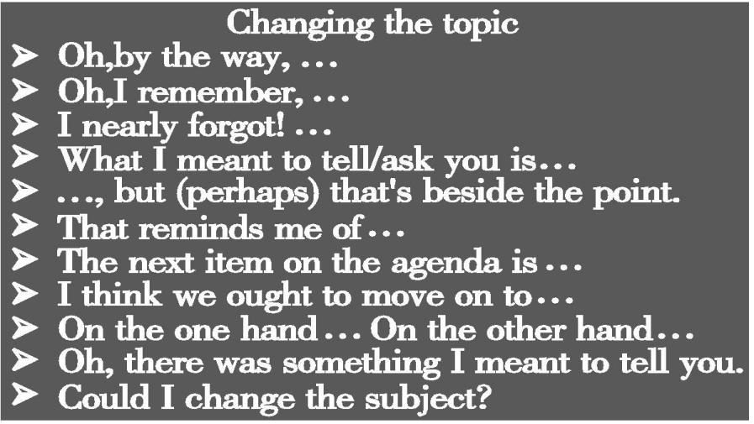

Suggested answers:

A:Oh, by the way, I saw a programme about robot doctors last night. It was very interesting. Do you think robots will do more of these important jobs in the future?

B:Certainly. They will probably do most of our labour for us.

C:Maybe, but that’s beside the point. In my opinion, robots are dangerous! They are much stronger than we are and may be superior to us in the future.

A:I think we ought to move on to the topic of robot technology. I know the idea of it has been around forever. The ancient Greeks and Chinese both made clever devices that weren’t much different than some of the robots we have today.

B:Yes, but the modern idea of intelligent robots that look like humans is only about 100 years old.

C:I think we had better move on to what robots can do. Let’s see... there are simple repetitive tasks like factory work and housework.

A:Yes,and I think there will be more complex jobs in the future like in healthcare, education,or entertainment.

C:Oh, there is something else I meant to ask you—does anyone know who even came up with the word“robot”?

B:Wasn’t it Isaac Asimov? He was that scientist who wrote a lot of science fiction stories.

A:No ... the word “robot” was coined much earlier, I think.

C:But that’s beside the point.I think we ought to move on to the benefits and dangers of AI to humans and our society ...

A:Oh, I nearly forgot why Asimov’s writing was so important—he created the Three Laws of Robotics. Law 1,a robot may not injure a human being,or,through inaction,allow a human being to come to harm; Law 2,a robot must obey the orders given it by human beings except where such orders would conflict with the first law; and Law 3, a robot must protect its own existence as long as such protection does not conflict with the first or second law!

B:But this is where the real danger lies. Those laws are not real laws—they are guidelines that hopefully humans remember when they programme the robots. How can we trust our safety if the robots are programmed by people who don’t keep those rules?

C:...

**StepⅤHomework**

假如你是李华,你的好朋友John发来电子邮件询问你公司最新研制的家用机器人的相关情况,请根据下面提示,给他回复一封电子邮件。

(1)可以在固定的时间做饭,做饭时间可以根据个人需要进行调整;

(2)可以陪老人聊天、下国际象棋、锻炼身体等;

(3)能及时处理紧急情况,例如:在老人突然病倒时及时拨打急救电话等。

注意:(1)词数80左右;

(2)可以适当增加细节,以使行文连贯;

(3)电子邮件的开头和结尾已为你写好,不计入总词数。

Dear John,

I’m glad that you’re interested in the robot developed by our company.

__________________________________________________________________________________________________________________________________________________________________________________________________________________________________________________________________________________________________________________________________________________________________________________________________________________________________________________________________

Suggested answers:

Dear John,

I’m glad that you’re interested in the robot developed by our company.

The robot is so advanced that it can cook meals at a fixed time, which can be adjusted according to individual needs.In addition, it can also accompany the elderly in having a chat, playing chess and doing exercise. Moreover, it can deal with emergencies. For example, if an old man falls ill suddenly the robot will call doctors for help. All in all, AI is changing the world as well as our life.

Looking forward to your earliest reply.

Yours,

Li Hua