Unit 4 Learning About Language 1 教案
课程基本信息
学科 | 高中英语 | 年级 | 高三 | 学期 | 秋季
课题 | Unit 4 Learning About Language (1): Vocabulary
教科书 | 书 名：普通高中教科书英语选择性必修第四册  出版社：人民教育出版社
教学目标
1. 通过文章填空，回顾上一节课的关键词和短语；
2. 通过短文填空和翻译练习，正确地在句子中运用condition、lack、secondary、drag、deserve等重点单词；
3. 通过词汇训练和话题探讨，了解并体验到分享的重要性。
教学内容
教学重点：
1. 通过短文填空和翻译练习，深入了解课文重点词汇的意义和用法。
2. 通过词汇分类练习，构建词汇语义网。
教学难点：
1. 找到字谜游戏中的隐含信息，表达对单元主题“志愿服务”的理解。
教学过程
Activity 1: Finish the summary of the Reading and Thinking passage
本活动旨在落实课时目标1。
Jo is a __________ teacher at a bush school in the __________, where the students have no modern __________ or resources. She struggles to teach science and is trying to __________ the conditions. One weekend, Jo visited a __________ village where she experienced the __________ lifestyle and culture of the locals, including their __________ in bad spirits and their practice of drying __________ food in a can. She enjoyed the __________ of Tombe's family and their traditional food. Jo reflects on whether she is making a difference in the students' lives but feels __________ to have spent time with Tombe's family.
【设计意图】该活动旨在帮助学生复习和巩固上一课的关键词和短语。通过填空的方式，学生需要在阅读中找出合适的词汇，既训练他们的阅读理解能力，又提高他们对词汇的理解和运用。

Activity 2: Completing the word puzzle with words from the blog entries
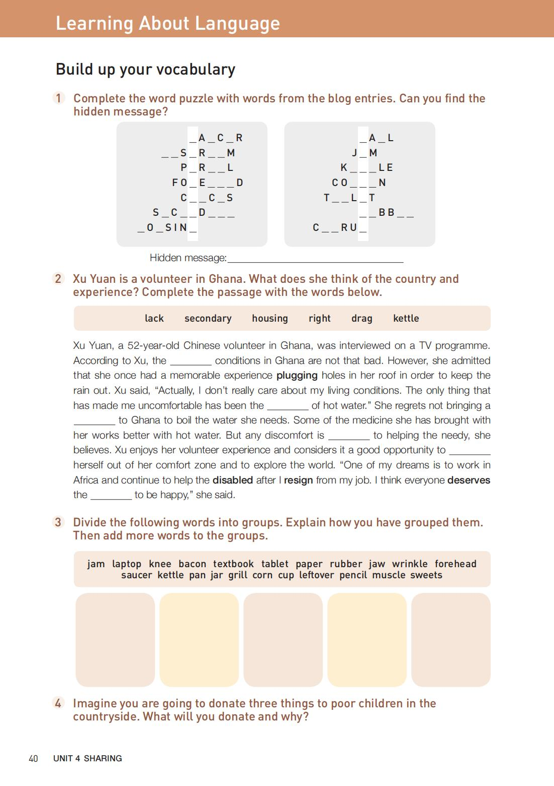
本活动为落实课时目标2作铺垫。
【设计意图】该活动旨在通过游戏的方式，帮助学生记忆和应用关键词。学生需要用给定的词汇去完成拼词游戏，这种寓教于乐的方式能激发学生的学习兴趣，提高他们的词汇记忆力。

Activity 3: Sharing the understanding of the hidden message behind the word puzzle “sharing matters”
本活动为落实课时目标3作铺垫。
【设计意图】该活动旨在通过解读拼词游戏，让学生了解了解到分享的重要性。这样的活动设计可以促进学生的情感教育和人文素养，让他们理解到学习英语不仅仅是学习语言，更是学习文化和价值观。

Activity 4: Completing the passage with the word below
本活动为落实课时目标2作铺垫。
【设计意图】该活动旨在通过填空练习，让学生在实际语境中应用所学的关键词，帮助学生更好地理解和记忆这些词汇，同时也能提高其语言运用能力。

Activity 5: Exploring the usage of the key words and phrases
本活动为落实课时目标2作铺垫。
【设计意图】该活动旨在帮助学生深入理解并应用关键词和短语。在教师的引导下思考和探索，学生能够更好地掌握词汇的用法，提高他们的语言能力和思维能力。

Activity 6: Finishing the translation exercise using the key words and phrases learned
本活动旨在落实课时目标2。

Volunteering often requires one to _______________________________ (脱离舒适区). It means being willing to work in ____________________________ (不熟悉的情况) and adapt to new environments. ______________________ (资源的缺乏) or modern equipment that one may be used to can be challenging at first, but the desire to make a positive impact and help those in need should always be at the forefront of one’s mind. The personal growth that occurs as a result should ______________________________ (次于) the positive impact made on the community. Everyone ____________________________ (应得一个机会) to give back to their community and make a difference in the world.
【设计意图】该活动旨在让学生在实际的语境中应用所学的词汇，帮助他们更好地理解和记忆重点词汇，同时也能提高他们的语言运用和翻译能力。

Activity 6: Diving the following words into groups
本活动为落实课时目标3作铺垫。
【设计意图】该活动旨在通过词汇分组，让学生对词汇进行分类和整理，这不仅可以提高学生词汇记忆力，还可以锻炼其逻辑思维能力。

Activity 7: Deciding donation choices
本活动旨在落实课时目标3。

Suppose the Ss are going to donate three things to poor children in the countryside. The T asks the Ss to decide what they will donate and share the reasons.
【设计意图】该活动旨在通过模拟捐赠活动，让学生理解和体验到分享的重要性，培养学生的社会责任感和公民素养，提高他们的情感态度和价值观。

