教学设计
课程基本信息
学科 | 高中英语（人教版） | 年级 | 高一 | 学期 | 春季
课题 | Discovering Useful Structures（必修第三册：第五单元）
教学目标
在本课学习结束时，学生能够：
1. 梳理常用情态动词的表意功能。
2. 能够根据具体语境恰当地使用情态动词。
3. 掌握过去将来时两种常用结构的用法。
教学内容
教学重点：
1. 复习和梳理常见情态动词的表意功能，引导学生根据真实语境恰当地使用情态动词。
2. 掌握过去将来时两种常用结构的用法。
教学难点：
结合语境，准确地掌握常见情态动词的功能和意义。
教学过程
Step 1 Find and think
Modal verbs have many functions, including the following (A-F). Find modal verbs in previous sections and discuss their functions.
A necessity B possibility C obligation D request E advice F intention
We can discuss it now.
You must do it at once.
Would you please pass me the salt?
You needn’t have stayed.
You ought to help him.
I would rather do it myself.
设计意图：通过分析句子，分析情态动词的表意功能。
Step 2 Grammar summary (1)
Different functions of modal verbs
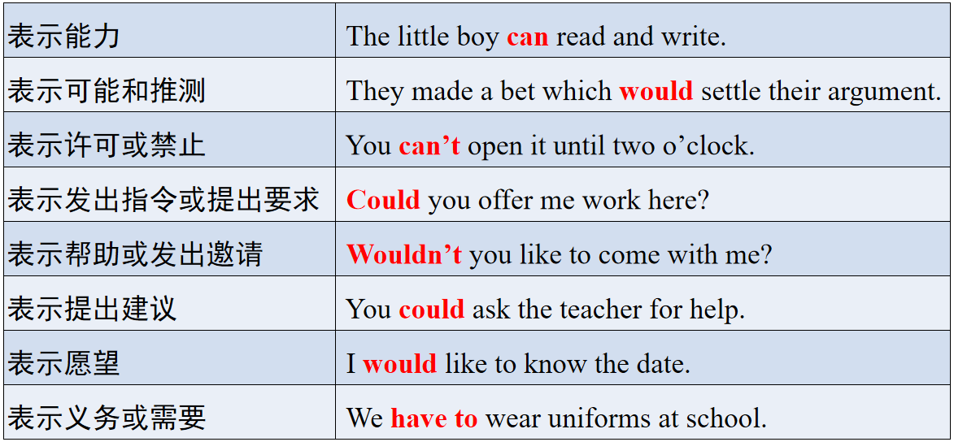
设计意图：总结情态动词的规律，深度掌握情态动词的用法。
Step 3 Practice (1)
Read the passage and fill in the blanks with suitable modal verbs in the box.
设计意图：引导学生选择恰当的情态动词完成语篇，建构意义。
2. Work on Activity 3. Both “would do” and “was/were going to do” can be used to talk about future events or intentions in the past. Complete the following sentences that describe the future using either form of the given verbs.
3. Complete the sentences with would, was/were going to, and the words in brackets.
设计意图：引导学生在练习中掌握would和was/were going to的区别。
4. Work on Activity 4. Work in pairs. Discuss the scene from The Million Pound Bank Note on page 52 and share your understanding of the story. Use modal verbs when necessary. The example below may help you.
设计意图：引导学生在真实语境下口头交流阅读剧本的体会。
Step 4 Read and compare
Read the sentences below and think of differences between “was/were going to be/do” and “would be/do”.
1. We thought it was going to rain but it was a beautiful day.
2. I was going to tell him, but he didn’t give me a chance.
3. The children were going to play football when it began to rain.
4. He said he was going to see the match but it was cancelled.
5. He said he would be there at 8 o’clock and so he will.
6. They told me that they probably would not grow corn the next year.
7. She burnt the letters so that her sister would never read them.
8. When my parents went on business trips, my grandparents would look after me.
Step 5 Grammar summary (2)
- was/were going to be/do：
表示过去计划、安排要做的事；
表示说话人根据当时的迹象推断即将发生的事；
表示过去的打算或计划，但因外界干扰而中断，常有but出现；
多用于非正式场合或口语中。
- would be/do：
表示过去将要发生的事；
表示愿意或承诺要做的事；
表示过去某个时期常见的情况或习惯性的动作；
除用于口语外，多用于正式场合或书面语中；
设计意图：引导学生比较两种过去将来时结构的用法。
Step 6 Practice (2)
Complete the sentences with would, was/were going to, and the words in brackets.
设计意图：引导学生在练习中掌握would和was/were going to的区别。
Step 7 Assignment
Finish the exercises about the modal verbs and the past future tense.
设计意图：通过练习，巩固所学的知识。

