教学设计
课程基本信息
学科 | 英语 | 年级 | 高一 | 学期 | 春季
课题 | Unit 1 Festivals and Celebrations(Listening and Talking)
教科书 | 书名：高中英语必修第三册  出版社：人民教育出版社
教学目标
In this class, students will
1.listen for different festival experiences and emotions;
2.practise the listening skill of prediction---predicting according to related pictures and questions;
3.talk about their own festival experiences and emotions.
教学内容
教学重点：
1.listen for different festival experiences and emotions;
2.practise the listening skill of prediction---predicting according to related pictures and questions.
教学难点：
talk about their own festival experiences and emotions.
教学过程
Step one: Warming-up (picture appreciation)

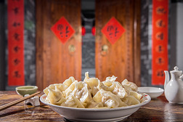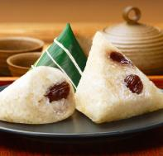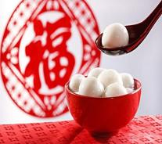
Intent: To lead to the topic and prepare for the following predicting task.
T:When it comes to festival, it is always related to certain special food. For example, mooncakes remind us of which festival. Mid-autumn Day. Dumplings are the typical food for Spring Festival. Zongzi, we often eat it on Dragon-Boat Festival. Sweet dumplings are the traditional dishes for Lantern Festival. Today we’re gong to listen to a conversation about festival.

Step two: Predicting

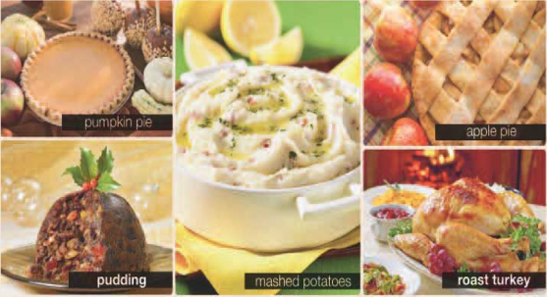
Intent: To train students to make reasonable predictions based on the given information and get students prepared for listening tasks.
T:Song Lin and Max are talking about a recent festival experience.Before listening,we can make reasonable predictions based on the given information. From the picture here, can you predict what festival they will talk about?
Step three: Listen for main idea
Intent: To train students to listen for the main idea and content structure of the material.
Listen to the conversation for the first time and try to find out the answers to the following questions.
1.What festival are they talking about?
2.What aspects of the festival were mentioned ?Tick the answer you heard.
origin typical food activities ◻ emotions
Step four: Listen for details
1.Skimming:Before listening, go through the questions quickly and circle the key words.

1) What did Max do during the festival?

2)What dishes did Max's mother cook? Tick the dishes you heard.

3)What did Max and his family do during and after the dinner?

4)What was the best part of the festival?
Intent: To train students to skim the questions before listening and get prepared.

2.Listen to the conversation again and answer the questions on page 7.

1)What did Max do during the festival?

He the Christmas tree and under it. Then he helped his mum for the on Christmas Eve.
2)What dishes did Max's mother cook? Tick the dishes you heard.

3)What did Max and his family do during and after the dinner?

During dinner, they .They also with the kids afterwards.
- What was the best part of the festival?
The best part was on Christmas morning.
Intent: To train students to listen for detailed information.
Step five: Listen for language

Listen again and tick the phrases that Max or Song Lin uses expressing feelings and emotions
It was fantastic! How wonderful! How exciting!
That’s amazing! It was great fun! It’s very exciting.
It was great to … I’m really happy that… I’m pleased to…
Intent: To get students focus on the related expressions.

Step six: Analyzing language
Read the conversation below and underline the phrases that express feelings about festivals.
Joe:Did you enjoy the holiday, Song Lin?
Song Lin:Oh yes, it was great, thanks! The food, the parades, and the beautiful fireworks—it's always exciting for me. It's good to spend time with my family, too, although it can get a bit boring in my hometown after a while. How about you?
Joe:Well, this was my first Chinese New Year. I loved watching the traditional performances, and I was invited to lots of delicious meals. But, to be frank, the fireworks going off throughout the night were really annoying.
Song Lin:Oh, well, yes, I can see your point there! But it's all part of the tradition to frighten away the evil spirits.
Joe:Yes, well, there seemed to be a lot of them in my area! Anyway, except for that, everything was fine. I'm really looking forward to the next festival.
Intent: To get students to prepare for the talking task.
Step seven: Talking
Talk about a recent festival experience and share how you felt about the festival and why.
Intent: To train students’ spoken abilities to talk about festival experiences using related expressions and prepare for the writing assignment.
Step eight: Homework
Write down your sharing experience in detail in the exercise book.
Intent: To get students organize the spoken language in detail and transform it into written form.

- It’s very exciting.
- I’m pleased to…

