**Unit 3 Sea Exploration**

**Using Language 1教案**

**Get to know about whales and other sea animals**

**Teaching aims:**

By the end of this period, students will be able to:

1. To get the main idea and the key details by listening to the conversation.
2. To learn to use some words and phrases to express sequence.
3. To develop the awareness of protecting sea animals.
4. To make a plan for a trip to see the animals.

**Teaching key and difficult points:**

1. Help students to arouse their awareness of protecting sea animals and express sequence in oral communication.
2. Instruct students to express sequence in oral communication.

**Teaching procedures:**

**StepⅠLead-in**

**Activity** **1** **Watch** **some** **pictures** **and** **share** **what** **you** **know** **about** **these** **sea** **animals.**

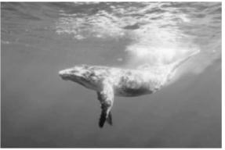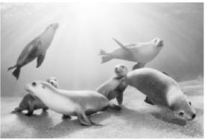

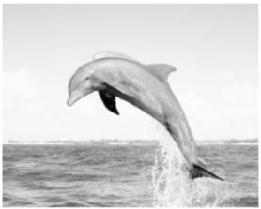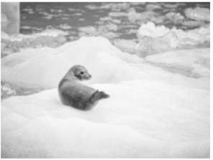

**Activity** **2** **Read** **the** **poster** **and** **discuss** **the** **questions.**

**1**.What aspect of the camp would you like best?

**2**.Do you think it is important to carry out research on whales and other sea creatures?

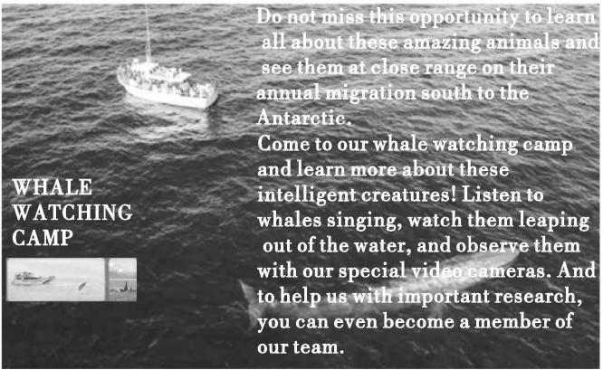

Suggested answers:

**1**.I would like the opportunity to see the whales at close range best.

**2**.Yes,absolutely.Because this research helps us learn more about the wonderful world we live in, and it also helps us learn more about these amazing creatures so that we can better protect them.

**StepⅡ Listening** **for** **the** **main** **idea**

Ask students to listen to the conversation and answer the following question.

What three things were the campers asked to do?

Suggested answers:

**1**.To find out some facts for a whale profile.

**2**.To think about why they do whale research.

**3**.To go out with and write a report of the work they do.

**StepⅢ　Listening** **for** **sequence**

Listen to the conversation again and number the following sentences in the correct order.

____After that,we gave the group of whales a name,and each member a number.

____They will be added to the directory so we can identify them in the future.

____Most whales have slightly different fins and marks,which can help us to tell them apart.

____Meanwhile,we also noted their location,so we can track their movements and plot their migration path.

____Then we took pictures of their fins.

____Finally,we contacted other whale research groups around the world to share the information with them.

____First,we followed a group of whales with the boat.

____Later,we created a database of their fins and locations.

Suggested answers:

6,7,3,4,2,8,1,5

**StepⅣ Listening** **for** **the** **key** **information**

**Activity** **1** **Listen** **to** **the** **conversation** **again** **and** **answer** **the** **following** **questions.**

**1**.How many species of whales are there?

**2**.What is the criterion to divide the main types of whales?

**3**.What do whales use sounds for?

**4**.Why do the campers take pictures of the whales’ fins?

**5**.Why do they contact other research groups?

Suggested answers:

**1**.Over 80.

**2**.The criterion is whether they have teeth or not.

**3**.They use sounds to communicate and hunt.

**4**.This can help them to tell the whales apart.

**5**.They want to share the information with them.

**Activity** **2** **Listen** **to** **what** **Sally** **said** **again** **and** **draw** **a** **mind** **map** **to** **show** **the** **basic** **information** **about** **whales.**

Suggested answers:

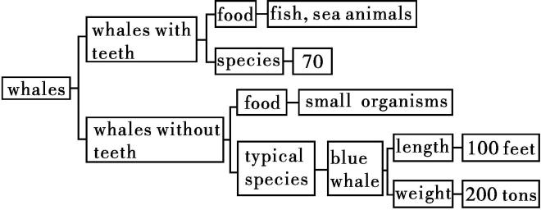

**StepⅤ Speaking**

**Activity** **1** **Brainstorm** **expressions** **showing** **sequence** **in** **the** **speaking.**

Suggested answers:

firstly, secondly, first of all, after that, next, later, meanwhile, finally

**Activity** **2** Ask students to tell your partner about what happened in the whale watching camp.

Example:

A: Today we learnt about whales and whale research. First, we found some information and facts about whales. We used the library and the Internet.

B:What did you do after that?

...

Suggested answers:

A:Today we learnt about whales and whale research. First, we found some information and facts about whales. We used the library and the Internet.

B:What did you do after that?

A: Well, after that we thought about why we do whale research.

B:So why do you do whale research?

A:There are lots of reasons. First of all, we need to know how many whales there are. Then, we need to know where they go. And finally, we need to understand more about them.

B:Then what did you do next?

A:After that, we went out whale watching, following a group of whales in a boat.

B:That sounds neat. Did you just watch them, or did you do anything else?

A:We started by taking pictures of their fins, so we could tell them apart. At the same time, we noted their location,so we could track them.

B:What did you do afterwards?

A:We created a database and gave each whale a name and number. Then finally, we shared our information with other whale research groups around the world.

B:It all sounds so wonderful! I wish I could have joined you.

A:I do, too.

**Activity** **3** **Watching** **and** **talking.**

Watch the video *Protecting* *Biodiversity* and then talk with your partner and make a plan for a trip to see the animals.

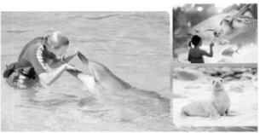

Suggested answer:

For our trip, we would like to go to the Shanghai Ocean Aquarium. We can first visit the special exhibition of saving sharks. Then we can go to see the seahorses whose number declined greatly for the past decade. However, most people do not know much about seahorses at all. I think we need to raise awareness about seahorses and marine conservation in China. The last spot will be The Chinese Pavilion, which displays the aquatic organisms and bio-system in the Yangtze River and some national endangered rare aquatic creatures, like Chinese alligator and Chinese sturgeon.

**StepⅥ Homework**

翻译下列习近平总书记关于建设海洋强国的讲话

**1**.我国是一个海洋大国,海域面积十分辽阔。一定要向海洋进军,加快建设海洋强国。

**2**.要下决心采取措施,全力遏制海洋生态环境不断恶化趋势,让我国海洋生态环境有一个明显改观,让人民群众吃上绿色、安全、放心的海产品,享受到碧海蓝天、洁净沙滩。

Suggested answers:

**1**.China is a country with vast oceans. We are bound to explore the sea and accelerate the construction of ocean power.

**2**.We are determined to take measures to prevent the ocean ecological environment from becoming worse. We are determined to improve the environment significantly and ensure that the masses can consume green and safe sea products as well as enjoy the blue sky and clean seashores.