Reading and Thinking

基本信息 | 话题 | 主题 | 教学时长
 | Learn about the development of  space exploration | Human and Nature | One period  (40 minutes)
1.教材分析 | What: The topic of the text is the development of space exploration. Staring up at the  stars, humans have always had a natural curiosity about space. In the 20th century, space  travel became a reality with American and Soviet space missions. While humans have  attained great achievements, space travel has always involved great risks. Despite the risks,  human exploration continues. Compared with other countries, China’s space programme  started later, but it has made great progress in a short time. As many countries are planning  further missions, with joint efforts the future of space exploration will be brighter.  Why: The text is intended to help students not only learn about the famous events in  human space exploration, but also actively think about the spirit of space exploration.  How: The reading text is a popular science article consisting of 3 parts. The first part  states the reasons for space exploration. The second part presents the development of human  space exploration. The last part describes the bright future of space exploration.
2.学情分析 | What they Know: The students in this class are from Senior Two. Through previous  learning, they are quite familiar with some famous events of human space exploration, but  seldom have they learned about the history of space exploration in a systematic way.  Besides, they can easily locate topic sentences, but their ability to summarise the main ideas  still needs training. Not all the students can express their ideas in English freely, so  discussion with partners is needed to get them fully prepared.  What they Want to know: They might want to know more about human space  exploration, further improve their generalization ability and get more chances to express

their ideas.
What they will Learn: In this period, they will learn to summarise the main idea of
each paragraph by focusing on topic sentences and key words or ideas, and then explore the
development of space exploration.
3.教学目标 | By the end of this class, students will be able to  1. summarise the main idea of each paragraph by focusing on the topic sentences and  repeated words or ideas and sort out the structure of the text.  2. acquire detailed information about the development of human space exploration by  means of a timeline.  3. analyse what makes it possible to turn the impossible space dream into a reality.  4. express their opinions on the value of space exploration and explore the spirit of space  exploration.
4.重点难点 | Key Points  1. Lead students to summarise the main idea of each paragraph and sort out the structure.  2. Scaffold students to sort out the development of human space exploration.  Difficult Point  How to lead students to express their opinions on the value of space exploration and explore  the spirit of space exploration.
5. 教学过程 | 教学目标 | 教学活动与步骤设计意图 | 评价要点 | 时间  与互  动模  式
 | Review the  knowledge gained in the  previous  period. | Step 1 Activate and Lead in  Activity 1 Quiz  Students have a quiz about space exploration based  on their previous knowledge. | The teacher  observes  whether  students are  able to  answer the  questions | IW/  CW  5’

 |  | 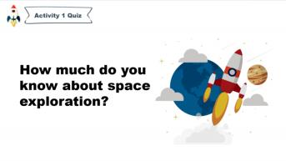  Activity 2 Think and Answer  Students think about the main reasons for space  exploration.  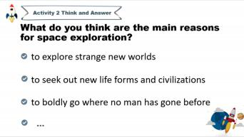 | about space  exploration  and share  their opinions  on why we  continuously  explore  space.
设计意图：1. To arouse their interest and activate students’ prior
knowledge about space exploration.
2. To set up the context, lead in the topic and get students ready for reading.
 | Figure out  the logic  between  lines.  Summarise  the main | Step 2 Read for Structure  Activity 3 Read and Fill  Students skim the text and fill in the blanks.  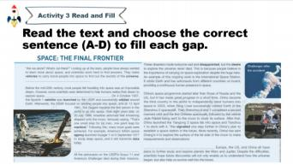  Activity 4 Read and Summarise  Students read the text again and summarise the main | The teacher  observes  whether  students are  able to  understand  the logic  between lines  and  paragraphs.  The teacher  observes | IW/  CW  12’

 | idea of each paragraph by focusing on the topic  sentences  and repeated words or  ideas.  Sort out the structure of  the text. | idea of each paragraph.  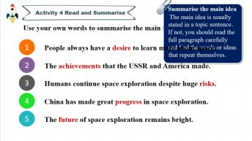  Activity 5 Observe and Comb  Students observe the main idea of each paragraph  and sort out the structure of the text.  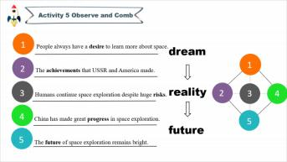 | whether  students are  able to  summarise  the main idea  of each  paragraph.  The teacher  observes  whether  students are able to sort  out the  structure of  the text based  on the main  idea of each  paragraph.
 |  | 设计意图：To help students practice their reading skills—summarising the main ideas, and grasp the structure of the text and logic between lines.
 | Acquire  detailed  information  about the  development of human  space  exploration. | Step 3 Read for Details  Activity 6 Read and Complete  Students read the text for a third time and complete  the timeline of human space exploration.  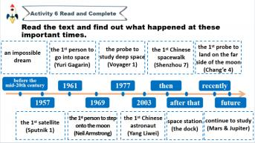 | The teacher  observes  whether  students are able to sort  out the  development  of human  space  exploration. | IW  6’

 |  | 设计意图：To help students figure out the development of human space exploration in a logical way.
 | Analyse  what makes it possible to  turn the  impossible  space dream  into a  reality.  Express their opinions on  the value of  space  exploration and explore  the spirit of  space  exploration. | Step 4 Think  Activity 7 Further Think  Students discuss with partners and think about how  to turn an impossible dream into a reality.  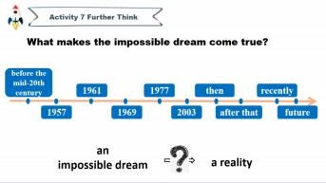  Activity 8 Think and Share  Students watch a video clip about America’s  Challenger and share their opinions about the value  of space exploration.  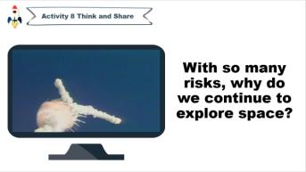 | The teacher  observes  whether  students are able to figure  out what  makes the  space dream  come true.  The teacher  observes  whether  students are  able to  express their opinions on  the value of  space  exploration. | CW/  GW  16’
设计意图：To help students cultivate critical thinking and think deeply
about the spirit of space exploration.
 | Make a  summary of this period and  form  positive | Step 5 Summarise  The teacher leads students to make a summary of the  text. | The teacher  observes  whether  students are  able to sum | CW  0.5’

2024 年普通高中新课程新教材优质课评选暨优秀课例汇集活动——英语学科（个人赛）

 | values. | 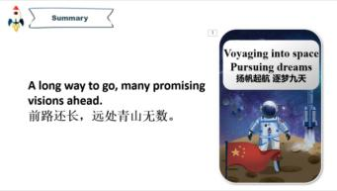 | up the theme  and  develop  positive  values.
 |  | 设计意图：To sum up the theme and value of the reading text.
 | Assess  themselves  from  different  aspects. | Step 6 Self-assess  Students think about what they have learned and  finish self-assessment.  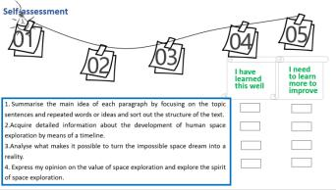 | The teacher  observes  whether  students are  able to assess  their  performances  in this class  according to  the checklist. | I  0.5’
 |  | 设计意图：To help students develop meta-cognitive strategies and promote their ability of autonomous learning.
6. 板书设计 | Unit 4 Space Exploration  Space: the Final Frontier  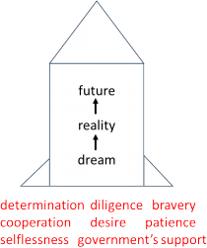

7. 作业布置 | Compulsory:  1. Search online or read relevant books for information about China’s achievements in space  exploration after 2019.  2. Underline the infinitives in the reading text.  Optional:  Design a poster or shoot a video to introduce the development of space exploration.  设计意图：1. To help students consolidate their understanding of the topic, further process  what they have learned and get prepared for the next period.  2. To encourage students to present what they have learned in a practical and meaningful  way.

