教学设计
课程基本信息
学科 | 英语 | 年级 | 高一 | 学期 | 春季
课题 | B3U2 Morals and Virtues Listening and Talking
教学目标
In this class, students will be able to:
1. understand the gist and specific details (six elements) through listening;
2. tell a story with the aid of three key questions;
3. talk about the importance of kindness, and form a positive attitude toward sharing kindness.
教学内容
教学重点：
- Obtain the key information of the listening text and understand what is “playing it forward”;
- Talk about the importance of kindness and tell a story about kindness.
教学难点：
- Catch the six elements and linking words of a story through listening;
- Tell a story with the aid of three key questions.
教学过程
Step 1 Lead in
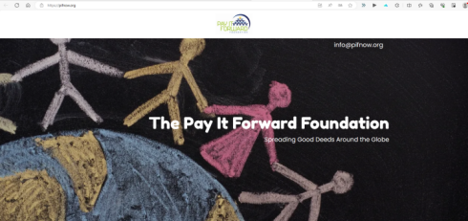
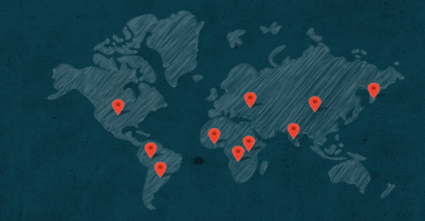
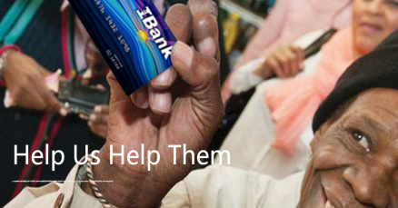
Free talk: Show the homepage of the Paying It Forward Foundation with students and lead them to guess what this foundation is about.
【设计意图】通过“The Pay It Forward Foundation”网站主页、活动图片和分布地图导入话题，引发学生对善举的思考，激起学生的思维意识，也为后续听力中新词汇(如chain)进行了铺垫。

Step 2 Predict: the radio show
- Where may this conversation happen?
- What is the possible relationship between the two speakers?
【设计意图】听力文本是一段电台访谈节目，听前预测对话双方关系、对话地点，有利于下一个活动的开展和完成。

Step 3 Listening for the gist
Listen to a radio show, check your prediction and answer the following questions.
- Where may this conversation happen?
In a radio show studio.
- What is the possible relationship between the two speakers?
The interviewer and the interviewee/The host and the guest.
- Which picture expresses the meaning of “paying it forward”?

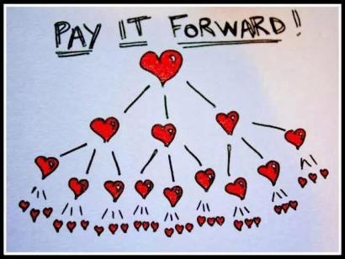


A B C
Picture C. It means when you receives kindness from someone, you go out and show kindness to another person.
- What are they mainly talking about?
A song named “Chain of Love”.
- What does the guest want the listeners to do?
The guest wants the audience to join the chain of kindness and “pay it forward”.
【设计意图】第一次听力活动，学生运用一定的听力技能听取内容大意和关键信息，理解“pay it forward”的内涵和外延，说出嘉宾的主张和倡议。

Step 4 Listening for detailed information
- What elements should be focused on when we listen to a story?
Six elements: when, where, who, what and how, and why the story is important.
- Listen to the story and complete the mind-map.

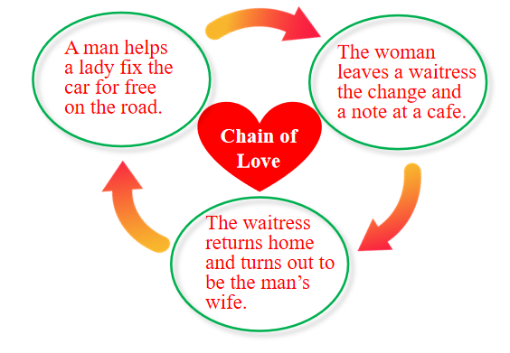
- Culture Note:
- In America, waitresses are normally paid a very small wage, but get most of their earnings from customers to tip about 15% or more of the cost.
- It is unusual for a customer to pay for a meal with a $100 bill and then let the waitress keep the change.
- Talking: What’s your understanding of “Chain of Love”?
- Kindness can balance nature;
- Kindness can bond people;
- Kindness can improve our society;
- Kindness can better ourselves.
- Kindness can be passed. So when someone does you a big favor, don’t pay it back, but pay it forward.
【设计意图】学生学会通过把握故事的六要素去听故事。通过第二次听力活动，学生获取歌曲“Chain of Love”的细节信息，完成思维导图，并谈论友善的重要性。不仅提高学生获取信息的能力，而且让学生了解文化背景，感受到小小善举的重大意义。

Step 5 Listening for linking words
- Listen to the story again and take down the linking words.
The linking words include: but, instead / late, when, then / then.
- Thinking: What makes it a smooth story?
For one thing, the story develops step by step; for another, linking words make it smooth and logical.
- Brainstorm for more linking words and expressions.
Linking Words:
once upon a time, long ago
first of all, then, after that, later, finally
so, however, although, but
Useful Expressions:
I remember this happened when I was...
I was on my way to...
I was sitting... when...
It was a...day/morning...
There were... on the street...
【设计意图】会听故事在英语学习中起到非常重要的作用。第三次听力活动，引导学生从听力文本中找出可用于叙述故事的衔接词和句式，理解其语言功能，为学生提供了开场白、叙事逻辑和时态上的指引。并通过头脑风暴思考更多的衔接词和句式，为后面的口头表达做好准备。

Step 6 How to tell a story
- How can we tell a story?
- What is the story about? (Background: when, where, who)
- How is the story developed? (correct tenses) (step by step) (use linking words)
- Why is it important to you? Why do you remember it?
- Share your story of showing or receiving kindness.
Teacher’s example:
Last weekend, I walked up to the store as usual. But when it was my turn to pay for my groceries, I found myself short about ten yuan. I was about to take off things I could do without, when a stranger handed me a ten-yuan note, smiling. At that time, I, who am never speechless, was speechless. I asked for the man’s name and address so that I could repay him. However, he said I should just regard it as his gift for me. I was so touched by his gesture that I decided to pay it forward. If the same happened to someone else, I would definitely pay for him/her. So, whoever you are, thank you for the random act of kindness that not only has helped me out, but has made my day.
【设计意图】教师提供给学生讲故事的策略，帮助学生理清思路，知道故事从那哪个方面讲以及怎么去讲，策略的学习有助于提高学习效率。教师示范，学生模仿输出，讲述发生在自己身边的爱心故事。

Step 7 Critical thinking
- As a teenager, what can we do to spread kindness?
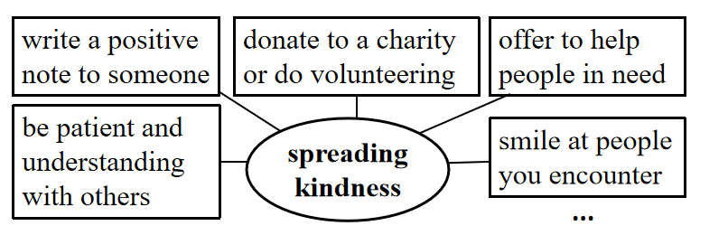
Small acts of kindness can make a big difference. So we can join the chain of kindness and pay it forward to make this world better.

- Reflect on what you’ve learned in this class, and send a message to the Pay It Forward Foundation.
【设计意图】学生对于“爱心链”这一故事的理解和探讨，既培养其听说能力，还升华主题，渗透了人生观和道德观的培养。通过批判性思维活动，学生会意识到一次小的善举能给人带来意想不到的温暖和光亮；并通过自己的善行去影响他人，就能创造更美好的社会氛围。

Step 8 Theme conclusion
(Confucius) Don't miss doing any good thing no matter how insignificant it looks.
(William Wordsworth) The best portion of a good man’s life is his little, nameless, unremembered acts of kindness and of love.
【设计意图】通过名人引言，让学生明白，善举不分大小，善举温暖心灵，善举润物无声，体现在平凡生活的点滴之中，只有用心体会，才能发现道德和美德在社会生活中不可忽视的力量。升华主题，传递爱心，塑造学生的美好品格。

Step 9 Homework
View a public service announcement “One Day”(见配套学习资源推荐) and write a story of sharing or receiving kindness. Here are some words and expressions that may help you.
Outline  When:________  Where:_______  Who:_________  What and how:___________  Why is the story important:_  Linking words:___________ | Linking Words  once upon a time, long ago  first of all, then, after that, later, finally  so, however, although, but | Useful Expressions  I remember this happened when I was...  I was on my way to...  I was sitting... when...  It was a...day/morning...  There were... on the street...
【设计意图】鼓励学生运用课堂中所学词汇和句式，充分发挥想象力和创造力，讲述自己的故事或公益广告“One Day”中的一个故事。讲故事也是培养学生表达能力的一种有效方式；更重要的是，讲故事可以把学生已有的知识、生活经验和所学内容结合起来，有助于探究主题意义，发展学生的素养。

