**Unit 4 Sharing**

**Period 2 Learning about language 教案**

**教材分析:**

该部分分为2 课时，第一课时Building up your vocabulary以志愿服务和中国对外援建为主要素材， 梳理本单元Reading and Thinking板块已经出现的重点词汇，设计了层次丰富的词汇活动。活动1以趣味宁谜的游戏形式复习重点词汇，同时在字谜的答案中还隐藏了一个重要的寓意——“分享很重要(SHARING MATTERS) ”。这既是活动1对学生的启示，也是整个单元主题意义的重要体现。活动2中的语篇讲述了一位中国志愿者在加纳生活和参与援建的经历。虽然生活上很艰苦，困难很多，但是志愿者表现出了积极乐观的人生态度和继续为非洲援建贡献力量的决心，这对于青少年学生来说是非常重要的世界观、人生观和价值观教育。活动3和活动4可以作为一个整体来看。首先，通过活动3的词汇分类和关联拓展，培养学生构建词汇语义网的意识和能力；然后，活动4基于这些基础词汇的整理，启发学生进一步聚焦青少年学习和生活中的三种必需品，形成一份捐赠清单并说明理由。 第二课时该部分综合复习按结构分类的句子成分，包括名词短语、动词短语、副词短语、形容词短语和介词短语。如果学生能够主动使用不同的短语，并根据交际需要用来丰富句子内容，那么可以增加语言表达的多样性。活动1要求学生识别句子中的短语类别和功能。活动2以“一带一路”建设为背景，在延伸主题意义的同时，强化对短语的使用。活动3的设计具有开放性和创造性，启发学生从编辑的视角尝试通过增加短语成分的方式修改、润色一篇普通的志愿者招聘广告，让其更加吸引读者，同时也能让学生在改写活动中更加直观地体会短语的语用功能。

**学习目标与核心素养:**

1.To practice using key words from the text of reading.

2.To cultivate the spirit of volunteerism, and further understand the dedication through the volunteers’ work.

3.To identify the different phrases and state their functions.

4.To apply what students have learned in revising an advertisement by add more phrases.

**重点:**

1.To practice using key words from the text of reading.

2. To identify the different phrases and state their functions.

**难点:**

To apply what students have learned in revising an advertisement by add more phrases.

**教学过程：**

**Period 1 Building up your vocabulary**

**Step 1 Lead –in**

**It’s a good virtue of Chinese people to share good things with others, up to now Chinese people’s sharing has helped many countries on their road to a better life.**

Watch a short video about China help Uganda complete the installation of the satellite television project.

**(Purpose：to serve as a warming-up for the following activities.)**

**Step 2 Activity 1**

**Complete the word puzzle with words from the blog entries. Can you find the hidden message?**

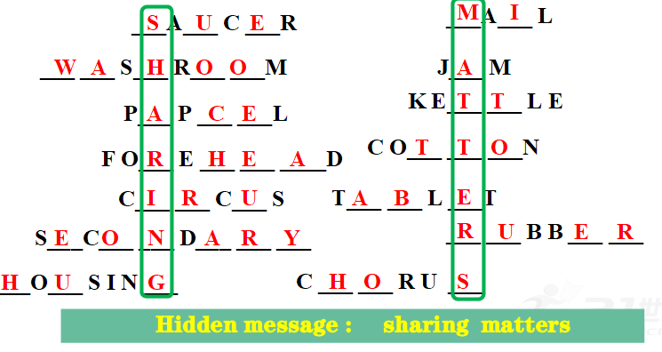

**Hidden message : sharing matters**

**(Purpose：to use the key words in a word puzzle related to the topic of sharing .)**

**Step 3 Thinking**

**How do you understand the message “Sharing Matters”?can you give an example where Sharing Matters?**

Sharing refers to giving others what you own for free, aiming to make them obtain the same delight you get. Meanwhile sharing can satisfy our spiritual needs and bring the pleasure which sometimes cannot be bought by money.So sharing is both a manifestation of our trust in the process of interpersonal communication and a bridge to help further enhance the friendship.For example, when we have some old articles which we don’t use any more, we can donate them to those in need. This behavior of charity is typical of sharing.

**(Purpose：to think and share opinions about“Sharing Matters” .)**

**Step 4 Activity 2**

**1.Xu Yuan is a volunteer in Ghana.What do you know about Ghana?**

The Repulic of Ghana

“The Top Ten Tourism Countries of Africa”

“The Home of Coco”

The Belt and Road Initiative proposed by China helps Ghana develop in many ways

**2.What does Xu Yuan think of the country and experience? Complete the passage with the words below.**

lack secondary housing right drag kettle

Xu Yuan, a 52-year-old Chinese volunteer in Ghana, was interviewed on a TV programme.According to Xu, the _________conditions in Ghana are not that bad. However she admitted that she once had a memorable experience plugging holes in her roof in order to keep the Rain out. Xu said, “Actually, I don't really care about my living conditions.The only thing that has made me uncomfortable has been the ______of hot water.” She regrets not bringing a_____ to Ghana to boil the water she needs. Some of the medicine she has brought with her works better with hot water. But any discomfort is __________to helping the needy, she believes. Xu enjoys her volunteer experience and considers it a good opportunity to_______ herself out of her comfort zone and to explore the world.“One of my dreams is to work in Africa and continue to help the disabled after I resign from my job. I think everyone deserves the __________to be happy, ” she said.

**Answers : housing lack kettle secondary drag right**

**( Purpose: to help students practise key vocabulary in a paragraph.)**

**Step 5 Discussion**

**1. What difficulties did Xu Yuan meet when volunteering in Ghana?**

The roof of the house had holes which needed to be plugged to keep the rain out .The lack of hot water made her uncomfortable.

**2. What does XuYuan think of the country and experience?**

She thinks living in Ghana is not that bad. Any discomfort is secondary to helping the needy. It is a good chance to drag out of her comfort zone and to explore the world.

**( Purpose: to consolidate the students’ understanding of volunteering abroad.)**

**Step 6 Activity 3**

**Divide the following words into groups.Explain how you have grouped them.Then add more words to the groups.**

jam laptop knee bacon textbook tablet paper rubber jaw wrinkle forehead saucer kettle pan jar grill corn cup leftover pencil muscle sweets

**(Purpose: learn more about the key vocabulary from the text and add to that vocabulary with words students can find on their own.)**

**Step 7 Activity 4**

**Imagine you are going to donate the three things to poor children in the countryside. What will you donate and why ?**

I would donate more extra-curricular books, as these can be hard to get in poor rural areas； and school supplies, such as pens and paper, because these are another practical things that perhaps they can not easily afford.

**What other gifts can you think of that might be helpful to poor areas?**

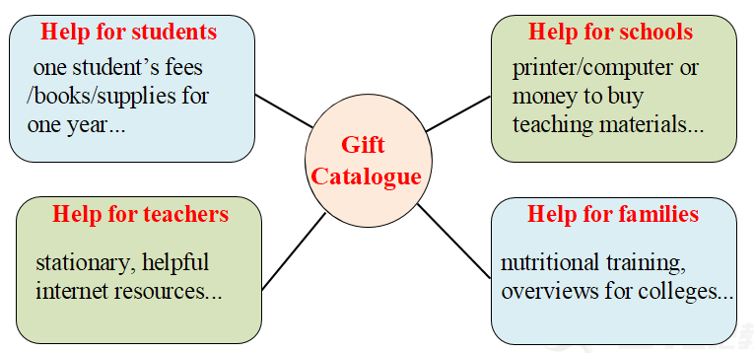

**(Purpose:to consolidate vocabulary and apply It to students’ own lives.)**

**Step8 Homework**

**(Purpose:to consolidate what has learned in the class.)**

**Period 2 Review useful structures**

**Step 1**

**Lead-in**

**1.Watch a short video and answer questions**

1) What was presented to Thailand as a gift?

2)What speed do Fuxing trains operate at per hour?

3)In which country in Southest Asia the first high-speed railway also used the Fuxing bullet train ?

4) Is China helping many countries in Southeast Asia build railways?

**2.Read the sentences and pay attention to the phrases used in them**

**(Purpose: to warm up for the following activities.)**

**Step 2 Review**

**Review five types of phrases.**

**(Purpose:to review five types of phrases and their functions.)**

**Step 3 Activity 1**

**Identify the phrases in the following sentences and state their functions. Mark noun phrases as NP, verb phrases VP, adverbial phrases AdvP, adjective phrases AdjP, and prepositional phrases PrepP.**

**(Purpose:to see how phrases are used in the context and learn inductively the purpose of their use. )**

**Step 4 Activity 2**

**1.Complete the passage with the phrases below in their proper forms.**

***beautiful modern road, a chorus of, dusty track,***

***straight towards, a large amount of investment,***

***with dangerous disease***

China has offered ____________________________ to many countries in its Belt and Road Initiative. In the Congo, many ___________ have been transformed into ______________since then. Trains run ________________ Europe from China, and to China from Europe, bringing new jobs and opportunities to both ends. Chinese healthcare workers have also been sent to provide aid to places ______________________. Despite all the difficulties involved in this project, these efforts have been greeted with __________ support from the locals.

**Answers :a large amount of investment, dusty track,beautiful modern road, straight towards,with dangerous disease,a chorus of**

**2.Questions**

**How much do you know about the Belt and Road Initiative?**

1) When was the idea of the Belt and Road first put forward?

In 2013

2)What kind of projects does it carry out?

Economic cooperation and culture communication, such as building roads and railways, volunteer work in education and health care.

3) What is the purpose of the Belt and Road?

The purpose of the Belt and Road is a win-win for all.

**(Purpose:to practise using phrases in the context of a paragraph.)**

**Step 5 Activity 3**

**1.Imagine you are an editor of a volunteer website. Here is an advertisement for volunteers.**

Improving Health in Guinea

In order to ease suffering in Guinea, volunteers are needed to provide healthcare information. As a volunteer, you will be responsible for organizing lectures, preparing posters, and visiting schools and families. There is no doubt that these activities will leave you with unforgettable memories. The program will last for one year or more, depending on your performance.

You need to be over 18 and be able to communicate in English. You don’t need to have overseas experience, but you should be friendly and outgoing.

If you are interested in volunteering, please speak to our representative online.

**2.Add phrases to the following advertisement to make it more exciting.**

**Tips**

* **How can you make the advertisement more attractive?**
* **What phrases can you add to describe the situation in Guinea?**
* **What phrases can you add to stress the importance of volunteers and the activities?**
* **What phrases can you add to arouse the emotion of the intended readers?**

**Suggested answer:**

**Improving Health in Guinea**

In order to ease suffering in Guinea *from a lack of doctors and good healthcare advice,* volunteers *with a heart to help others* are needed to provide healthcare information *to people in rural villages*. As a volunteer, you will be responsible for organizing lectures, preparing posters, and visiting schools and families *throughout the southern part of the nation.*

There is no doubt that these activities will leave you with unforgettable memories *for the rest of your life.* The program will last for one year or more, depending on your performance.

You need to be over 18 and be able to communicate *well both in spoken and written English (or in French).* You don’t need to have overseas experience, but you should be friendly and outgoing *with a wonderful smile.*

**(Purpose: to apply what students have learned in revising an advertisement by add more phrases.)**

**Step 6 Pair work**

**1. How much do you know about Guinea ?**

**2.What is the purpose of this advertisement?**

To recruit volunteers to provide healthcare information .

**3.What are the key points in the advertisement?**

The volunteers should be responsible for organizing lectures, preparing posters, and visiting schools and families;

They need to be over 18 and be able to communicate in English;

They should be friendly and outgoing.

**(Purpose：to develop thinking skills.)**

**Step 7 Homework**

**(Purpose:to consolidate what has learned in the class.)**