教学设计
课程基本信息
学科 | 英语 | 年级 | 高一 | 学期 | 春季
课题 | Unit 4 Space exploration Reading for Writing
教学目标
1. Knowledge objectives
Students will have a good command of the words and expressions about space exploration. They will try to read and analyze an argumentative essay which reveals the benefits of space exploration and write an essay about the topic.
2. Ability objectives
(1) Students will finish the questions by reading and discussing and get the attitudes of the author.
(2) Students will apply their skills of speaking, reading and writing to a whole task.
(3) Students will be inspired to reflect on the topic about the existence of aliens and to profoundly think about the conflicts between the human beings and other creatures on other planets.
3. Emotion objectives
Students will increase their interest in learning English and their critical thinking of space exploration will be inspired.

教学内容
教学重点：
1. to guide students to master the techniques of writing an argumentative essay about the necessity of space exploration and enhance their skill of writing.
教学难点：
1. to develop students’ ability in analyzing the different views on space exploration.

教学过程
Step 1 Warming up
Students enjoy some pictures about the space exploration and the astronauts’ daily life in the spaceship. Then suppose students were invited to visit the international space station. “What will we see in the space?” Let’s enjoy a video clip (made and dubbed by myself).
*Purpose of my design: (1) to help students review the Reading and Thinking part and preview the project so as to grasp all the parts in the unit as a whole. (2) to catch students’ s attention about the topic and stimulate their interest in the outer space.

Step 2 Discussing
Students look at some pictures and think about the necessity of space exploration.
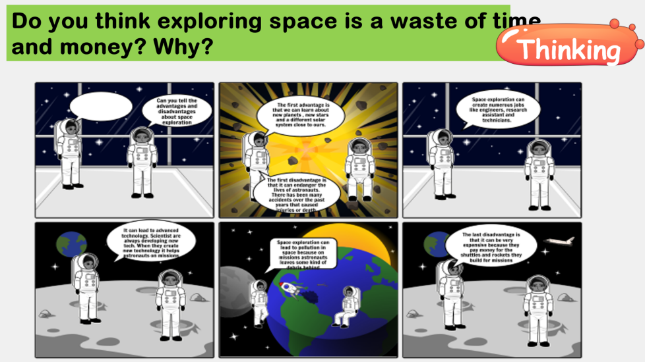
*Purpose of my design: to arouse students’ interest of discussing whether human beings should explore the outer space and help students know the general ideas on this topic.

Step 3 Reading the passage
Students read the passage in the textbook and think about the following questions.

1. Why are some people against space exploration?
Because they think it is a waste of time and money, and that we should feed the world's poor and find immediate solutions to other problems, such as pollution and fatal diseases, instead.
2. What has space exploration done for food production?
Satellites study land and weather patterns. These studies help farmers grow more crops and warn them about natural disasters before they occur.
3. What did the pictures of Earth from space make people realize?
They made people realize that our planets resources are limited.
4. How does space exploration benefit the products that people use nowadays?
Advanced technology developed for space exploration has promoted technological improvements that benefits us all by allowing products to be made to a higher standard.
*Purpose of my design: to help students strengthen the understanding of the passage and make preparations for the following writing task.

Step 4 Analyzing the passage
Students are guided to analyze the structure and language features of the argumentative essay. And the structure of the essay usually is “general-specific-general”.

Step 5 Writing
Before writing an argumentative essay, some exercises are given to the students, which helps them understand the theme better.
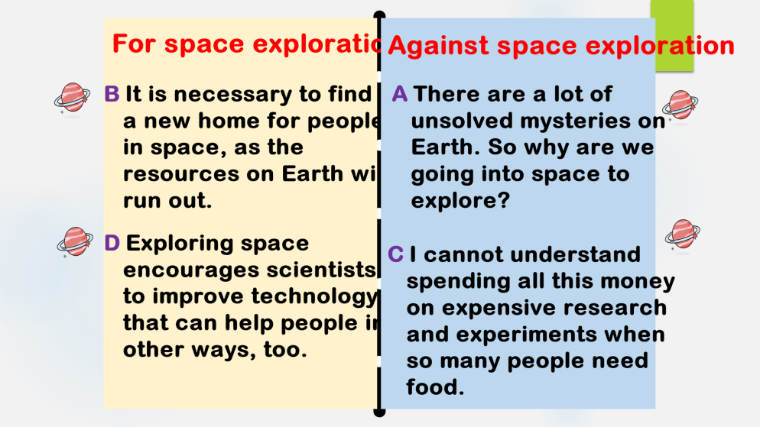
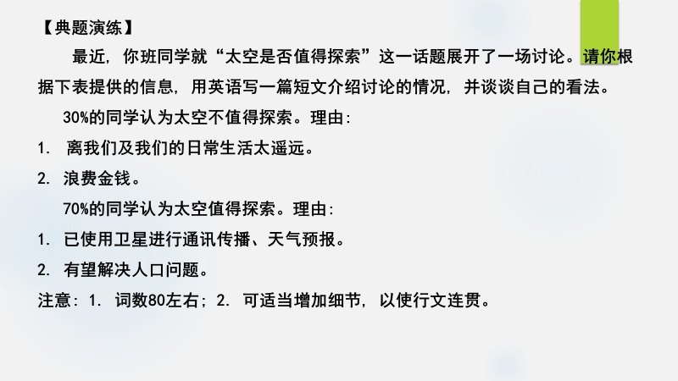
Some useful expressions are provided for students to write an essay.
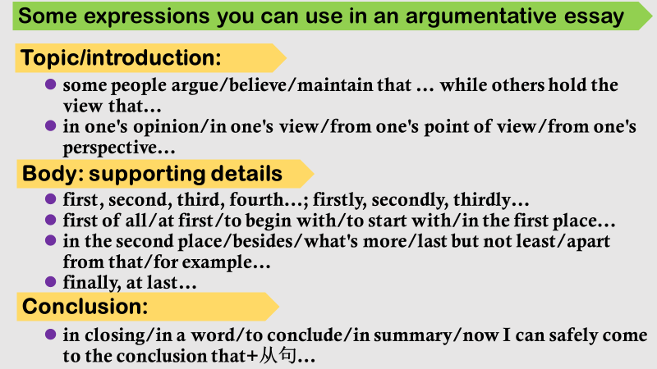

Sample writing:
Recently our class had a heated discussion on whether space is worth exploring. Students hold different ideas about it.
30% of us think space exploration is not worthwhile, holding the belief that space exploration is too far away from us and our daily life and is a waste of money.
However, 70% think space is worth exploring because we have benefited a lot from it, such as using satellites for communication and weather forecast. What’s more, with further space research, we may solve the population problem by moving to other planets one day.
As far as I am concerned, it is worthwhile to explore the space. Not only can it promote the development of society but also enrich our life.

*Purpose of my design: to cultivate students’ ability of writing an argumentative essay based on a topic, which will help improve their critical thinking ability.
Students are guided to have a peer-review with their partners.
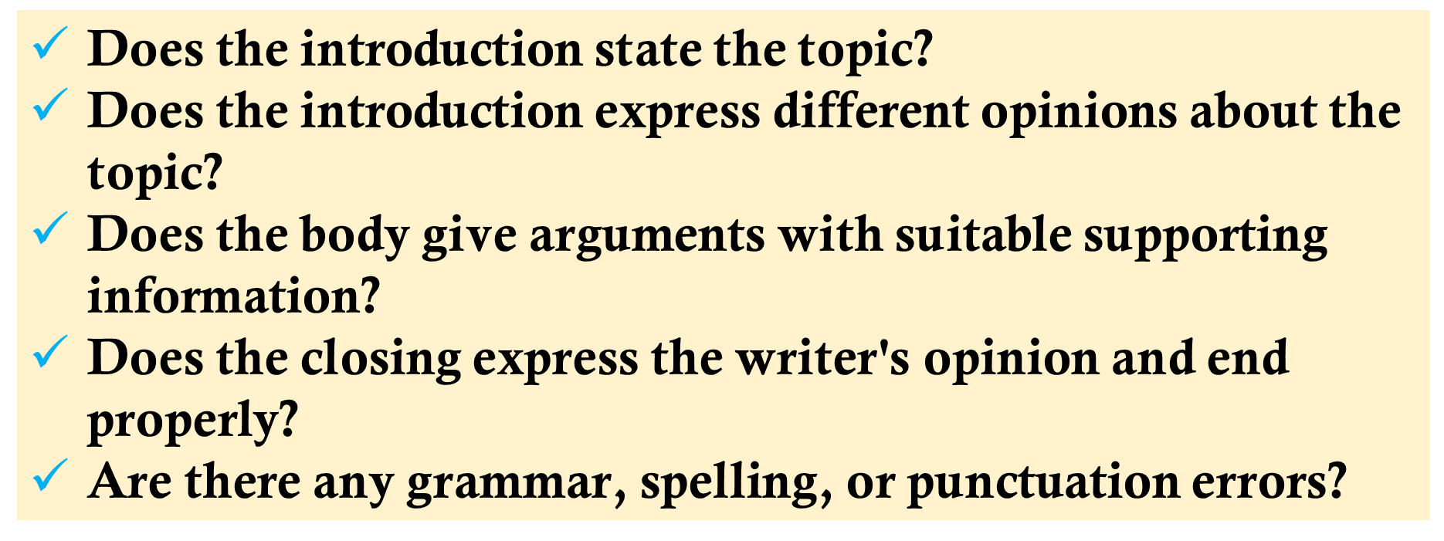
Step 6 Assignments and summary
(1) polish up your writing
(2) have a debate on whether human beings should explore the outer space
*Purpose of my design: to enhance students’ understanding and reflection on the necessity of space exploration by a further debate.

