**【分层训练】五年级下册英语一课一练-Unit 4 When is the art show？ 课时（3）**

**一、单选题**

1．The music room is on the __________ floor.

A．three B．threeth C．third

2．I'm _________ years old, today is my _________ birthday.

A．ten, tenth B．tenth, ten C．tenth, tenth

3．There are ____ special days in April.

A．second B．three C．fourth

4．Our classroom is on the ___________ floor.

A．three B．two C．fifth

**二、音标题**

5． 读一读，判断下列每组单词画线部分读音是否相同

（1）maths mother

（2）fifththin

（3）this there

（4）three these

（5）birthday that

6．读一读，判断发音是否相同。

（1）A. three B. they

（2）A. thin B. maths

（3）A. this B. grandfather

（4）A. fourth B. third

（5）A. those B. thirteen

7．判断每组单词中画线部分的读音是否一致。

（1）A. maths B. mother C. this

（2）A. father B. third C. brother

（3）A. thirteen B. thin C. there

（4）A. that B. mother C. third

（5）A. fifth B. birthday C. maths

8．将下列单词根据th的发音进行分类。

|  |
| --- |
| think they this thank bath those other brother  father third fifth there thin them this thirsty |

（1）th /θ/:

（2）th /ð/:

**三、判断题**

9．判断下列句子中单词画线部分读音是否相同  
His brother is a maths teacher.

10．判断下列句子中单词画线部分读音是否相同  
Thursday is his tenth birthday.

11．判断下列句子中单词画线部分读音是否相同  
This is her father and that is her mother.

**四、匹配题**

12．

A. 这；这个 B. 数学 C. 爸爸 D. 第三 E. 那；那个

（1）maths

（2）this

（3）that

（4）father

（5）third

**五、单词拼写**

13． Look！My brother is tall and t . 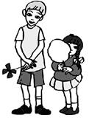

14． My b party is on Sunday. 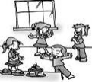

15．Mr. Li is our m teacher. 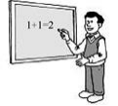

16．I have t storybooks. 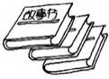

17． —Whose b is in February? 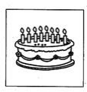

—Mine.

18． —when mother's Day? 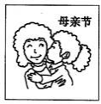

—It's the Sunday in May.

19．My  is on the wps20 of May.

20．His f is a m teacher.

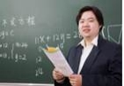

21．写出下列单词

（1）

（2）

（3）

（4）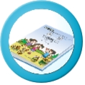

（5）

（6）

（7）

（8）

22．T (他们的）party will be on .



23．My wps31 luck number is wps32 .

24．The month of a year is April.

**答案部分**

1．C

2．A

3．B

4．C

5．（1）F

（2）T

（3）T

（4）F

（5）F

6．（1）F

（2）T

（3）T

（4）T

（5）F

7．（1）F

（2）F

（3）F

（4）F

（5）T

8．（1）think, thank, bath, third, fifth, thin, thirsty

（2）they, this, those, other, brother, father, there, them, this

9．（1）F

10．（1）T

11．（1）T

12．（1）B

（2）A

（3）E

（4）C

（5）D

13．thin

14．birthday

15．maths

16．three

17．birthday

18．is；on；second

19．brother's；birthday；third

20．father；maths

21．（1）three

（2）thirteen

（3）thin

（4）maths

（5）that

（6）this

（7）mother

（8）brother

22．Their；Thursday

23．mother's；three

24．fourth