Unit 2 Using Language 2 教案
学 校 |  | 年级班次
教学时间 |  | 学 科 | 英语
课 题 | Unit2 iconic attractions | 课 型 | 写作课
备课人 |  | 课 时 | 2课时
教学内容 | The amazing animals of Australia --- describe an iconic animal in China
课标分析 | 本课写作活动主题为describe an iconic animal in China。本单元以澳大利亚为主题，第一篇文章从博主的视角介绍其地理位置、美食、土著居民、乐器等，进而在写作部分自然又介绍其传统动物。此外，由第一篇课文的要求介绍中国标志性的特色到写作部分的中国传统动物的描述，都始终在讲中西方各自的特点。在开阔学生视野的同时，又能进一步训练学生的思维写作能力。本篇写作文章重在分析修辞手法的应用，所以在描述中国传统动物上要有意识的运用相关技巧。
教材分析 | 本课教学内容选自2019人教版新教材高中英语选择性必修四Unit 2 Iconic attractions的Using Language板块中reading for writing部分。该部分阅读语篇的标题是The Amazing Animals of Australia，中文标题为《澳大利亚神奇的动物》。课标任务是要求学生在此篇课文的基础上写出一种中国的传统动物。
学情分析 | 学生基础处于中下等水平，词汇有限，课文理解有一定难度，写起来很多句子表达不丰富。其次，学生对澳大利亚的动物不了解，理解起来也难，并且学生对中国的传统动物也了解的不够具体，这就很难写出具体的信息。所以，还是要借助教辅资料来开展写作任务。
学习目标 | - To know some typical animals in Australia;  - To finish related exercises;  - To understand the usage of some rhetorical devices and use them in their compositions.  - To learn and remember some key phrases and sentence patterns.  5. To describe an iconic animal in China.
教学重点 | - To understand the usage of some rhetorical devices and use them in their compositions.  2. To learn and remember some key phrases and sentence patterns.
教学难点 | How to describe an iconic animal in China.
教学策略 | 活动教学法，合作学习法
教具准备 | PPT、导学案
教 学 过 程 |  |  |  | 修改或调整

步骤一：Lead in （5分钟）Before reading : Watch some pictures and a short video to know some basic information of the iconic animals of Australia . （为下文澳大利亚动物的讲解做铺垫）
【教学问题】
Q: Do you know the favourite animals in Australia?

步骤二：文本解构，目标阅读（8分钟）
Students:
Read the text and answer some questions.
【教学问题】
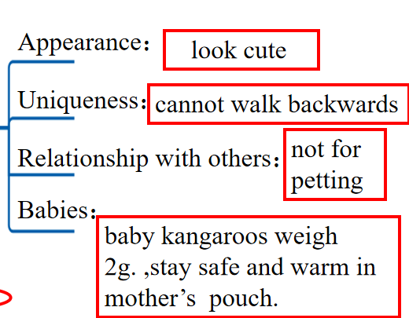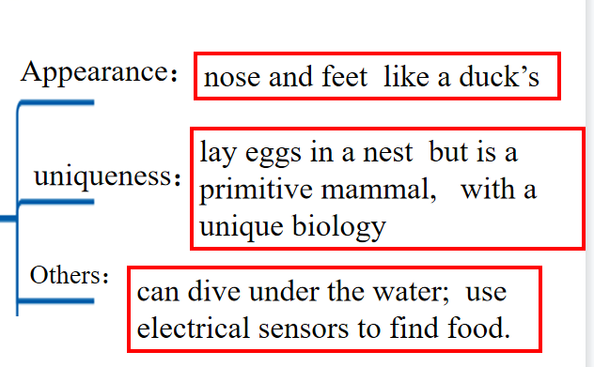

步骤三：回顾课文，思路探究（2分钟）
After reading: Read the text again. How does the writer describe these animals? Find at least three rhetorical devices the writer uses to arouse the readers’ interest.
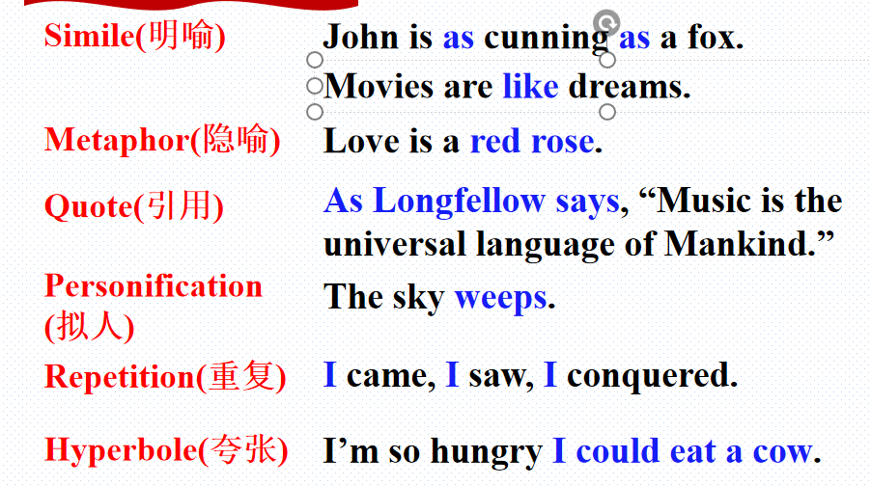
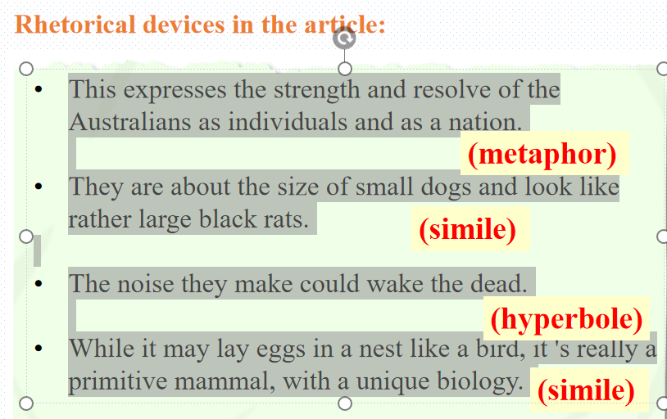
【教学问题】
Q: Brainstorm a list of iconic animals in China.
Do some research and make notes. For example:
where they live
what they eat
what they look like
how they are different from other animals
how they interact with people
any other unusual or interesting facts about them

步骤四：话题讨论，写作构思（5分钟）
【题目呈现】 大熊猫是中国的标志性动物。请根据以下要点， 找雌 写一篇80词左右的英文文章，介绍大熊猫的生活习 Male 性和特点等相关知识。内容包括:
1.大熊猫的特征;
2.饮食、栖息地和繁殖;
3.现状。

【步骤分解】
★步骤1精准审题
本文是说明文;主要时态是一般现在时 ;人称是第三人称。

★步骤2 构建框架
第一部分:
第二部分:
第三部分:

★步骤3要点翻译
(1)大熊猫笨重的身躯和圆圆的脸,再加上黑白相间的皮毛使其看上去很可爱。(过去分词短语)
With a large clumsy body and a round face, (1)combined with a black and white coat, giant pandas look lovely.
(2)竹林是它们最喜欢的栖息地,主要分布在中国中部山区。(which引导非限制性定语从句) Bamboo forests are their favorite habitats,(2)which are mainly located in the mountains ol central China.
(3)体型较大的雄性可能会长到18米长，体重超过100公斤,而雌性通常较小。(while)
Large males may grow up to 1.8 meters in length and weigh more than 100 kg(3) while females are usually smaller
(4)它们很喜欢吃竹子,每天大约吃28磅。(v-ing 短语作伴随状语)
They have a greedy appetite for bamboo,(4)eating about 28 pounds every day.
(5)然而,在圈养时,它们可以以牛奶、花园里的水果和蔬菜为食。(5)feed on milk, fruits and vegetables in the garden(feed on).
(6)雄性熊猫利用自己的感觉来避免彼此，在春天找雌性交配。(不定式)
Male pandas use their senses (6)to avoid each other and to find females for mating in the spring.
(7)随着保护工作的改进,野生大熊猫的数量增加了(increase in)
(7)an increase in the wild giant panda population.

步骤4 连句成文
With a large clumsy body and a round face. combined with a black and white coat, giant pandas look lovely.Large males may grow up to 1.8 meters in length and weigh more than 100 kg while females are usually smaller.
They have a greedy appetite for bamboo,eating about 28 pounds every day.However, in captivity they can feed on milk, fruits and vegetables in the garden.Bamboo forests are their favorite habitats, which are mainly located in the mountains of central China. Male pandas use their senses to avoid each other and to find females for mating in the spring.
With improved conservation efforts, there is an increase in the wild giant panda population.
Homework
Polish your works and swap it with your partners.
板 书 设 计
Blackboard design
describe an iconic animal in China
Step one Reading for basic information.
Step two Plots design
Step three writing
目标达成检测
学生在规定时间之内尽量写好本篇文章并与同伴互赏。
课 后 反 思
加强学生对经典句型的背诵。

