教学设计
课程基本信息
学科 | 英语 |  | 年级 |  | 高一年级 | 学期 |  | 秋季
课题 | 必修第三册Unit 1 Reading for Writing
教学目标
1. 了解蒙古族的“那达慕大会”的相关信息，感受蒙古族人民的文化氛围；
2. 分析文章的结构特点和语言特色；
3. 学习以日记的形式描写过去经历过的节日的写作技巧。
教学内容
教学重点：
1.Master the writing skills of expressing feelings and emotions.
2. Improve the students’ ability to write an open sentence.
教学过程
Students’ activities |  | Teacher’s activities |  | Purpose |  |  | 效果评价
Lead in  Brainstorm the names of festivals that are celebrated both home and abroad. |  | Help students to learn more about the festivals that are celebrated both home and abroad. |  | 用不同的节日来引起学生对课堂的兴趣，并导入今天的文章的内容。 |  |  | 学生在教师的引导下熟悉了很多我们国家及国外的节日。
Reading  Task1:Prediction  Look at the title and the picture of the text and predict the main idea.  Task 2: Scanning  Scan the passage quickly and find the activities the author experienced in Mongolia.  Task 3: Detailed-reading  - Read the passage very carefully and try to find the writing skills of a diary.  2. analyse the structure of the diary. |  | Lead students to predict what the author wants to share by writing this passage.  Ask the students to read the passage quickly and answer the following question:What activities did the author experience?  Lead the students to find writing skills of a diary.  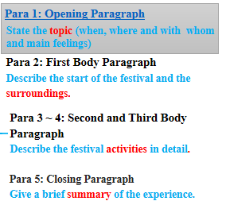 |  | 培养学生通过文章所给的细节快速地预测全文的主要内容，帮助学生尽快进入阅读状态。  帮助学生学习文本的内容和写作特点，为接下来的写作部分做好铺垫。 |  |  | 学生能通过阅读理解文本的内容及写作特点，初步为接下来的日记写作奠定了基础。
Writing  - Make an outline of the diary--The Spring Festival.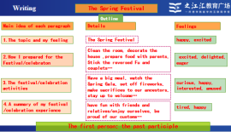  - Write the beginning paragraph following teacher’s explanation.  - Finish the following writing part. |  | Suppose you’re going to write a diary to record your favorite Spring Festival story, how will you write it?  Help students to make an outline of the writing.  Lead the students to write and polish the beginning of the writing.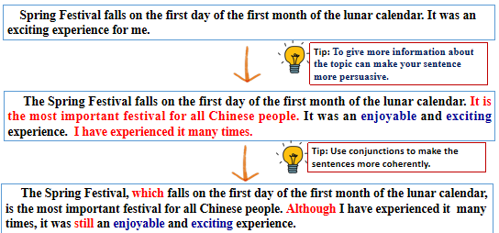  Help students to finish the following paragraphs and give them some guide. |  | 让学生熟悉并回忆春节的美好回忆，在课堂上与他人分享自己家乡的春节活动。  让学生在练习中学会日记的语言特点及句子的改写技巧。 |  |  | 学生基本会完整地输出对春节的细节性描述，能写一篇简单的描写节日的日记。
Post-writing：  Peer-editing  Exchange drafts with a partner. Use the checklist to give feedback on partner's draft. |  | Show the criteria of the assessment and ask students to assess their partner’s writing. |  | 通过共同总结所学，巩固认知。通过评价表，让学生习得写一篇合格的日记的标准，并帮助同伴 一起提升写作技能。 |  |  | 学生在老师的引导下完成了对同伴写作的批改和指正。

Assignment
The 2021 Spring Festival was special to us, as all the Chinese people were asked to stay home rather than celebrating the festival with relatives and friends because of COVID-19. So please write a diary to record this special Spring Festival.

