教学设计
课程基本信息
学科 | 英语 | 年级 | 高一 | 学期 | 春季
课题 | Unit1 Festivals and Celebrations—Video Time
教学目标
通过本课学习，学生能够：
1.更深入了解元宵节；
2.领悟元宵节的文化意义；
3.学会快速做笔记的技能；
4.学会用英语简要介绍一个传统节日。
教学内容
教学重点：
1.帮助学生更深入了解元宵节；
2.帮助学生学会用英语简要介绍一个传统节日。
教学难点：
帮助学生学会用英语简要介绍一个传统节日。
教学过程
【导入】赏析英文版名作《生查子---元夕》引言：When the moon was over the willows, we’d met after dusk. 引导学生思考：
1) Who is the writer?
2) Could you recite the full poem in Chinese?
3) Who does “人” refer to in the poem? （此题先不提供准确答案，为后续讨论做铺垫。）
4)What festival is the poem related to?
5) What activity of the Lantern Festival in ancient times is mentioned?
6) What do people do during the Lantern Festival in modern times?
【看前活动】1.根据下表，检测学生对元宵节的了解情况。

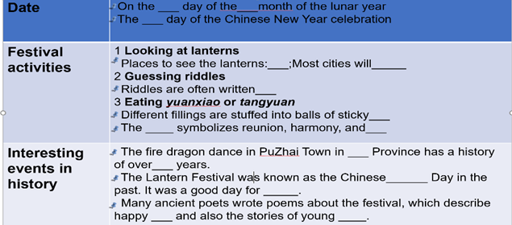
【看前活动】2.根据下表，学习边看快速记笔记的方法。
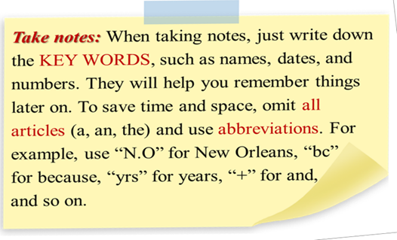
【看中活动】1观看视频，完成下表填写。

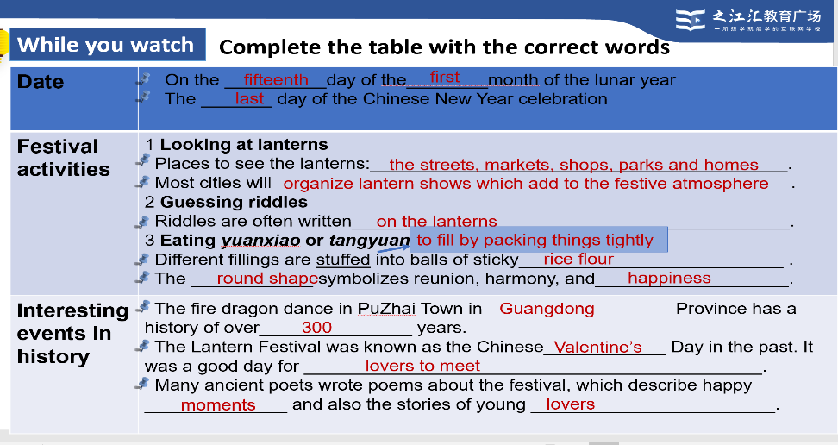

【看后活动】1讨论：
1. Why is the Lantern Festival celebrated both in China and abroad?
2. How is the table designed? 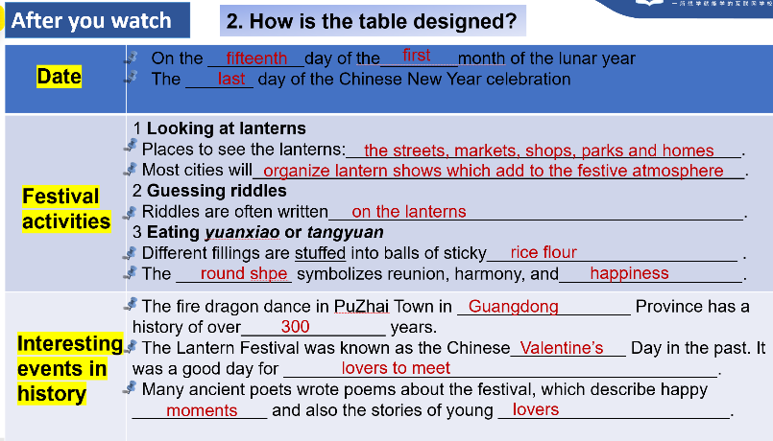

3. What items are mentioned when you introduce a traditional festival?

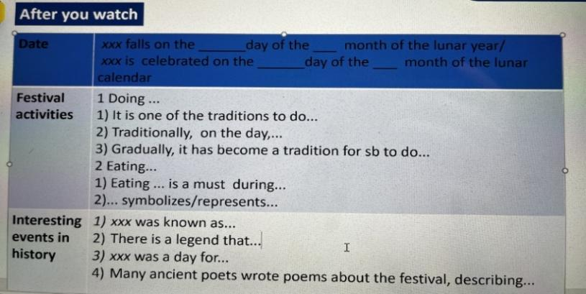
4. Who does “人” refer to in the poem? Could you find any evidence in the poem?

【看后活动】2 口语表达：
Work with a partner. Use the notes you took to help you
give a brief introduction to the Lantern Festival.

【作业】
1.观看《话说中国节》系列视频中的一个，并就你感兴趣的部分运用课上所学快速做笔记的技巧做笔记。

2. 拍摄一段英语视频介绍汤圆的做法。

