教学设计
课程基本信息
学科 | 高中英语 | 年级 | 高一 | 学期 | 秋季
课题 | Unit5 The Value of Money —— Listening and Talking
教学目标
In this class, we are able to:
- have a good understanding of the film clip.
- describe people’s changing attitudes.
- use sequencing words and connecting properly to express yourself.
教学内容
教学重点：
1. Ask Ss to watch a film clip from The Million Pound Bank Note.
2. Guide Ss to describe how people's attitudes change in the scene.
教学难点：
- Guide Ss to describe how people's attitudes change in the scene.
- Guide Ss to retell the story.
教学过程
Step1: Lead in
Discuss and share
1. What would Henry do after leaving the brothers' house?
2. What would happen after opening the envelope?
Step2: Look at the pictures and Guess (P55-1)
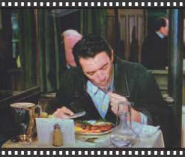
P1: Henry is eating. He seems quite hungry, but also quite happy to be eating such a large meal.
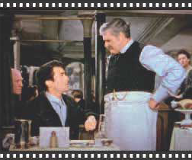
P2: The waiter seems quite angry. Perhaps Henry does not have enough money to pay the bill.


P3: Both the waiter and Henry look like they are in a state of shock. The waiter is looking at a piece of paper. Is this the million-pound bank note?

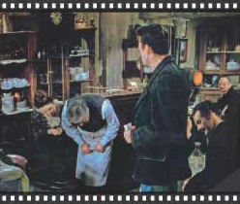
P4: Henry is leaving, and everyone is treating him like he is a king. Even though his back is turned to us, he still looks unsure.
Step3: Discuss and answer the questions(P55-2)
Think and discuss the questions according to the film clip.
1. Why does the owner of the restaurant want Henry to sit somewhere else?
2. What does Henry order? Why is the waiter surprised?
3. Why does the owner think Henry hesitates to pay the bill?
4. Why does the owner think the bank note is probably real?
5. What happens in the end?
Step4: Describe the attitudes
Step5: Retelling(P55-3)
Work in groups. Retell the story in the film clip you have just watched. The pictures in Activity 1 may help you.
Step6: Homework
Watch the film clip again after the class and retell it by yourself.
Then share it with others in the next class.

