**Unit5 Launching Your Career**

**Learning About Language 2**

**Review useful structures教案**

**Teaching aims:**

By the end of this period, students will be able to

1. find and observe long sentences in the topic context and analyse their structural features.

2. use long sentences in a text.

3.learn from the outstanding people in the professional field.

**Teaching key and difficult points:**

1.Help students to find out and observe long sentences in the topic context and analyse their structural features.

2.Instruct students to use long sentences in a text.

3.How to analyse the long sentences and use them in their writing.

**Teaching procedures:**

**StepⅠLead-in**

Share a video about how to develop a career plan and analyse the long sentences.

**StepⅡReview** **and** **analyse**

**Activity** **1** **Read** **and** **observe.**

Are they short sentences or long sentences?Why are these sentences so long?

1.As an adult, one of the first questions you are asked when meeting someone new is,“What do you do?”

2.There are many free tests online, so give one a try.

3.Some people know what they want to do from a young age, but many others just have a few ideas bouncing around in their heads.

Summarise the structure of three types of sentences

|  |  |  |
| --- | --- | --- |
| **Compound** **sentence** | Two or more simple sentences | and,but,or,so,for... |
| **Complex** **sentence** | A main clause and one or more subordinate clauses | what,which,that,who,how... |
| **Compound-complex** **sentence** | Two or more parallel clauses,one or more of which is a subject-subordinate compound sentence |  |

**Activity** **2** **Match** **these** **long** **sentences** **with** **their** **types.**

|  |  |  |
| --- | --- | --- |
| **1**.As an adult, one of the first questions you are asked when meeting someone new is,“What do you do?” |  | A.Complex  sentence |
| **2**.There are many free tests online, so give one a try. |  | B.Compound-  complex sentence |
| **3**.Some people know what they want to do from a young age, but many others just have a few ideas bouncing around in their heads. |  | C.Compound  sentence |

Suggested answers:

ACB

**Activity** **3** **Analyse** **and** **summarise.**

Ⅰ.**1**.The Internet is useful and we use it a lot.

**2**.I have travelled to many places, but I still want to visit more.

**3**.Shall I send the book to you, or will you come to get it?

**4**.They have different ideas, so they have solved the problem in different ways.

**5**.Don’t turn off the computer before closing all programs, or you could have problems.

Ⅱ.**1**.What surprised me most was his way of speaking.

**2**.His suggestion is that we should stay calm.

**3**.The shocking news made me realise what terrible problems we would face.

**4**.They were worried over the fact that you were sick.

**5**.The letter that I received yesterday was from my sister.

**6**.A number of high buildings have arisen where there was nothing a year ago but ruins.

Ⅲ.Many men who spend their working life in the city devote their weekends to voluntary toil in their gardens, and when the spring comes, they experience all the joy of having created beauty.

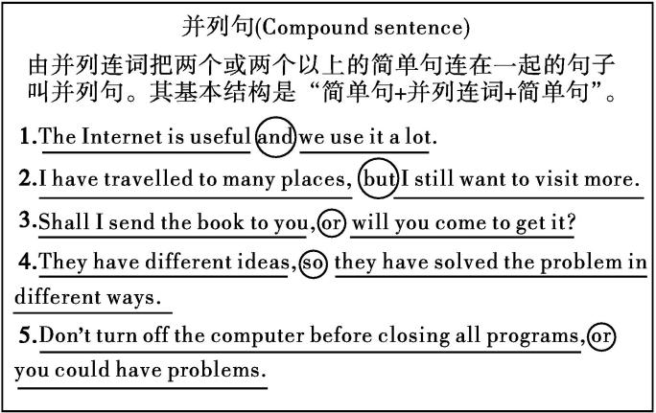

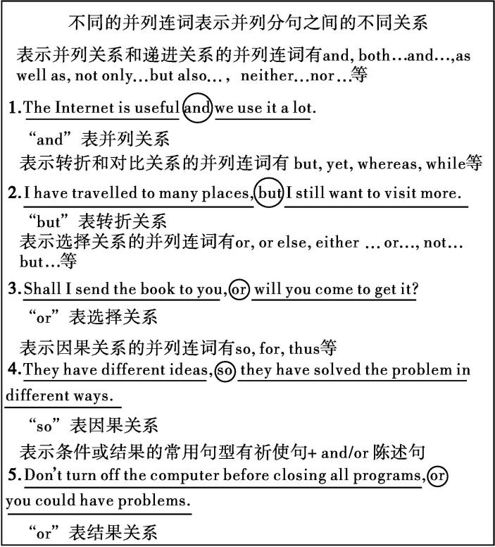

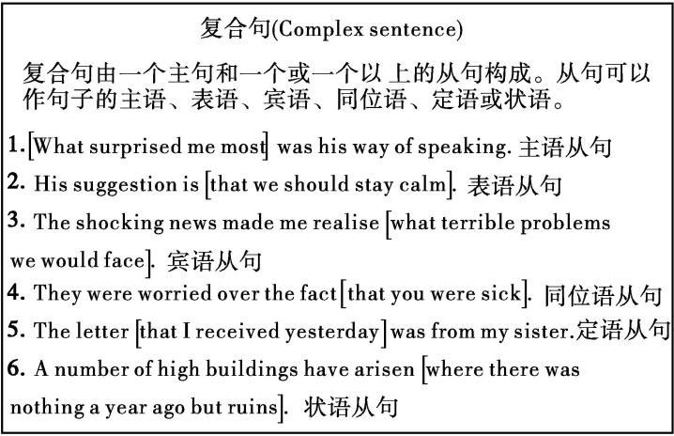

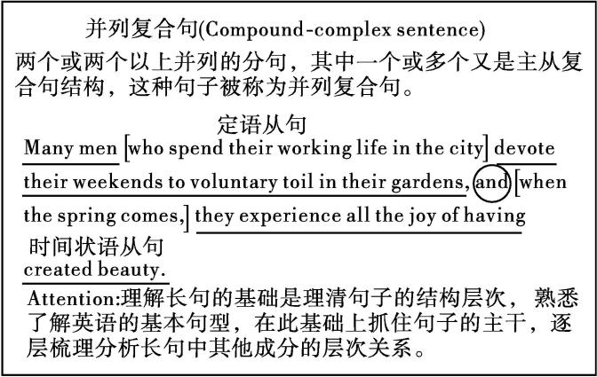

**StepⅢ Practice**

Ⅰ.Change these simple sentences into long sentences. Pay attention to the connectors you need to use.

**1**.Career guidance ought to be included at high school.The school should also offer a work experience programme.

**2**.Dreaming to become somebody great is easy. Working to achieve your dream can be quite hard.

**3**.You never know where you’ll be working in the future. Learn as much as possible. Study a foreign language.It is wise to do these things for the sake of your future.

**4**.Social occupations require communicating with people. This often involves helping or providing service to other people.

**5**.AI is developing rapidly. Lawyers, teachers, librarians,drivers and receptionists may find their jobs replaced by AI in the future. Many people believe this to be true.

Ⅱ. Complete the sentences using *what*, *which*, *that*, *who*, and *how*.Then put the sentences into the correct order to make a complete passage.

Advice on Making a Career Plan

　　A.The plan will require you to focus on 　　　　you want to do and 　　　　to achieve it.

1　　B.A career plan makes you think about your future, including 　　　　careers interest you most and 　　　　skills and trainings you will need to succeed.

　　C.Of course, the CV should be tailored to match the careers in your plan, 　　　　will leave you well prepared to make the most of all opportunities 　　　　become available to you.

　　D.Finally, for useful information on 　　　　to decide on careers and 　　　　to put in your CV, find some websites 　　　　specialise in career advice or go to someone 　　　　can help.

　　E.Along with your career plan, you should also think about a CV, 　　　　is essential for showing your potential employers your skills and experiences.

　　F.These two things are 　　　　you should start thinking about right now, as they will safeguard your future, 　　　　is important to everyone.

Ⅲ.翻译长难句

**1**.When the explorers first set foot upon the continent of North America, the skies and lands were alive with an astonishing variety of wildlife.

**2**.The ability to accurately understand how others are feeling may be used by a doctor to find how best to help his/her patients, while a cheater might use it to control potential victims.

**3**.Many people now misunderstand emotional intelligence as almost everything desirable in a person’s make-up that cannot be measured by an IQ test, such as character, motivation, confidence, mental stability, optimism and “people skills”.

Ⅳ.Read the two profiles below. Write a paragraph about one of them or any other person you admire. Try to make the sentences work together effectively.

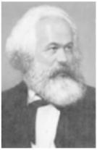

Karl Marx;1818—1883;born in Germany, died in London; studied law and philosophy;philosopher and thinker, economist, historian, sociologist, revolutionary socialist;creator of Marxism, founder of international communism, co-writer of *The* *Communist* *Manifesto*

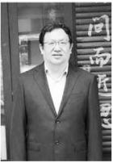

Zhong Yang;1964—2017;botanist,professor at Fudan University;dedicated his life to research on seeds;travelled to places which no other botanists had ever been to;spent years in remote and primitive areas searching for and collecting seeds

Suggested answers:

Ⅰ.**1**.Career guidance ought to be included at high school,which should also offer a work experience programme.

**2**.Dreaming to become somebody great is easy, but working to achieve your dream can be quite hard.

**3**.You never know where you’ll be working in the future,so learn as much as possible and study a foreign language, because it is wise to do these things for the sake of your future.

**4**.Social occupations, which often involves helping or providing service to other people require communicating with people.

**5**.AI is developing rapidly and many people believe that lawyers, teachers, librarians, drivers and receptionists may find their jobs replaced by AI in the future.

Ⅱ.A.what;how　B.what;which/what

C.which;that　D.how;what;that/which;who

E.which　F.what;which

214536

Ⅲ.**1**.当探险家首次踏上北美大陆时,天空中和陆地上满是野生动物,生机勃勃,种类繁多。

**2**.这种准确理解他人感受的能力可能被医生用来找到最佳治疗方法,也可能被骗子用来控制潜在的受害者。

**3**.如今,许多人将情商误解为人无法通过智商测试衡量的一种理想品质,比如性格、动机、信心、心理稳定、乐观主义和人际交往技巧等方面。

Ⅳ.略

**StepⅣ** **Homework**

Revise your draft by using long sentences properly.