**【分层训练】五年级下册英语一课一练-Unit 4 When is the art show？ 课时（2）**

**一、单选题**

1．Today is my ________ birthday.

A．thirteen B．four C．eleventh

2．There ________ some special days in April.

A．is B．are C．be

3．Wow! May is __________.

A．fur B．first C．fun

4．January 1st is __________.

A．New Year's Day B．Children's Day C．May Day

5．—Is the Children's Day on July 1st?

—__________

A．Yes, it is. B．No, it isn't. C．No, they aren't.

6．There are some other special __________ in May.

A．day B．days C．months

7．There is a __________ festival in May.

A．reads B．read C．reading

8．Father's day is on the __________ Sunday in June.

A．second B．third C．three

9．There are __________ seasons in a year.

A．four B．fourth C．three

10．My birthday is on November __________.

A．second B．two C．twoth

11．—When is the singing contest?

—It's on Jul. _________.

A．one B．1th C．1st

12．There are _________ days in a week.

A．seven B．seventh C．7th

13．—When is Children's Day?

—June the_________.

A．first B．second C．third

14．Which month are they_________ about?

A．talking B．talk C．talked

15．My mother's birthday is on_________ （一月三日）.

A．July 20th B．June 7th C．January 3rd

16．The sports meet is on_________ （十二月一日）.

A．March 12th B．December 1st C．April 6th

17．My birthday is on_________ （十月五日）.

A．October 5th B．September 9th C．June 8th

18．There are a few fun things ____ May.

A．on B．in C．of

19．Mothers' Day is _______ the _______ Sunday of May.

A．on, second B．in, second C．on, two

20．—When is New Year's Day?

—It's on ________.

A．January B．January 1st. C．January 2nd

21．January is the ________ month of a year.

A．second B．first C．fourth

**二、词汇分类**

22． 读一读，选出每组单词中不同类的一项。

（1）

A．fifth B．first C．three

（2）

A．March B．Easter C．June

（3）

A．Monday B．May C．April

（4）

A．what B．fool C．when

（5）

A．day B．year C．love

23．选择每组单词中与其他两项不同类的一项。

（1）

A．when B．it C．which

（2）

A．Easter B．April C．February

（3）

A．one B．three C．first

（4）

A．year B．day C．love

（5）

A．Monday B．May C．March

**三、单词拼写**

24． 读基数词，写序数词。

（1）one

（2）two

（3）three

（4）four

（5）five

25． 看图片，写出下列日期

（1）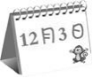_______________________

（2）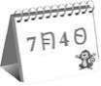_______________________

（3）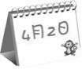_______________________

（4）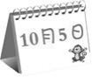_______________________

（5）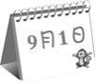_______________________

**四、匹配题**

26．给节日选图片

A. wps7 B. wps8 C. wps9 D. wps10

October 1st January 1st June 1st July 5th

（1）Children's Day

（2）game show

（3）China's National Day

（4）New Year's Day

27． 选出下列节日的日期。

A March 8th.

B September 10th.

C August 1st.

D June 1st.

E. October 1st.

（1）National Day

（2）Army Day

（3）Children's Day

（4）Teachers' day

（5）Women's Day

28． 将下列数字与相对应的序数词连接起来。

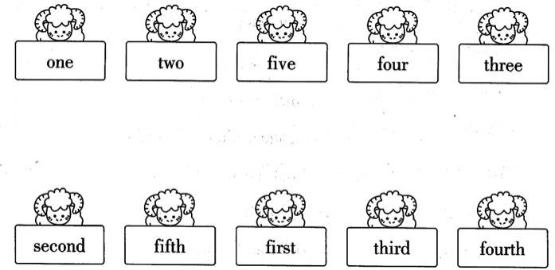

**五、选词填空**

29．

|  |
| --- |
| at, on, in, about |

（1）My birthday is May.

（2）Ann's birthday is March 1st.

（3）We are talking the new film.

（4）I get up six o'clock.

**六、判断题**

30．判断下列序数词和缩写是否正确。

（1）one – frist – 1st

（2）two – second – 2nd

（3）three – third – 3nd

（4）four – forth – 4th

（5）five – fiveth – 5th

**七、翻译**

31．写出下列日期

（1）2月4日

（2）5月1日

（3）8月3日

（4）9月2日

（5）12月5日

**八、情景交际**

32．—When is ?

—It's on （一月一日）.

33．—When is ?

—It's on （五月一日）.

34．—When is ?

—It's on （十月一日）.

35．—When is ?

—It's on （六月一日）.

**九、连词成句**

36．are，in，some，There，special，other，days，June，(.)

______________________________________________

37．October, festival, is, reading, on, The, 4th (.)

______________________________________________

**答案部分**

1．C

2．B

3．C

4．A

5．B

6．B

7．C

8．B

9．A

10．A

11．C

12．A

13．A

14．A

15．C

16．B

17．A

18．B

19．A

20．B

21．B

22．（1）C

（2）B

（3）A

（4）B

（5）C

23．（1）B

（2）A

（3）C

（4）C

（5）A

24．（1）first

（2）second

（3）third

（4）fourth

（5）fifth

25．（1）December 3rd

（2）July 4th

（3）April 2nd

（4）October 5th

（5）September 1st

26．（1）A—June 1st

（2）D—July 5th

（3）B—October 1st

（4）C—January 1st

27．（1）E

（2）C

（3）D

（4）B

（5）A

28．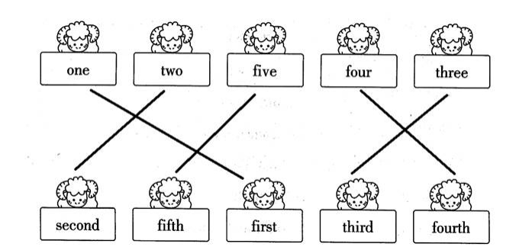

29．（1）in

（2）on

（3）about

（4）at

30．（1）F

（2）T

（3）F

（4）F

（5）F

31．（1）February 4th

（2）May 1st

（3）August 3rd

（4）September 2nd

（5）December 5th

32．New Year's Day；January 1st

33．May Day；May 1st

34．China's National Day；October 1st

35．Children's Day；June 1st

36．There are some other special days in June.

37．The reading festival is on October 4th.