**【分层训练】五年级下册英语一课一练-Unit 5 Whose dog is it？ 课时（3）**

**一、音标题**

1．选出画线部分读音不同的一项（ ）

A．morning B．trunk C．sing

2．选出画线部分读音不同的一项（ ）

A．bank B．thank C．song

3．按照发音规则, 给下列单词分类。

wps2

（1）ng:

（2）nk:

4．判断下列单词画线部分的读音是否相同。

（1）song sing

（2）English long

5．判断下列单词画线部分的读音是否相同。

（1）bank pink

（2）think thank

6．分别写出两个含有划线部分且与其发音相同的单词

wps3wps4wps5

wps6wps7wps8

**二、单选题**

7．选出画线部分发音不同的一项（ ）

A．drink B．sing C．think

8．选出画线部分发音不同的一项（ ）

A．pink B．young C．song

9．选出划线部分发音不同的单词( )

A．sing B．think C．．ink

10．选出划线部分发音不同的单词( )

A．eating B．drink C．singing

11．选出划线部分发音不同的单词( )

A．long B．thank C．pink

12．选出与例词画线部分发音相同的一项：drink

A．pink B．long C．young

13．选出与例词画线部分发音相同的一项：ring

A．trunk B．bank C．song

**三、判断题**

14．—What are you doing, Mr. Elephant? 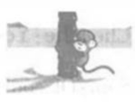

—I am drinking water with my trunk.

15．—I'm eating dinner. What about you, Mr. Elephant? 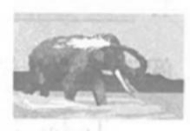

—Me too.

16．—Is your brother sleeping? 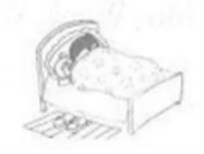

—Yes, he is. He's tired.

17．My little brother is singing.

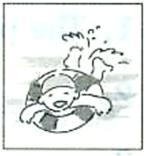

18．I am drinking after the sports meet.

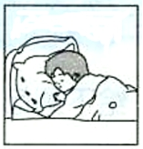

19．The phone is ringing.

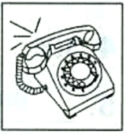

**四、阅读理解**

20．A 读短文，判断对错。

Today is Saturday. It is sunny and warm. I go to the zoo with my parents. There are so many animals in the zoo. Look! The rabbits are jumping. They are so cute. Oh, there is a panda. The panda likes bamboo best. It is eating bamboo now. What's that? It's a lion. It's sleeping under the tree.

（1）It is sunny and hot on Saturday.

（2）There are many animals in the zoo.

（3）The rabbits are jumping.

（4）The panda's favourite food is bamboo.

（5）The tiger is sleeping under the tree.

B

阅读短文, 选择正确的答案。

Today is Sunday. Kevin's family are all at home. Kevin is doing his homework. His father is reading the newspaper. His mother is washing the clothes. His sister is writing an email to her friend. His grandma and grandpa are watching TV in the living room. Their pet dog Pipa is sleeping under the sofa.

21．There are_________ people in Kevin's family.

A．five B．six C．seven

22．Kevin is_________.

A．doing his homework B．watching TV C．writing an email

23．Kevin's grandparents are_________.

A．in the kitchen B．in the bedroom C．in the living room

24．Pipa is_________.

A．eating B．sleeping C．playing

**答案部分**

1．B

2．C

3．（1）song ring sing thing morning long

（2）trunk think drink thank bank

4．（1）T

（2）F

5．（1）T

（2）T

6．drink；bank；long；English

7．B

8．A

9．A

10．B

11．A

12．A

13．C

14．（1）F

15．（1）F

16．（1）T

17．（1）F

18．（1）F

19．（1）T

20．（1）F

（2）T

（3）T

（4）T

（5）F

21．B

22．A

23．C

24．B