**【分层训练】五年级下册英语一课一练-Unit 2 My favourite season 课时（2）**

**一、单选题**

1．选出不同类的一项（　　）

A．spring B．why C．summer

2．I can skate winter.

A．on B．in C．to

3．找出不同类的单词（　　）

A．season B．spring C．summer

4．We often go swimming in .

A．summer B．winter C．spring

5．What do you often do in summer?

A．I often go swimming. B．I often make a snowman.

6．Why do you like winter?

A．Because I like snow. B．Because I can go on a picnic.

7．I like ______ （秋天）best.

A．summer B．autumn

8．I can go _____ every day.

A．swim B．swimming

9．I often ________ with my parents in spring.

A．go hiking B．goes hiking C．going hiking

10．— _________ you like the music, kids?

— Yes. It's very beautiful.

A．Are B．Do C．Does

11．There are __________ seasons in a year.

A．three B．two C．four

**二、填空题**

12．给下面的季节单词选择对应的图片。

A. 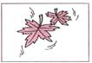 B. 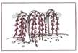

C. 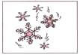 D. 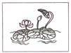

（1）summer

（2）spring

（3）winter

（4）autumn

13．根据图片写出相应的四个季节的单词。

①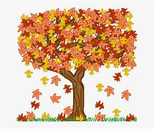

②

③

④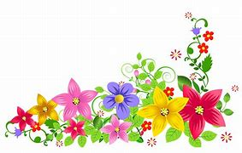

14．—Which season do you like best, Amy? 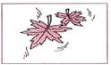

—I like 　 　best.

15．—Which season do you like best, Sarah? 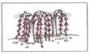

—I like 　 　best.

16．—Which season do you like best, Peter? 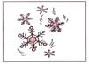

—I like 　 　 best.

17．—Which season do you like best, John? 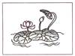

—I like 　 　best.

18．读—读，连—连。

① Spring is 　 　 A. hot and the days are long.

② Summer is 　 　 B. green with flowers and songs.

③ Autumn is　 　 C. white and the year is gone.

④ Winter is 　 　 D. golden and farmers are busy.

19．为下列句子选择相应的中文选项。

　 　 What's the weather like today? A．我每天都能去游泳。

　 　 Today is cold. B．冬天是白色的。

　 　 I can go swimming every day. C．你最喜欢哪个季节？

　 　 Winter is white. D．冬天很冷。

　 　 Which season do you like best? E．今天天气怎么样？

**三、选词填空**

20．选出与所给单词属于同类的单词。

summer, windy, autumn, fly, winter, go, cloudy, sunny, sing

（1）Spring:

（2）rainy:

（3）grow:

**四、连词成句**

21．I,play,can,snow,the,in(.)

22．season,do,like,which,you,best( ?)

**五、补全对话**

23．选出下列句子对应的答语。

A. Yes, I do. B. She likes summer best. C. It's windy.

（1）—Which season does your mother like best?

—

（2）—Do you like summer?

—

（3）—What's the weather like today?

—

**答案部分**

1．B

2．B

3．A

4．A

5．A

6．A

7．B

8．B

9．A

10．B

11．C

12．（1）D

（2）B

（3）C

（4）A

13．autumn；summer；winter；spring

14．autumn

15．spring

16．winter

17．summer

18．B；A；D；C

19．E；D；A；B；C

20．（1）Summer, autumn, winter

（2）windy, cloudy, sunny

（3）fly, go, sing

21．I can play in the snow.

22．Which season do you like best?

23．（1）B

（2）A

（3）C