Unit 3 Video Time教案
课程基本信息
学科 | 高中英语 | 年级 | 高三 | 学期 | 秋季
课题 | Unit 3 Video Time
教科书 | 书 名：普通高中教科书英语选择性必修第四册  出版社：人民教育出版社
教学目标
1. understand some words and phrases related to marine research, like vessel, samples, atmospheric, conduct tasks and so on;
2. know more about China’s most sophisticated vessel Kexue and the research work on it;
3. realize the importance of marine research.
教学内容
教学重点：
1. 通过观看视频，了解更多科考船“科学号”的相关知识。
2. 通过视频分析和讨论，让学生能认识到海洋研究的重要性。
教学难点：
1. 如何落实和理解与海洋探索相关的词汇。
教学过程
Activity 1: Thinking
本活动旨在落实课时目标2。
Why do people explore the ocean?
【设计意图】该活动旨在激发学生原有图式，引发学生思考人类为什么要探索海洋，为后续视频播放提供语言和思想准备。

Activity 2: Introduction of the video and ask questions
本活动旨在落实课时目标2。
Deep into the Sea
The video is about Kexue, China’s most sophisticated research vessel, which is designed to conduct a wide range of tasks. Based on Kexue, China has taken the lead in building a world-class platform for marine research.
1. Do you know the vessel Kexue?
2. What do you know about the vessel Kexue?
【设计意图】该活动旨在扫清观看视频前的知识和部分语言障碍， 对“科学号”科考船有一个初步的了解。
Activity 3: Look at the pictures from the video. What do you think these people are doing ?
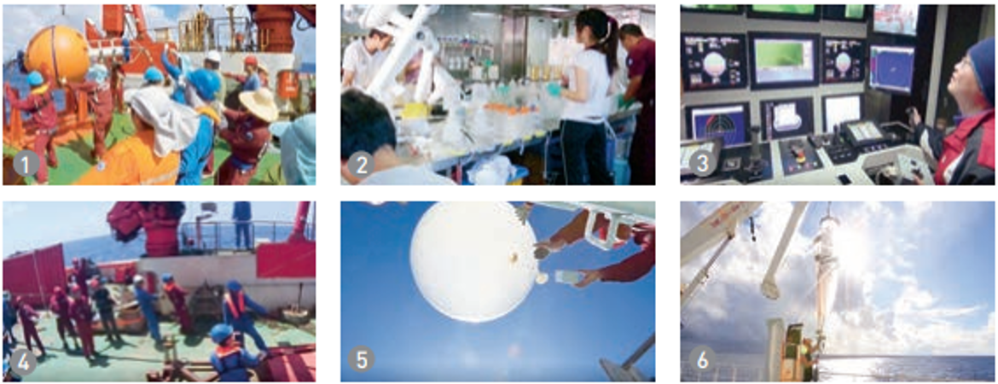
本活动旨在落实课时目标1和目标2。
【设计意图】该活动旨在通过讨论6幅图片，了解科考船上相关工作和学习英语词汇，激发学生兴趣，提高英语学习的积极性，并为后续视频观看做好准备。
Activity 4: While watching, think about the answers to exercises 2-3.
本活动旨在落实课时目标1和目标2。
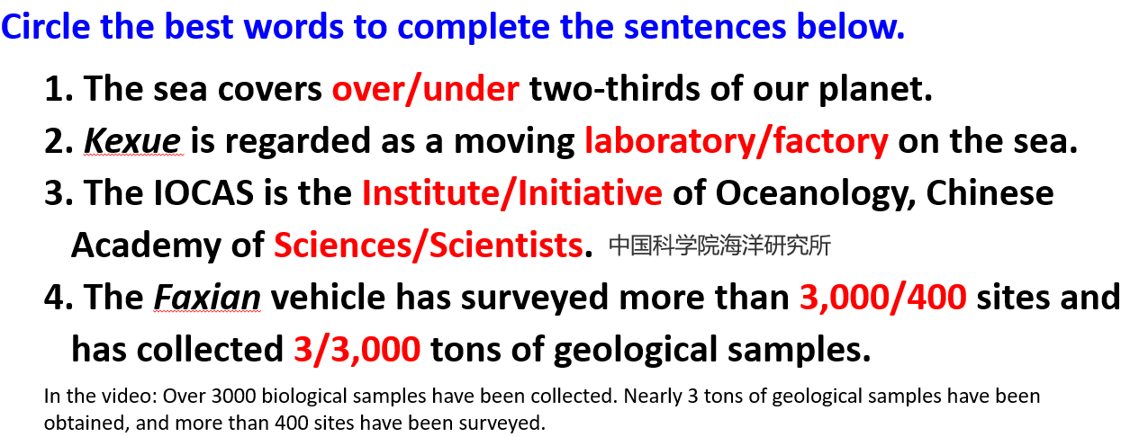
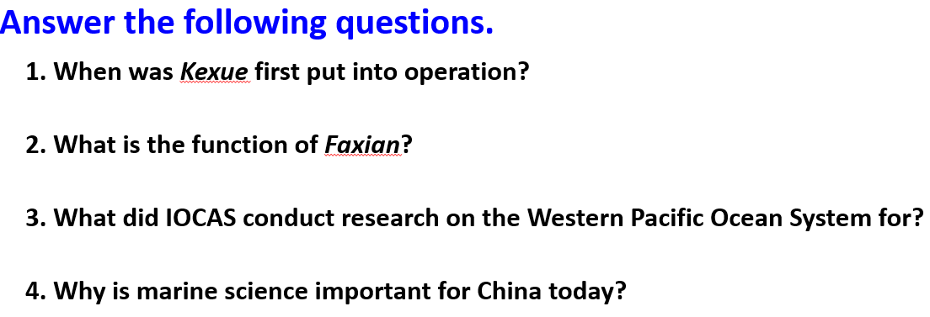
【设计意图】该活动要求学生在观看视频过程中，引导学生看和听相结合，思考相关信息点和为什么海洋科学对于今天的中国如此重要。通过反复观看，培养学生视听能力。

Activity 5: Let’s think
本活动旨在落实课时目标3。

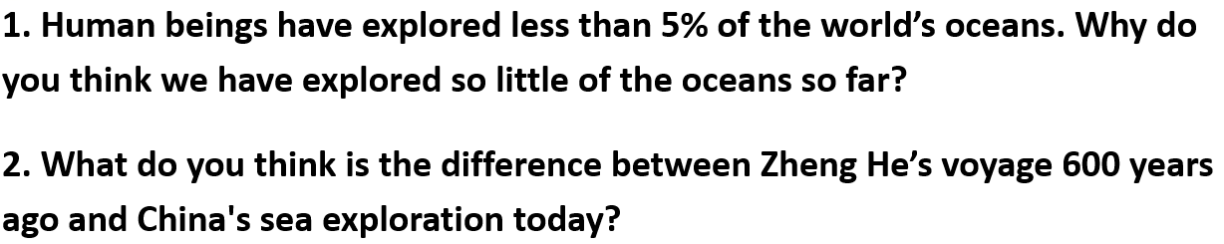
【设计意图】该活动旨在帮助学生深入理解海洋探索的重要性，提升他们对单元主题意义的认知，深刻体验新时代祖国繁荣昌盛的自豪感，培植学生热爱祖国、热爱学习的人生价值取向。

