**【分层训练】五年级下册英语一课一练-Unit 5 Whose dog is it？ 课时（5）**

**一、单选题**

1．读一读，找出不同类单词

（1）

A．drawing B．sing C．playing

（2）

A．where B．watch C．what

（3）

A．eating B．ringing C．climb

（4）

A．summer B．sleep C．spring

（5）

A．trees B．park C．school

2．The tigers are __________ under the tree.

A．sleep B．sleeping C．sleeps

3．They are with each other.

A．played B．play C．playing

4．What is the cat doing?

A．It is climbing. B．It can climb.

5．Look! Zoom is ________ now ! ( )

A．sleeping B．sleep C．sleeps

6．They're playing with __________.

A．other B．each C．each other

**二、填空题**

7．选出与下列单词对应的图片。

① eating A. 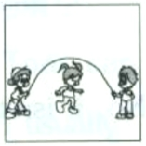

② drinking B. 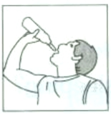

③ jumping C. 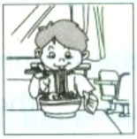

④ sleeping D. 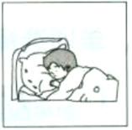

8．读—读, 仿照例子写单词。

例: play—playing

①eat ②walk ③climb

④run ⑤dance

9．写出下列动词的现在分词

drink sleep play eat

jump climb shop run

10．The monkey is (jump).

11．The monkey is (climb) a tree.

12．My sister is (eat).

13．His sister is (drink).

14．The bear is (sleep).

**三、选词填空**

15．

|  |
| --- |
| A. eating B. later C. do D. under  E. their F.ours G. mine H. climb |

（1）My rabbits are eating carrots.

（2）The pen is .

（3）The dog is not only yours. It's .

（4）You can play with Fido .

（5）Monkeys can trees.

（6）I often my homework on the weekend.

（7）Your pen is the chair.

（8）Look! The rabbit is carrots.

**答案部分**

1．（1）B

（2）B

（3）C

（4）B

（5）A

2．B

3．C

4．A

5．A

6．C

7．C；B；A；D

8．eating；walking；climbing；running；dancing

9．drinking；sleeping；playing；eating；jumping；climbing；shopping；running

10．jumping

11．climbing

12．eating

13．drinking

14．sleeping

15．（1）E

（2）G

（3）F

（4）B

（5）H

（6）C

（7）D

（8）A