教学设计
课程基本信息
学科 | 英语 | 年级 | 高一 | 学期 | 春季
课题 | UNIT 4 SPACE EXPLORATION Reading for Writing
教学目标
1、Knowledge and Ability: Comprehend the author's attitude towards space exploration; grasp the linguistic features and structure of the argumentative essay.
2、Process and Method: Able to express your own idea and write an argumentative essay about space exploration based on the the writing method we’ve learned this class.
3、Attitude: Hold objective attitude towards space exploration.
教学内容
教学重点：
1. Focus on helping students understand the detailed structure of the argumentative essay.
2. Focus on leading students write an argumentative essay based on the relevant knowledge we’ve learned during class..
教学难点：
1. The difficulty will lie in guiding students to find out the the relationship between the supporting evidence.
2. Help students analyze the thesis statement by using the checking list formed during class.
教学过程
Activity 1: Lead-in
By using a picture of Starship’s failed test flight to explore space, I will introduce the topic of space exploration to students. And then show Elon Musk’s positive attitude towards space exploration. Ask students’ attitude towards is to arouse students’ interest in this topic.
Activity 2: Read for Main Idea
The point of writing is to have a general understanding of the main idea of the essay, therefore, we need to read first. Ask students to underline the topic sentence of each paragraph by locating the discourse markers.
Activity 3: Read for Structure
Finish the structure of this essay based on the main idea above.

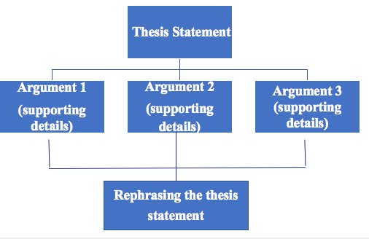
Judging from the structure, it can be concluded by the students that this structure develops in a linear way, so it is called linear development and explain what linear development it is.
（线性结构：以主题句开头，在以后的支撑句中发展这个中心句）
After finish the structure, it is time for us to read the details.

Activity 4: Read for Content

Read for thesis statement.
1. Lead students to find out how to write a thesis statement.
Thesis statement is composed of background, others’ opinion and the author’s opinion. Meanwhile, help students analyze the structure of thesis statement by using discourse markers, such as instead, however.
- Guide students to infer the opponents’ opinion that space exploration can't help feed the world’s poor and can't help find immediate solutions to other problems. This can be divided into two arguments: Argument 1:Space exploration can’t help feed the world’s poor. Argument 2: Space exploration can't help find immediate solutions to other problems.

Read for Argument 1.
(1) Structure: It is made up of the topic sentence and supporting evidence in the following. Ask students how the topic sentence and supporting evidence are written.
(2) The way to understand topic sentence:
Allow students to get that the reasoning method adopted here is called counterargument because this topic sentence is against the opponents’ argument 1 and explain this reasoning method.
- The way to understand supporting evidence:
By analyzing a list of discourse markers, then, after, as a result, I’ll help students understand these discourse markers show the cause and effect relationship.
Read for Argument 2.
(1) Structure: It is also made up of the topic sentence and supporting evidence in the following.
(2) The way to understand topic sentence: From the verb phrase “has already promoted”, we can get it shows a fact.
(3) The way to understand supporting evidence:
Ask students two questions:
Q1: And how does space exploration benefit the products that people use nowadays?
Q 2: Then how does the author to show his supporting evidence?
A1: Advanced technology developed for space exploration has promoted technological improvements that benefit us all by allowing products to be made to a higher standard.
A2: According to the three discourse markers for example, also, today, it lists three examples to support this argument 2.

Read for Argument 3.
Ask student the question below:
Q1: What is the relationship between this argument and the Opponents' argument 2 that pace exploration can't help find immediate solutions to other problems.
A1: This argument is against opponents’ argument. So the reasoning method adopted here is called counterargument.
Q2: What did the pictures of Earth from space make people realise?
A2: They make people realise that our planet’s resources are limited.
Q3: Then what are people doing to solve this problem?
A3: Scientists are trying to find to other new planet.
By asking students the three questions, I will guide students to answer that the essay explains the details to show supporting evidence, so the supporting evidence is shown by explanation.

Read for Closing
In the end, ask students to say the element of the last paragraph.Students might say it rephrases its thesis statement and persuades us to believe space exploration can bring us benefits.
Summary for the Content
Ask students to finish the summary for the content by using the form on students’s worksheet.
Summary for Language Features
Ask students to summarize the language features:
1. Discourse Markers:
instead, however, firstly,then, after, as a result, secondly, for example, also, finanlly, in closing, therefore, etc.
2. Linear Development:
Topic sentence is followed by supporting evidence.

Activity 5: Read for Writing
Task 1:Ask students to finish the task below.
Are these arguments for or against exploring space? Put them in the table below.
A. There are a lot of unsolved mysteries on Earth. So why are we going into space to explore?
B. It is necessary to find a new home for people in space, as the resources on Earth will run out.
C. I cannot understand spending all this money on expensive research and experiments when so many people need food.
D. Exploring space encourages scientists to improve technology that can help people
in other ways, too.

Task 2: Write an argumentative essay draft to express your opinion about space exploration based on the table above.

Task 3:Appreciate and polish the draft sent by our classmate by using the checking list.
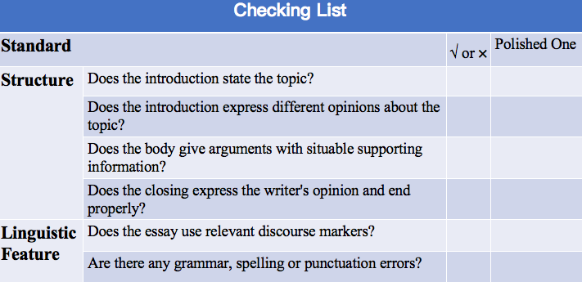

Activity 6: Assignment
1. Share your writing with your classmates and exchange your ideas about your essay.
2. Polish your writing with your classmates according to the checking list and your classmates' feedback.

