**【分层训练】五年级下册英语一课一练-Unit 3 My school calendar 课时（2）**

**一、单选题**

1．I will run on the __________.

A．English party B．sports meet C．school trip

2．—_________is the sports meet?

—It's in April.

A．Where B．When C．What

3．We have a school trip _________ May.

A．on B．at C．in

4．—When is the New Year's Day?

—It's in _________.

A．February B．January C．December

5．We plant trees on Tree Planting Day because it is in _________.

A．spring B．summer C．autumn

6．Father's Day is in .

A．February B．March C．June

7．Children's Day is June.

A．in B．at C．on

8．—When is your father's birthday?

— in June.

A．There are B．It's C．They are

9．— is the school trip?

—It's usually in May.

A．Where B．Who C．When

10． is the first month of a year.

A．February B．December C．January

11．Mother's Day is May.

A．In B．on C．at

12．—When the Easter party?  
—It's in April.

A．is B．am C．are

13．选出不同类(　　)

A．Children's Day B．Mother's Day C．school trip

14．-_______is the singing contest? (　　)

- It's usually ____ May.

A．When; on B．when; in C．When; in

15．The Easter party is _____ April.(　　)

A．in B．on C．At

16．________ is the first month of a year.(　　)

A．February B．December C．January

17．______ is in January.(　　)

A．New Year's Day B．Father's Day C．Easter Day

**二、判断题**

18．Happy Children's Day.

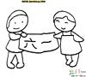

19．Father's Day and Mother's Day are in the same month.

**三、匹配题**

20．根据句子意思填写正确的月份

A 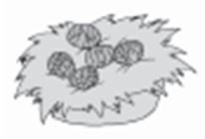 B 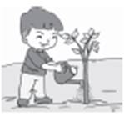 C 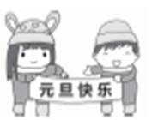 D 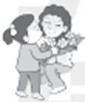 E 

（1）New Year's Day is in 　 　.

（2）The Easter party is in 　 　.

（3）Tree Planting Day is in 　 　.

（4）Children's Day is in 　 　.

（5）Mother's Day is in 　 　.

21．选择合适的图片。

⑴Tree Planting Day is in March.

⑵John likes Children's Day.

⑶My favourite month is January.

⑷Mother's Day is in May.

A. 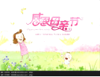 B. 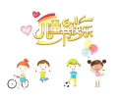

C.  D. 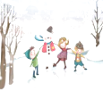

22．给下列图片选择对应的短语。

A. singing contest B. Chinese test

C. school trip D. sports meet

（1）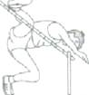

（2）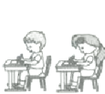

（3）

（4）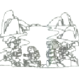

**四、句型转换**

23．仿照例句，用所给内容完成对话

例：When is Mother' s Day? It' s in May.

（1）Father' s Day

A: 　 　 B:

（2）New Year' s Day

A: 　 　 B:

（3）Children' s Day

A: 　 　 B:

**五、阅读理解**

24．阅读短文，判断正误。

I'm Betty. I come from the US. I'm in Grade Five. I like summer. Because my birthday is in summer. It's on July 11th.I usually celebrate(庆祝)my birthday with my family. I eat fish, noodles，vegetables，fruit and so on(等等).Sometimes I have a party with my friends. I can have a good time.

（1）Betty's birthday is on June 11th .

（2）Betty eats a lot of food on her birthday.

（3）Betty often has parties with her friends.

（4）Betty is from America.

**答案部分**

1．B

2．B

3．C

4．B

5．A

6．C

7．A

8．B

9．C

10．C

11．A

12．A

13．C

14．C

15．A

16．C

17．A

18．（1）正

19．（1）错误

20．（1）C January

（2）A April

（3）B March

（4）E June

（5）D May

21．C；B；D；A

22．（1）D

（2）B

（3）A

（4）C

23．（1）When is Father's Day?；It's in June.

（2）When is New Year's Day?；It's in January.

（3）When is Children's Day?；It's in June.

24．（1）错误

（2）正

（3）错误

（4）正