Unit5 Laughing your career Using language 1教案
课程基本信息
学科 | 英语 | 年级 | 高三 | 学期 | 秋季
课题 | 选择性必修四Unit5 Laughing your career Using language（Period 1）
教科书 | 书 名：普通高中教科书英语选择性必修第四册  出版社：人民教育出版社
教学目标
1.通过课文图片以及教师补充，了解一些专业以及它们的要求；
2.通过听力，了解不同国家好大学的要求以及不同人对职业的态度；
3.能运用所学，选择好自己的理想专业，并完成“我的理想专业”演讲。
教学内容
教学重点：
1.通过听力，了解不同国家好大学的要求以及不同人对职业的态度。
2.能用运用所学，完成演讲，并规划自身的职业生涯。
教学难点：
1.能运用所学,完成演讲，并规划自身的职业生涯
2.形成积极正面的专业和职业观念，并规划自身职业生涯
教学过程
Activity 1: Talk about university majors
Look at the pictures below. Think about which university major each picture might show.
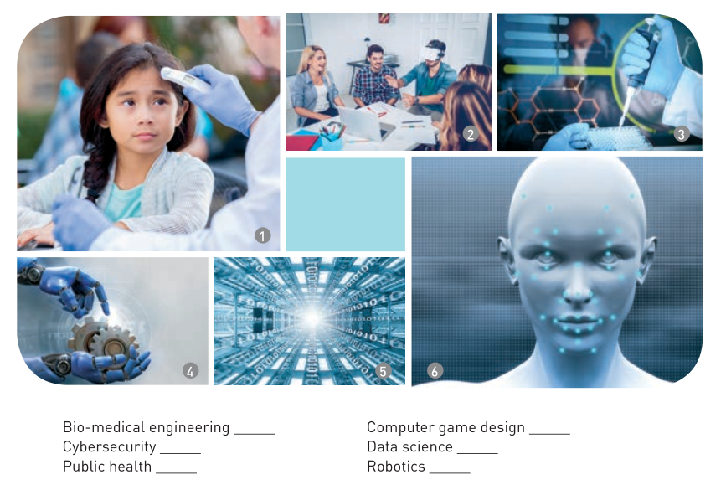
Q1: What’s your dream university?
Q2: What major do you want to study? Why?
Q3: What are the requirements for this major?
Activity 2:Listen and check
Listen to the conversation and get the main idea.
Listen to the conversation and tick the chart according to what is needed to get into a good university in each country.
Requirement | China | UK | USA

Get a good grade

Pass the entrance exam

Write an essay
Activity 3: Listen and take notes
Listen to the conversation again, and take notes on what each student would like to study and why.
Student | Chosen major | Reason
Liu Ming
Susan
Olivia

Activity 4: Listen again and answer the questions
Q1: What did Liu Ming say about cyber security and data science?
Q2: What did Susan say she was told?
Q3: What did Olivia say they need to do to get into good universities?
Q4: Are these their own ideas?
Fill in the blanks
- ____________ that my future career might depend on what university I end up getting into.
- ______________________________, it could help me find work overseas. It would be great to see more of the world!
- _____ that they’re really fascinating subjects if you’re good at computer programming. But I’m hopeless at programming!
- ___________ that there’s no point choosing a subject that you like but you’re not very good at.
Q5: What do the expressions you have filled in have in common?
Q2: What are their functions?
- Identify references: When we speak, we often refer to someone else’s opinion or what we have heard, read or been told. When expressing this in speech, we use phrases such as I heard/read that…, according to …, I was told that…,etc
Activity 5 Think and express ideas
1. Do you agree with Olivia’s parents when they say that a person’s career might depend on what university they get into? Why or why not?
2. Do you agree that there is no point studying something that you like but you are not very good at? Give your reasons.
Assignment
1. Search the Internet for more information about university majors and your ideal major.
2. Interview different people to know more about their choices of their majors or jobs.
3. Prepare a speech on “My Ideal Major” including reasons, requirements and so on.

