Unit 5 Launching Your Career
Learning About Language 1
Build up your vocabulary教案
课题 | Unit 5 Period 2 Build up your vocabulary | 单元 | Unit 5 | 学科 | English | 年级 | Grade 3
教材  分析 | 该板块的三个词汇活动分别针对不同目标。活动1鼓励学生围绕“职业和职业规划”的主题构建相应的词汇网络，并能够用相应的语言描述自己感兴趣或重要的职业。活动2围绕词汇策略， 重点训练词类转换法， 需要学生举一反三， 借助单元中出现的生词， 复习、总结以前学过的同类词，并能造句运用。活动3需要学生组织语言补全语篇，并模仿该短文的结构，描述自己崇敬的人物在相关职业领域作出的贡献和对自己职业规划的影响。鼓励学生以优秀人物为榜样，做好自己的职业规划。本单元练习册的Using Words and Expressions板块还有一个指导学生重点关注和积累词语搭配的活动4，这是词汇学习中又一个重要的策略，需要学生平常利用工具书或课外读物积累和巩固词汇，由量变到质变，更好地内化和运用语言。
学习目标与核心素养 | Knowledge objectives:1. Be able to use key vocabulary in sentences and paragraph correctly：  2.Practice using key words as different parts of speech.  Skill objectives: Be able to state personal views about career in an organized manner.  Emotional objectives: Be able to cooperate with others.  Thinking quality objectives: Be able to think about “what is a great career” and what one should do to achieve a great career.
重点 重点 | - Be able to use key vocabulary in sentences and paragraph.  - Practice using key words as different parts of speech.
难点 | Share opinions about dream career and great career .

教学过程
教学环节 | 教师活动 | 学生活动 | 设计意图
导入新课 | Lead –in  Review “Working out what you want to do”  The career you have defines your life，and so taking time to think about it is an essential exercise for young people.The best time to start thinking about possible careers is when you are still at school，before you make any choices about your__________ One of the most effective ways to get some insight on____________is to complete a“career aptitude test”. The results of the test will tell you about your ___________and interests，and some tests also suggest careers that you maybe suited to. One particular test asks the participants to grade their_____for a variety of work tasks.Their answers are then analyzed and divided up between six different types of ___________.the participants is then given a chart showing their score for each type of work personality.The top three scores are used to make a code that indicates the participant's overall work personality.This code is then used _______________a list of career suggestions.The career suggestions are also based on your education and experience level.In conclusion， career aptitude tests are clearly a useful tool. However， it's important to remember that they are only meant for________.The secret to a good career is finding something that you______________.  Answers: further education a possible career path preferences strengths work personalities to generate guidance are passionate about  Go over the key vocabulary.  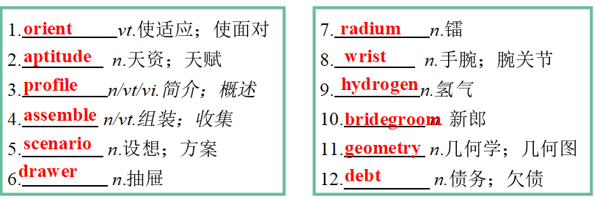  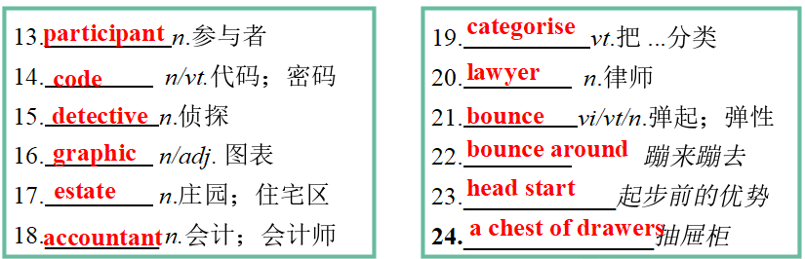 | Students complete the passage  Students go over the key words learned in the previous class. | To review the content of the text..  To review the key words learnt in the previous class.  .
讲授新课 | Activity 1  Complete these sentences with words from the reading text, then write down your own dream career and give reasons.  1.The first time I observed the process of water being split into oxygen and ___________, I was deeply attracted by the charm of chemistry. So I want to become a chemist in the future.  2. My aunt developed _________cancer three years ago. Seeing her suffering makes me want to become a doctor to protect people from such diseases  3. I want to become a _________because I think fairness and justice is of great importance to society, and I hope I can make some contribution in that respect.  4. I have always been passionate about books, so I want to be a _________.By providing a comfortable reading environment and good books, I hope more people can enjoy reading.  5. I always feel amazed when I see my grandfather's huge medicine chest with countless small______that store many herbs. Now I am studying Chinese medicine and I hope I can be an expert in this field, too.  Answers:  hydrogen breast lawyer librarian drawers  Pair work  1.What other names of occupation can you list ?  2.Name some piloteers (领航者)in different occupations and talk about their achievements in pairs.  Doctor : Zhong Nanshan Li Lanjuan  Scientist : Yuan Longping Tu Youyou  Astronaut: Zhai Zhigang Wang Yaping  Ye Guangfu  Diplomat : Wang Yi Hua Chunying  Geng Shuang Zhao Lijian  3.Apart from those conventional occupations, do you know some emerging occupations?  4.What your contemporaries—- the generation after 00s want to do ?  5.Talk about your dream career in pairs , then report your partner’s dream career to the whole class. | Students complete the sentences with words from the reading text, | To use the key words related to the topic of launching career .  .
 | Activity 2  Complete the sentences with the correct forms of the words you have learned in this unit. Circle the part of the speech.Then think of more words that can be used in both noun and verb forms.  1.Hearing the news that he had made the school team, David joyfully ________(n.,v.) the ball against the wall.  2.The old basketball looked very used and had lost its ________(n.,v.).  3.The zoologists set up _____(n.,v.) cameras in the panda reserve.  4.There was a huge debate about whether the reporter should be accused of _____(n.,v.) on the star couple.  Answers: bounce v. bounce n. spy n. spying v.  Find out other words in the reading text which can be used in both noun and verb forms.  1.Getting a head start in considering your future career may help you for the rest of your life.  2.Others focus more on asking you to rate different kinds of work scenarios, like working as a librarian or a lawyer.  3.One popular test asks the participants to grade their preferences for a variety of work tasks.  Box the words which can be used in both noun and verb forms in the following sentences .  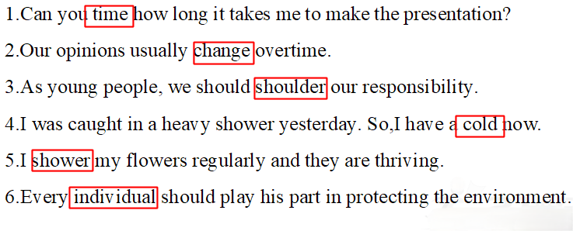 | Students complete the sentences with the correct forms of the words and circle the part of the speech.  Students add more words which can be used in both noun and verb forms. | To practice using key words as different parts of speech.  To think more word which can be used in both noun and verb forms.
 | Activity 3  Use the words in the box to complete the following excerpt from a student's speech.  commit bounce around rather than come to a conclusion define in common radium had a great influence on  Probably everyone dreams of having a great career, but first let's___________what this means. When thinking about what makes a career great, many ideas may______________ in your head, such as the desire for money, power, or fame. Different people might have different opinions about this, but wouldn't it be kind of greedy to focus on money and fame___________on something more meaningful? Please close your eyes and think of someone professional and successful. It could be a famous entrepreneur, a great leader, a scientist or an artist or a teacher who______________________you.My choice would be Marie Curie, who discovered___________. For me, she is great not just because she was world famous, but because she made great contributions to mankind. Being a female scientist was much less common in her time, but in spite of this she devoted her life to her career. So I ________________________ that if you want a great career, you need to___________yourself to something meaningful. I believe all great careers have this___________.  Answers: define bounce around rather than had a great influence on radium have come to the conclusion commit in common  Group work  Discussion  Discuss the following questions . then report your discussion result to the whole class.  1.What do you think of this speech?  2. Do you agree with the speaker? Why or why not?  3. How do you definite a great career?  4. What do all great careers have in common? | Students complete the following excerpt from a student's speech.  Students discuss the questions and report discussion result to the whole class.  . | To practise using key words in a paragraph.  To share opinions about great career.
课堂练习 | Languages points  1. justice n. 公平；公义；公正  【教材原句】  I want to become a lawyer because I think fairness and justice is of great importance to society, and I hope I can make some contribution in that respect.  我想做一名律师，因为我认为公平和正义对社会非常重要，我希望我能在这方面做出一些贡献。  【实例品读】  There was a certain amount of rough justice in his downfall.  他的垮台也算是大致公平。  【热点归纳】  bring sb to justice 将某人绳之以法， 缉拿归案  do justice to sb/sth=do sb/sth justice 公平对待某人/某物；充分展现某人/某物的最佳素质  do yourself justice充分发挥(自己的能力)  【考点精练】  (1)That photo doesn't __________________________.  那张照片把你给照走样了  (2)She didn't____________________ in the exam.她在考试中没  有充分发挥出自己的水平。  2. accuse vt指控；控告；谴责’  【教材原句】  There was a huge debate about whether the reporter should be accused of...关于这名记者是否应该被指控(有罪)，人们进行了激烈的辩论……  【实例品读】  I don't want to accuse my best friend of telling lies.  我不想指责我最好的朋友撒谎。  【热点归纳】  accuse sb of(doing) sth控告某人(做) 某事； 谴责某人(做)某事  charge sb with(doing) sth控告某人(做) 某事  【考点精练】  翻译句子：  她控告他偷她的表。  She accused him of stealing her watch.  She charged him with stealing her watch.  3. greedy adj. 贪婪的；贪心的  【教材原句】  Different people might have different opinions about this, but wouldn't it be  kind of greedy to focus on money and fame rather than on something more meaningful?  不同的人对此可能会有不同的看法，但是专注于金钱和名誉而不是更有意义的事情不是有点贪心吗?  【实例品读】  He stared at the diamonds with greedy eyes.  他贪婪地盯着这些钻石。  【热点归纳】  be greedy for...对……贪婪； 渴望……  greed n.贪婪； 贪心  greedily adv， 贪婪地  【考点精练】  (1)Not everyone is simply_______________power.  并非人人都是贪恋权势的。  (2)The hungry man ________ shoveled the food into his mouth.  那个饥饿的人贪婪地、大口大口地吃  Exercises  1.The teacher's system of punishments appealed to the children's  sense of ______(公平)．  2．She practically _______(控告) me of starting the fire!  3．She was too full of wonder and desire to be ________(贪婪)．  4. That's long enough for me to come to a c_________,Sherlock responds . | Students learn how to use the new word in this period.  Students finish the exercises by themselves. | To grasp the usage of the new words.  To help the students consolidate key vocabulary
课堂小结 | 1.Use key vocabulary in sentences and paragraph  2.Use key words as different parts of speech.  3.Share personal views about dream career and great career . | Students review the key vocabulary and phrases in this class. | To reflect what have learnt in this class.
板书 | Names of occupation: teacher scientist actor diplomat  soldier judge astronaut accountant firefighter guider policeman architect pilot...

