**Unit 1 Science and Fiction**

**Reading and Thinking 教案**

**教材分析**

本单元主题语境是“人与自我”，以“科幻小说”为主题，引导学生学习并欣赏科幻小说这类具有独特魅力的文学作品。选材自中外著名科幻作家及代表作品，让学生了解并掌握科幻小说在题材、内容和写作手法上的特点，融入了科技发展的内容，探讨“人与自我、人与世界”的关系，是从另外一种角度对人类社会本质及其发展的分析和思考。单元主题图是一幅未来城市的创意图片，展示了空中的飞行器以及形状奇特、泛着金属光泽的建筑，营造出一种带有梦幻色彩的未来氛围。引言“Today’s science fiction is tomorrow’s science fact.”,译为“今天的科幻小说即明天的科学现实。”选自科幻作家阿西莫夫。这句话绝不是妄言，那些曾经只出现在科幻作品中的奇思妙想已经随着科技进步成为当今的科学现实。学生在本单元的学习中，借助对科幻作品和科技发展的辩证理解，聚焦人类与机器人和人工智能的关系、时间旅行等话题，进行更为具体和深入的探讨。本课涉及的主题语境内容是“机器人”。本节读思课（Reading and Thinking）部分是由 Issac Asimov 一篇科幻小说改编 -----Satisfaction Guaranteed讲述了机器人制造公司员工 Larry的妻子 Claire与测试版家庭机器人 Tony之间发生的故事。Claire对 Tony从排斥、警觉，到接受、信任，再到被深深吸引的情感变化过程。帮助学生理解语篇中感情故事和机器人实验的明暗两条线索；引导学生对人类和机器人的关系展开初步探讨，简要表达自己的观点。

**教学目标：**

1.To figure out how science fiction is developed by figuring out the story line and emotion line.（activity 2,3,4,5,6）

2.To complete the story with bold but reasonable imagination.(activity 7)

3.To develop a right and critical attitude towards the development of robots and AI.(activity 8,9)

**整体认知：**

本课涉及的主题语境内容是“机器人”。本节读思课（Reading and Thinking）部分是由 Issac Asimov一篇科幻小说改编-----Satisfaction Guaranteed讲述了机器人制造公司员工 Larry的妻子 Claire与测试版家庭机器人 Tony之间发生的故事。Claire对 Tony从排斥、警觉，到接受、信任，再到被深深吸引的情感变化过程。帮助学生理解语篇中感情故事和机器人实验的明暗两条线索；引导学生预测故事结局并对人类和机器人的关系展开初步探讨，简要表达自己的观点。

**教学重点：**

引导学生根据语篇标题预测语篇的体裁结构和主题；理解语篇中感情故事和机器人实验的明暗两条线索。

**教学难点：**

培养学生阅读理解能力和思维品质。引导学生结合语篇内容和自己的认知，对人类与机器人的关系展开初步探讨。

**教学过程：**

Activity 1：Lead in

1.What do you think of when you see the pictures?

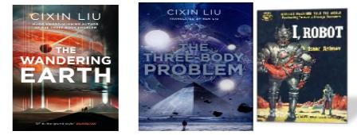

How do robots already help humans today? ____________________________

设计意图：

利用图片创设情境，学生大脑风暴图片联想，引出主题背景，激发学生已知信息，形成阅读期待。

2.Watch the video and answer the question.

Do you think it possible for a robot to

---look like a human being?

do everything for human beings?

have its own feelings or thoughts?

If a robot like Ameca lives with you, what do you think will happen?

_______________________________________________________________

设计意图：图片呈现家用机器人对人类生活的帮助，视频展示人机互动，对接课文文本内容，让学生对人与机器人的关系有所预期，点燃阅读兴趣。

Activity 2：Read for structure & main idea

Skim the text, divide it into three parts and match the main idea with each paragraph.

Para 1-2: A. How Tony helped Claire with her problems and how Claire felt towards it.

Para 3- 8: B. The result of Tony living with Claire.

Para 9: C. Why and how Tony came to Claire’s house. The text mainly tells us _______.

A．how a robot used for housework is tested out in a family.

B．why Claire fell in love with a robot.

C．a robot saved a human being from danger

设计意图：速读初析篇章结构，划分层次，了解故事情节发展脉络，理清文章中心大意。

Activity 3：Read for the title and text type

Q1: Whose satisfaction do you think will be guaranteed?________________

Q2: What is the text type of this passage?

A. Argumentation B. Narration C. Advertisement D. Exposition

设计意图：根据标题和各段关系了解记叙文的六大要素，为后面的主题讨论和结局合理预测语篇埋下伏笔。

Activity 4：Read for characters and relationships

How many characters are mentioned?_______

Who are they?_________________

What are the relationships to each other? _______________________

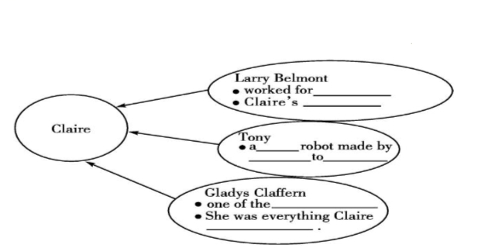

设计意图：再读文本，挖掘细节信息，理清主要人物及其关系。

Activity 5：Read for story line

How did Tony help her with her problems when (she said)------

She was not clever._____________

Her house was not elegant.______________

The sales-woman was rude to her._________________

She was not like Gladys Claffern.______________

She fell off the ladder.__________________________

设计意图：重点分析第二部分，抓好故事情节这条线索，即在不同场合下 Tony对 Claire的帮助，引导故事情节进一步发展。

Activity 6：Read for emotion line

Claire’s feelings towards Tony changed as the story developed. Read the passage carefully and figure out the changes.

Before Tony arrived, _________________

When she first saw Tony,______________

When offered to help dressing,___________

When offered sympathy,_________________

When helped talk to the saleswoman,_______________

When she fell off the ladder, Tony caught her in time an held her,_______________, Claire felt being envied. __________________________________, she cried all night .

设计意图：基于故事情节线索，分析揣摩 Claire对 Tony情感的变化，在课本 P3 Exercise 4图表最后两空的提示下预测故事走向。

To get the whole picture of the story

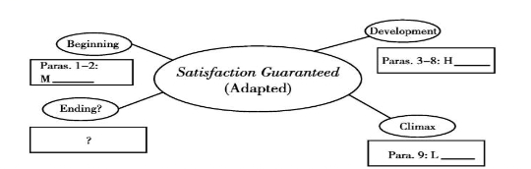

设计意图：按照记叙文结构特点整体把握故事全局，预测故事结局。

Activity 7：Read for the ending of the story

Work in groups and come up with a reasonable ending.

Tony let her go and disappeared from sight.

|  |
| --- |
| What would happen next at the party?  What would happen to Claire?  Why did Claire feel envied?  By whom?  Why did she cry all night? |

The next morning a car drove up and took Tony away

|  |
| --- |
| What would happen to Tony?  Did he pass the test in the experiment?  Would Tony be rebuilt? Why? |

Then listen to the rest of the story.

How different is it from your ending?_____________

设计意图：

接轨高考读后续写，给出段首提示句，结合所给文本，提出可预测性问题，小组交流个人对于故事结局的预测。然后聆听听力原文，比较结局的不同。Activity 8: Discussion

Is the test a success or a failure? why?

_________________________________________________________________

Did Tony really fall in love with Claire?

_________________________________________________________________

设计意图：

基于文本首段伏笔和标题，引导学生思想碰撞，深度交流讨论机器人实验的成败，回扣题目“Satisfaction Guaranteed”，更好地把握文本的主题。

Activity 9: Critical thinking

(Debate in two groups)

Nowadays the application of the robots has already become a trend. A debate will be held whose theme is “The Relationship with Robots: Good or Bad for Humans?”

Requirements: Four parts included:

opening statement, position, argument and conclusion.

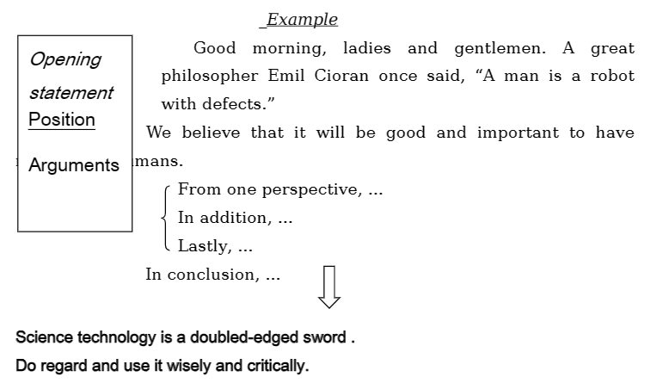

设计意图：引导学生对人类和机器人的关系展开初步探讨，简要表达自己的观点，并培养其创造性和批判性思维，形成正确的价值认知。

Activity 10. Homework

Complete the passage using what we’ve learned from the text.

A household robot called Tony was to be tested ______in Larry's house. Though Claire, Larry's wife, didn't like the idea at the beginning, she was persuaded to let the robot _______ (company) her while her husband was away on a business trip. The robot looked like a tall and handsome man ______ smooth hair. Though his facial ___________ (express) never changed, the robot spoke in a deep and attractive voice. At the first sight of Tony, Claire felt alarmed because he seemed________ (much) like a human than a machine. So when Tony offered to help dressing, Claire felt more than____________ (embarrass).However, Tony gradually won Claire's trust. He took good care of Claire and even managed to rescue her when she fell off the ladder. He also helped Claire realize her dreams by making her home elegant, _______(give) her a new haircut and changing her make-up. Therefore, at the party all the guests who _______ (invite) were filled with admiration when they saw her house was __________ (complete) changed. Claire felt satisfied and recovered her confidence. And Tony said he was so attached ________ her that he hated to leave her.

设计意图：文本语言知识的检测与运用。

**课后反思**

本节 Reading and Thinking读思课，故事性强，理解难度不大，课堂设计读前由话题相关的图片和视频引入，激发了学生学习兴趣和探索欲望，让学生对阅读内容形成期待。读中环节学生快速浏览文本，获取篇章结构和主旨大意信息；对于细节的挖掘，主要把握两条线索，即情节线（故事线）和情感线，更好地梳理了文本信息，也为下一步故事情节的预测埋下伏笔。这个过程问题设计合理，难度递进，绝大多数学生能力具备可以进行读中思考和问题解答。读后设置了开放性问题，以讨论和辩论的形式展开，目的是培养和提高学生思维的敏捷性、灵活性、批判性和创造性，突出主题意义的探究，但是基于学生自身知识面的因素，部分学生不能完全投入课堂，尤其辩论环节在组织思想之后不能脱稿表达，鉴于此，以后的教学要在重视词汇学习的同时，培养学生文化意识和即兴表达能力。