课题 | 普通高中英语（2019版）必修第三册 Unit 1 Festivals and Celebrations教学设计  Period 6 Reading for Writing
学科 | 英语 | 学段 | 高中 | 年级 | 高一
教材 | 人教版统编高中英语必修三（人民教育出版社2019年）
二级备课 | 英语备课组 |  | 主备
教学目标及教学重点、难点等
- 学习目标
- 通过阅读有关“那达慕大会”的日记，掌握节日见闻的内容要素和文本语言特点;
- 通过学习一篇记叙文的写作方法，介绍并写出自己的一次节日经历。
2. 教学重难点
- 教学重点：学习一篇记叙文的写作方法，介绍并写出自己的一次节日经历。
（2）教学难点：阅读有关“那达慕大会”的日记，掌握节日见闻的内容要素和文本语言特点。
教学过程
环节 | 教师教学活动摘要 |  |  |  |  | 学生学习活动
- 导入  - 写前前  - 写中 | Step 1: Lead-in（2 minutes）  Watch a short video of speech.  Q :What are the represented events of the Naadam Festival?  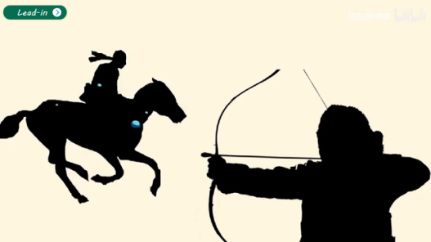  （设计目的： 通过观看视频激发学生兴趣，引出本课主题，同时补充那达慕大会的三个主要活动。）  Step 2: Pre-writing（20 minutes）  ①Fast-reading  Task 1: The type of the passage.(2 minutes)  Q 1:What is the type of text?  Q 2:How to write a diary?  Write in ______ tense.  Use pronouns like___________________ to show that the events happened to you.  Tell events in ___________________________ order.  Talk about how you were _______ or what you were ________when each event happened.  Task 2:Read and match the main ideas with each paragraph.(3 minutes)  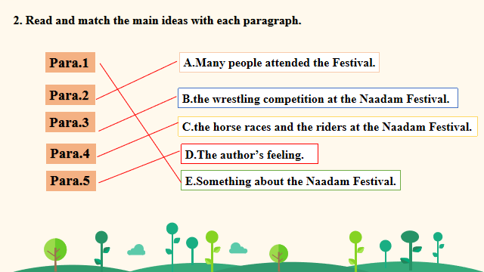  Task 3：Identify the structure of the passage.(2 minutes)  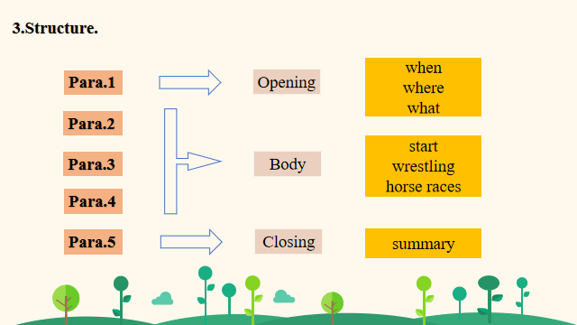  (设计目的： 通过识别文章类型、匹配文章段落大意与划分文章结构，帮助学生更好的书写文章。）  ②Detailed-reading  Task 4(Para. 1):Think about the questions.(2 minutes)  Task 4:  Students should read Para.1 and find the answers.  (1) What does “Naadam” mean?  (2) Which events does it include?  Task 5(Para.2-Para.4): Choose the best answer according to the text.(2 minutes)  1. How can we judge if a wrestler loses in wrestling?  A. The wrestler’s hands touch the ground.  Task 5&6:  Students should read and choose the best answer according to the text.  B. The wrestler’s knees are bent.  C. The wrestler’s hands are held by his rival.  D. The wrestler’s waist is held by his rival.  2. Why are the riders in the horse racing boys and girls?  A. They are lighter and the horses can run faster.  B. The teenagers are fond of this event.  C. This event is specially held for them.  D. Only teenagers are allowed to take part in this event.  Task 6(Para.6): Choose the best answer according to the text.(1 minute)  3. Which of the following words can best describe the author’s mood after the festival?  A. Annoyed. B. Thrilled. C. Scared. D. Embarrassed.  (设计目的： 通过细节阅读，帮助学生更好地理解文章。）  ③Learn some expressions  Task 7：Read the sentence patterns below and use them to rewrite.（4 minutes）  Task 7:  Students should read the sentence patterns below and use them to rewrite.  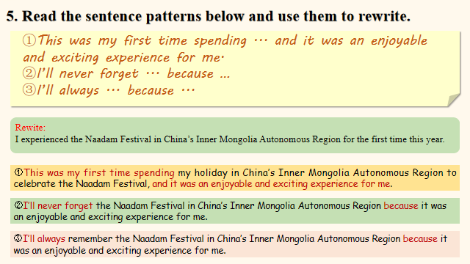  Task 8:  Students should underline the sentences that describe the writer’s feelings and emotions.  Task 8:Underline the sentences that describe the writer’s feelings and emotions. （4 minutes）  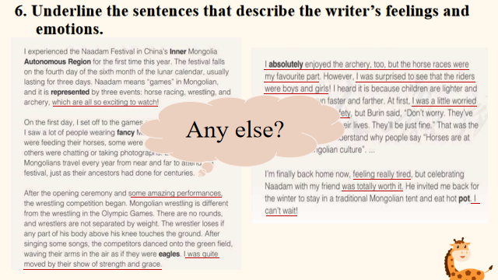  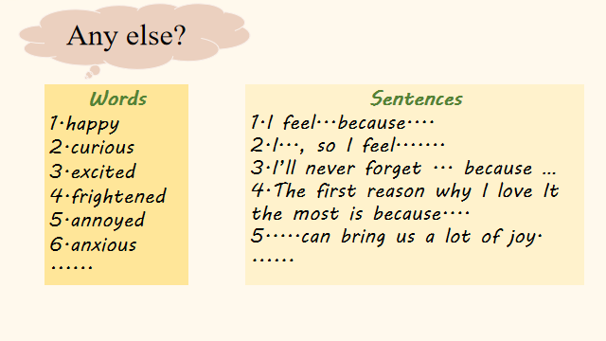  (设计目的： 通过例句与词汇学习，为学生积累语言表达，为写作做铺垫。）  Step 3: While-writing（15 minutes）  While-writing:  Students should learn the steps of the writing.  假如是李华，你的美国笔友Jack对中国传统文化很感兴趣。请你根据下面的提示用英语给他写一封电子邮件，介绍一下中国的传统节日。  一、审题  体裁:应用文  话题:以“介绍中国节日”为话题  时态:一般现在时  人称:第一、三人称  二、文章布局  ①开头：引出节日和时间  以“ I am glad to tell you something about ...It is celebrated in/on...”引出话题  ②正文：食物和活动  all kinds of food；clean house; do shopping; wear new clothes..  ③结尾：你对这个节日的感觉  I like this...because....  三、遣词造句  ①词汇库  月饼mooncake；灯笼lantern；亲戚relatives；民间的folk；甜点dessert；花园garden；  传统的traditional；欣赏admire；前夕eve；温暖warmth；庆祝celebrate；节日festival；准备prepare；最喜欢的favorite；激动exciting；美味的delicious  ②短语箱  各种各样的all kinds of；  为...做准备prepare for；  以...形状in the shape of；  回家go back home；  穿上put on；  释放set off；  聚在一起get together  ③链接句型  1. I’m glad to tell you something about the.....  2. My favorite festival is....  3. It is celebrated on/in....  4. During the festival, people....  5. It is my favorite festival because...  四、作文模板  Dear Jack,  I am glad to tell you something about the ________ .It is a traditional festival in China. It is celebrated on the ____ day of the _____ lunar month.  During this festival, people ... They eat ... People .....  It is my favorite festival because we kids can _____ .What's more, we can ______ . It makes me feel very happy and excited.  Yours,  Li Hua  - Sample Writing  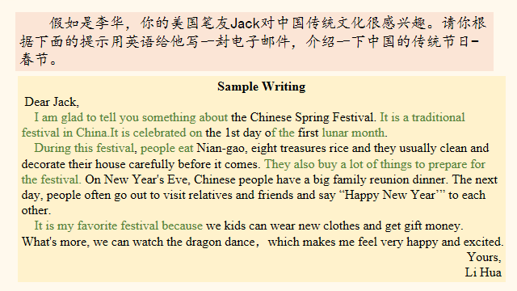  （设计目的：通过学习一篇记叙文的写作方法，介绍并写出自己的一次节日经历。）  Step 4: Post-writing（2 minutes）  Post-writing:  Students should exchange drafts with a partner.  - 写后  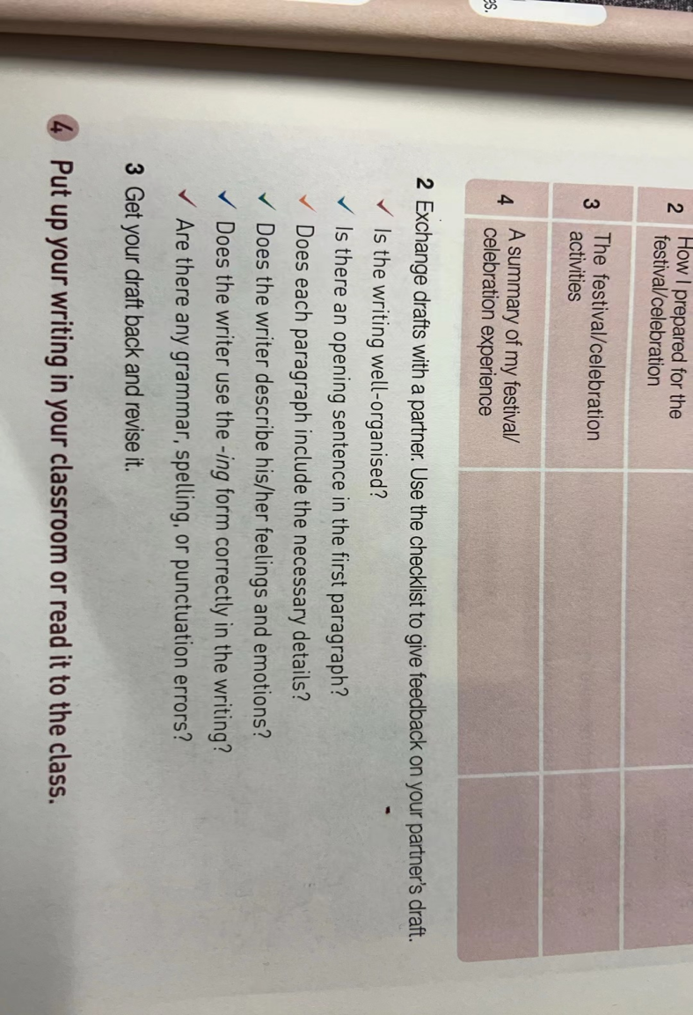  Step5: Homework（1 minute）  为了弘扬中国传统文化，你学校英语周报正在征集以“My Favorite Chinese Festival”为题的英语文章，你也想踊跃参加。现在请你介绍中国传统节日——中秋节。  My Favorite Chinese Festival  My Favorite Chinese Festival is the Mid-Autumn Festival.... |  |  |  |  | Lead in :  Students should watch the video and answer question.  Task 1:  Students will read the passage and think about those questions.  Task 3:  Students will think about the structure of the passage.  Task 2:  Students should skim the text and match the main idea to each paragraph.  Task 3:  Students will learn some expressions about advice and use them to give their suggestions to Li Rui.  Task 4:  Students will learn the language feature of a blog.
五、总结
六、教学反思

