Unit 3 Sea Exploration
Learning About Language 1
Build up your vocabulary教案
课题 | Unit 3 Build up your vocabulary | 单元 | Unit 2 | 学科 | English | 年级 | Grade 2
教材  分析 | 该部分的词汇学习部分共有三个活动：活动1要求学生根据英文释义写出对应的英文单词，  并在Reading and Thinking板块的主阅读语篇里找到包含对应单词的句子。然后， 学生要选择合适的单词补全新的句子。这一活动主要是帮助学生回顾和巩固新学的词汇，通过英文释义和在新语境中的运用，加深对词汇的理解与掌握。活动2的训练日标是新学的词块，通过选词填空的方式， 让学生在语境中正确运用词块。活动3提供了一篇短文， 介绍少年Zac Sunderland的环球航海冒险。该活动要求学生在理解短文内容的基础上，运用所学词汇补全缺失信息。该活动不仅能训练学生在相对复杂的语境中灵活运用词汇的能力，还能帮助学生增强语篇意识，拓展与单元主题相关的见闻， 深化“海洋探索”的主题意义探究， 学生阅读同龄人Zac的经历和感言， 更容易被Zac身上体现的为实现自己的理想所倾注的勇气和毅力所打动， 受到鼓舞。
学习目标与核心素养 | 1. To review China’s sea exploration.  2.To practice using key words and phrases from the text of reading.  3.To get to know something about Zac Sunderland’s sea journey.
重点 | To practice using key words and phrases from the text of reading.
难点 | To practice using key words and phrases in a passage.  To develop communicative ability through designed group and pair activities.

教学过程
教学环节 | 教师活动 | 学生活动 | 设计意图
导入新课 | Lead –in  1.Retell the exploration activities of the ocean in the past of our country according to the timeline below.  2.Go over the key vocabulary.  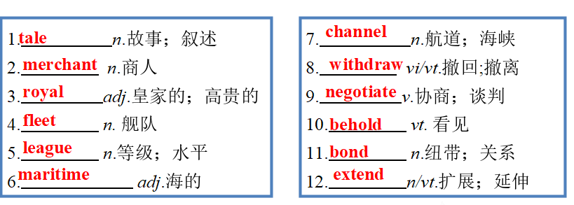  3.complete the passage using key words in reading and thinking.  There are many t__________ and legends about how seamen explored the oceans in the past. But how many of them are reliable? The fact is that they needed multiple ways to keep safe after s________ sail.  Using nature to help is the first and most useful form of exploration. This includes the North Star, Sun and clouds.  Using the weather. Experienced captains could see the b________ between weather and dangers. Either they withdrew the fleets or e________ their voyage.  Using the sea. Skillful sailors could use tides and currents to carry ships back to the shore or pass through narrow c_________.  These skills helped seamen explore the seas and discovered new lands. They needed not only the instruments but also courage and luck.  Answers: tales setting bonds extended channels | Students retell the exploration activities of the ocean in the past of our country  Students go over the key words learned in the previous class.  Students complete the passage using key words in reading and thinking. | To review the content of the text..  To review the key words learnt in the previous class.  .  To use the key words in a passage related to the topic of this unit again.
新课 | Activity 1  Write down the word that matches each definition.  1. _________ an imaginary story or an exciting description of an event  2. _________ related to the king or queen of a country  3. _________ to reach an agreement by discussion  4. _________ to stop taking part in an activity  5. _________ to make something longer or larger  6. _________ a connection between people  7. _________ a level of quality, ability, etc.  8. _________ a deep passage of water used as a route for ships  Answers: tale royal negotiate withdraw extend bond  League channel  Choose the appropriate words from above to complete the following sentences.  1. Their common experience created a strong _________ between them.  2. As a major figure in British politics, Churchill was in a _________ of his own.  3. The deadline has been ________ by two days.  4. I am reading a book about folk _________ and ancient legends.  Answers :  Bond league extended tales  Activity 2  Complete the sentences with the correct forms of the phrases in the box.  a sight to behold in hand withdraw from in return  1. Henry Norman Bethune devoted his life and profession to helping people without expecting anything _______________.  2. Last summer we visited an island in the Indian Ocean, whose rocky coastline and long golden beaches were ________________.  3. The tennis player ______________ several tournaments due to injury.  4. With lots of food and drink ____________, they set off for their picnic.  Answers: in return a sight to behold withdrew from  in hand  Find out phrases in the text  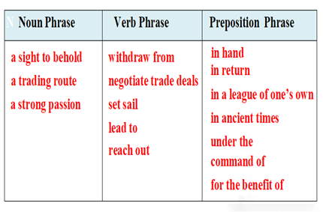  Activity 3  Complete the passage below with the correct forms of the words in the box.  find one’s way boredom reach out across the sea set sail form the foundation tale motivate  In 1519, Ferdinand Magellan, a Portuguese adventurer, made the first voyage around the world. On 14 June 2008, nearly 500 years later, a 16-year-old American boy, Zac Sunderland, ________ on a similar journey. After 13 months, he returned with a new world record: the youngest person ever to sail around the world.  Zac grew up on a boat and learnt how to sail when he was four, which _______________________ of his success. As a child, Zac read a book about Robin Lee Graham who had sailed around the world alone as a teenager in 1965. Zac was greatly inspired by Graham's _________________. After his 16th birthday, Zac started making plans for his journey. Using his own money, Zac bought a boat and set off.  ________________________ is often a mixture of danger and ____________________. Zac had to ____________________ through heavy storms and get by on little sleep on his journey. It was boring to stay on a boat all day, so Zac read lots of books!He also emailed his family using his laptop, telling them about his experiences around the world.  When the journey ended, Zac’s adventure received widespread media coverage. At his press conference, he talked about how passion and courage made his dream come true. In his opinion, there’s so much that people can achieve with the right ________________ and ambition. Just go for it!  Answers: set sail formed the foundation tale Reaching out across the sea  Boredom find his way motivation  Questions  - What problem did zac meet in his journey ?  Zac had to find his way through heavy storms and get by on little sleep on his journey. It was boring to stay on a boat all day, so Zac read lots of books!  - What made Zac’s journey successful?  It was passion and courage that made his journey successful.  Discussion  Compare to the great voyages in history, is Zac’s voyage meaningful ? Why?  Languages points  1. mixture n.混合；结合体；混合物  【教材原句】  Reaching out across the sea is often a mixture of danger and boredom.  远渡重洋往往既危险又无聊。  【实例品读】  The city is a mixture of old and new buildings.  这座城市是新老建筑兼而有之  【热点归纳】  mix vi.& vt.(使)混合；(使)掺和；(使)融合  mix with与……混合；融合  mix A with B＝mix A and B (together) 把A与B混合起来/融合在一起  mix up混淆；弄混；弄乱  mixed adj.混合的；混杂的  【考点精练】  (1)I listened to his adventure with a _______(mix) of amusement and disbelief.  (2)I don’t like to mix business __________pleasure.  (3)He was so nervous that he got the speech pages all _________(mix) up.  2. coverage n. 新闻报道；覆盖范围  【教材原句】  When the journey ended, Zac’s adventure received widespread media coverage. 旅程结束后，扎克的冒险经历得到了媒体的广泛报道。  【实例品读】  tonight's live coverage of the hockey game is on Channel 5.  今晚曲棍球比赛的现场直播在5频道。  【热点归纳】  media coverage 媒体 报道  cover vt. 覆盖；遮盖；涉及 n. 封面  【考点精练】  (1)She's _____________ the party's annual conference.  她正在报道这个政党的年会新闻。  (2)There're _____________ of foreign news in the newspaper.  报纸上有国外的新闻报道。  1. profession n. 职业；行业  【教材原句】  Henry Norman Bethune devoted his life and profession to helping people without expecting anything in return.  【实例品读】  He worked his way to the top of his profession.  他一步一步努力，终于成为行业内的翘楚。  【热点归纳】  by profession 就职业来说  professional adj. 专业的；职业的  professor n. 教授；讲师；教员  【考点精练】  (1)This was clearly a job for a real _____________.  这显然是需要真正专家才能担任的工作。  (2)He was made _____________at the age of 40.  他40岁时成为教授。  (3) The author of the guidebook is an architect _____________.  这本指南的作者是一名建筑师。  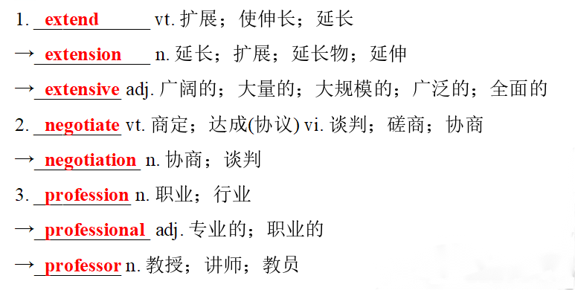  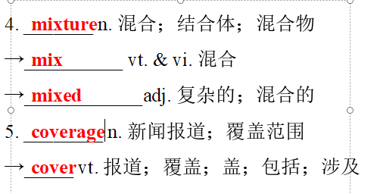 | .  Students matches each definition to the key words and choose the appropriate words to complete the sentences.  students  complete the sentences with the correct forms of the phrases in the box.  Students find out phrases in the text  Students fill in the blanks using the correct forms of the words in the box.  Students answer the questions  Students have a discussion .  Students learn how to use the new word in this period. | To help the students consolidate key vocabulary by matching words to their meanings and seeing how they are used in context.  To use the key phrases in sentences.  To sort out phrases in the text.  To help students practise key vocabulary in a paragraph.  .  To catch the main content of the passage.  To inspire students to think and express themselves.  To grasp the usage of the new words.
作业 | Homework  Do the exercises on  Page 76of Workbook.

