**【分层训练】五年级下册英语一课一练-Unit 2 My favourite season 课时（5）**

**一、单选题**

1．选出不同类的一项（　　）

A．favourite B．pick C．paint

2．找出不同类的单词（　　）

A．paint B．play C．picture

3．找出不同类的单词（　　）

A．picnic B．flower C．tree

4．—Which season do you like best?

—I like autumn,because I can .

A．pick apples B．sleep C．make a snowman

5．I can make a snowman in _______.

A．summer B．every season C．winter

6．There _________ beautiful flowers everywhere.

A．is B．has C．are

7．I often _______ a picnic with my family.

A．go for B．go to C．go on

8．I often play ________ the snow.

A．to B．in C．for

9．I can in the snow in winter.

A．plays B．play C．playing

10．I can't __________ in winter.

A．swims B．swim C．swimming

11．I like _______ because there are beautiful flowers everywhere.

A．summer B．winter C．spring

12．There _________ lots of snow.

A．is B．are C．am

**二、判断题**

13．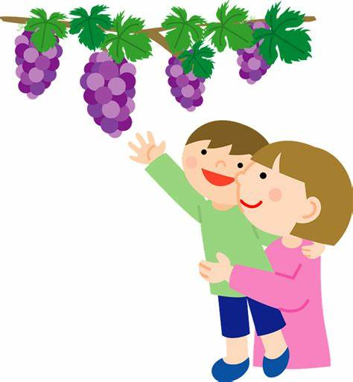pick apples

14．学科网(www.zxxk.com)--教育资源门户，提供试卷、教案、课件、论文、素材及各类教学资源下载，还有大量而丰富的教学相关资讯！make a snowman

15．学科网(www.zxxk.com)--教育资源门户，提供试卷、教案、课件、论文、素材及各类教学资源下载，还有大量而丰富的教学相关资讯！go on a picnic

16．go swimming

**三、选词填空**

17．根据句意选择正确的介词填空。

A. with B. at C. in D. on

（1）We often go　 　a picnic in spring.

（2）I can play　 　the snow in winter.

（3）I often go swimming　 　my friends.

（4）Look　 　the picture .It's beautiful.

18．选择适当的疑问词填空。

|  |
| --- |
| What When Where Which Why |

（1）—　 　do you like summer best?

—Because I can go swimming.

（2）—　 　do you get up?

—I get up at 6:30.

（3）—　 　do you do on Sundays?

—I often go shopping.

（4）—　 　season do you like best?

—Autumn.

（5）—　 　do you often play football?

—On the playground.

**四、匹配题**

19．给下列图片选择相应的短语。

A. pick apples B. go swimming

C. go on a picnic D. make a snowman

（1）

（2）

（3）

（4）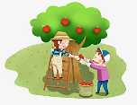

20．给下列句子选择对应的图片。

A. 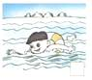 B. 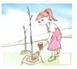 C.  D. 

（1）The girl likes spring. Because she can plant trees.

（2）The boy likes summer. Because he can swim.

（3）My brother likes winter. Because he can skate.

（4）My sister likes spring. Because she can fly kites.

**五、情景交际**

21．情景交际

⑴Which season do you like best?

⑵Why do you like winter?

⑶What do you often do in the summer?

⑷Do you like the music?

⑸What do you usually do on Christmas Day?

A、I usually go to the beach on Christmas Day.

B、Yes, I do.

C、Autumn.

D、Because I can sleep all day.

E、I often go swimming.

**六、补全对话**

22．给下列问句选择合适的答语。

A．It's sunny and cool．

B．Summer．

C．Because I can make a snowman．

（1）—Which season do you like best?

—

（2）—Why do you like winter?

—

（3）—What's the weather like in autumn in Beijing?

—

**七、填空题**

23．写单词或词组。

⑴ 

⑵ 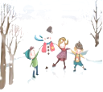

⑶ 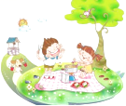

⑷ 

24． I like winter because I can 　 　.

25． I 　 　 on my uncle's farm in autumn.

26． I always 　 　 in summer.

27． I often 　 　 in autumn.

28．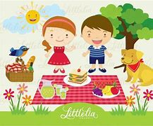 We often 　 　 together in spring.

**八、翻译**

29．翻译。

（1）Look at the green trees and pink flowers.____________________________

（2）I can't swim.____________________________

（3）I want to paint a picture.____________________________

（4）I can play in the snow.____________________________

（5）我喜欢春天。____________________________

（6）我最喜欢冬天，因为我可以堆雪人。

________________________________________________________

**答案部分**

1．A

2．C

3．A

4．A

5．C

6．C

7．C

8．B

9．B

10．B

11．C

12．A

13．（1）F

14．（1）T

15．（1）T

16．（1）F

17．（1）D

（2）C

（3）A

（4）B

18．（1）Why

（2）When

（3）What

（4）Which

（5）Where

19．（1）C

（2）B

（3）D

（4）A

20．（1）B

（2）A

（3）D

（4）C

21．C；D；E；B；A

22．（1）B

（2）C

（3）A

23．pick apples；make a snowman；go on a picnic；go swimming

24．make a snowman

25．pick apples

26．go swimming

27．pick apples

28．go on a picnic

29．（1）看那些绿色的树和粉红色的花。

（2）我不会游泳。

（3）我想画一幅画。

（4）我可以在雪地里玩。

（5）I like spring.

（6）I like winter best because I can make a snowman.