Unit 4 Sharing Project教案
课程基本信息
学科 | 高中英语 | 年级 | 高三 | 学期 | (秋季)
课题 | 选择性必修四 Unit 4 Sharing * Project
教科书 | 书 名：人教版教材  出版社：人民教育出版社
教学目标
At the end of this lesson, students will...
- summarize the basic components and features of a poster by reading the two examples in the textbook.
- learn the typical expressions of every aspects in a poster from the given posters.
3. design a poster for your own volunteer work and present it for peer evaluation.
教学内容
教学重点：
- Management of the content and structure of a poster.
2. Application of the typical expressions of every aspects in a poster.
教学难点：
The designing of a new poster.
教学过程
Activity 1 Get to Know Posters
- Have you ever read or designed a poster?
- Why do people design a poster?
- What information can you read on a poster?
【设计意图】了解海报的功能和基本构成。
Activity 2 Read Posters For Structure And Information
Read the following posters on Page 47 and answer the questions:
1.What aspects are included in a poster introducing volunteer work?
2.Can you find out the above information in the two posters?
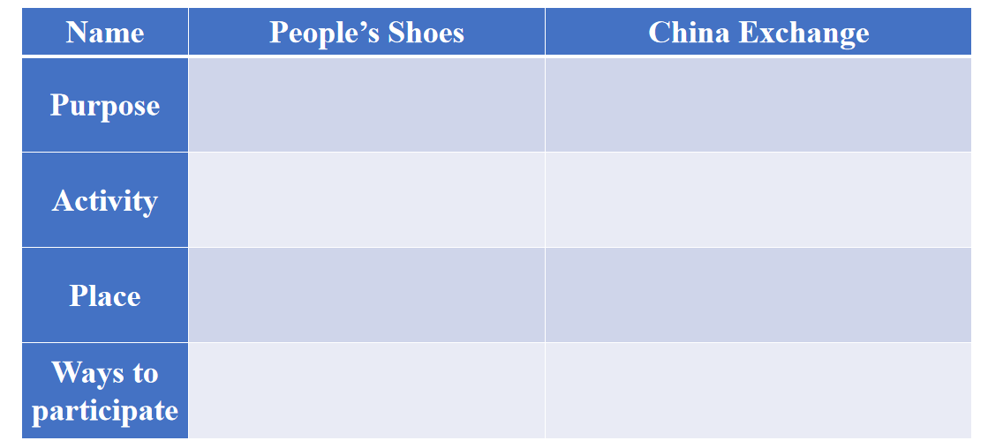
【设计意图】从语篇结构、话题内容的角度为学生自主设计志愿服务工作的宣传海报做铺垫。Activity 3 Read Posters For Language
1. What useful expressions are used to introduce each aspect of the volunteer work?
2.Can you add more expressions to introduce each aspect of the volunteer work?
【设计意图】从语言的角度为学生自主设计志愿服务工作的宣传海报做铺垫。
Activity 4 Read Posters For the Title
What are the features of the titles of the given posters?
【设计意图】通过分析标题的特征，为学生自主设计志愿服务工作的宣传海报做铺垫。
Activity 5 Learn to Design A Poster
1.What should be taken into account when designing a poster?
2.How can a poster be attractive?
3.What are the functions of the illustrations? Should we add pictures as many as possible?
【设计意图】引导学生关注图片、标题、字号、颜色、插图等语篇特征对海报的影响和作用。
Activity 6 Design Your Own Poster
- In your community, who or what do you think are in need for your help?
2. What business could you set up to help them?
3. How could others participate in your activities?
【设计意图】利用问题链引导学生思考志愿服务工作的对象、意义、方式、活动，并将这些信息以宣传海报的形式呈现出来，实现知识的应用与迁移。
Activity 7 Assignment

Review and reflect on your design and write down the procedures, challenges and solutions of designing a poster.

Present your poster to your classmate, explain your design and ask them to help you improve it.

Ask students and your teacher to comment and grade your design.
【设计意图】从语篇结构、话题内容的角度为学生自主设计志愿服务工作的宣传海报做铺垫。

