**Unit 3 Sea Exploration**

**Using Language 2教案**

**Express your opinions on sea exploration**

**Teaching aims:**

By the end of this period, students will be able to:

1. To figure out the organisation and language feature of an argumentative essay.
2. To learn to express their opinion on sea exploration.
3. To write an argumentative essay on sea exploration.
4. To develop a proper attitude on sea exploration.

**Teaching key and difficult points:**

1. Help students to analyse the organisation and language feature of an argumentative essay.
2. Teach students to write an argumentative essay on sea exploration.
3. Instruct students to write an argumentative essay on sea exploration.

**Teaching procedures:**

**StepⅠLead-in**

Ask students to express their opinion on sea exploration.

Suggested answer:Answers may vary.

**StepⅡWhile-reading**

**Activity** **1** **Reading** **for** **text** **type.**

What is the type of the text?

A.Exposition.　　　　 B.Narration.

C.Argumentation. D.Description.

Suggested answer:C

**Activity** **2** **Reading** **for** **the** **structure.**

What are the three parts in an argumentative essay?

Suggested answers:

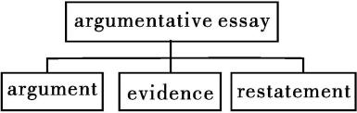

**Activity** **3** **Reading** **for** **detailed** **information.**

Read the two texts on Page 32 and find the arguments,evidence and restatement in them.

Suggested answers:

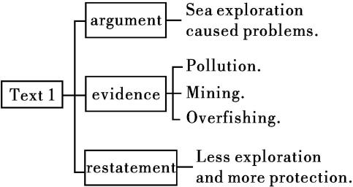

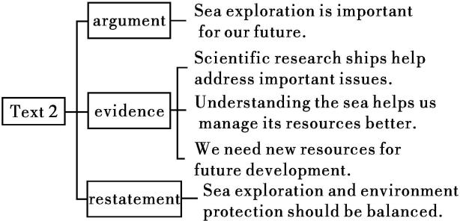

**Activity** **4** **Reading** **charts.**

Look at the two charts below and decide which one supports which text.

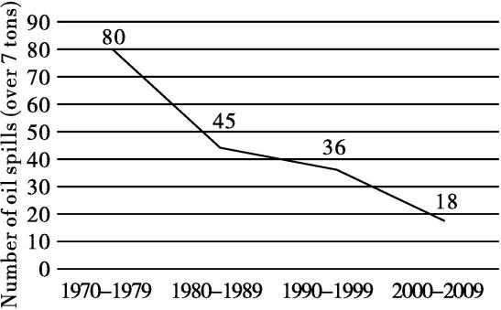

*Decline* *in* *oil* *spills*

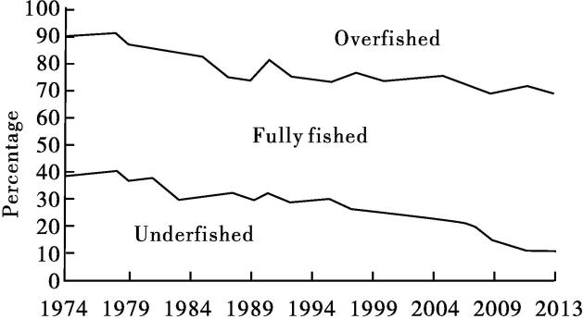

*Global* *trends* *in* *the* *state* *of* *world* *marine* *fish* *stocks*

Suggested answers:

Text 1 : Global trends in the state of world marine fish stocks

Text 2: Decline in oil spills

**StepⅢ Discussion**

**Activity** **1** **In** **groups**, **discuss** **the** **following** **questions.**

**1**.What is your opinion about sea exploration?

**2**.Are there any other aspects of sea exploration not mentioned that you think are important?

Suggested answers:

**1**.From my perspective, sea exploration is a wonderful thing,which may well serve us human beings in the future.

**2**.Yes, there are. We need to explore the ocean so that we can better understand issues such as acidification which leads sea water to become more acidic, and how to deal with such problems.

**Activity** **2** **Writing.**

Write an argumentative essay on sea exploration.

The following questions may help you.

·What is the purpose of sea exploration?

·How does sea exploration help us to protect the sea?

·How does sea exploration cause damage to the sea?

·Is there a good balance between protection and exploitation?

Suggested answer:

We should explore the ocean, first and foremost, because we do not know what we do not know. We thought we knew much about the ocean, but we were wrong. There could be life forms in the ocean, for example, that fit none of the categories we have for life. We already know many things about the ocean, but we need to learn more. A good example is ocean acidification, which is causing coral reefs to die. We know that using less fossil fuel would cause the process to slow down. We need more research to come up with plans and solutions.

To do the research, we have to enter an extreme environment not friendly to humans. This requires the development of new technologies that can also benefit us in other areas.

All in all, there are many good reasons to explore the ocean. If we care about science, about protecting our oceans, and about developing new technologies, we need to do all we can to support ocean exploration.

**StepⅣ Evaluating** **and** **polishing** **the** **draft**

**Activity** **1** **Use** **the** **PEEL** **method** **to** **help** **structure** **your** **argument.**

Point　　　What point do you want to make?

Evidence What facts and examples can you find to support your point? How reliable are the sources?

Explanation Explain how the facts support your opinion and show other opinions to be incorrect.

Link Connect this point to the next point,or back to the main point of the essay or paragraph.

**Activity** **2** **Polish** **your** **draft** **and** **share** **it** **with** **your** **partners.**

**StepⅤHomework**

**1**.Continue to polish your draft.

**2**.Read through the passage on Pages 78 and 79 and finish the writing. (Workbook P79 Reading and Writing)

Suggested answers:

Topic: Reducing pollution

Today our oceans are under threat because of pollution. What can we do to stop the crisis?

First, we can stop using single-use plastic products such as plastic shopping bags. These products can take 450 to 1,000 years to biodegrade. Our oceans have become one giant rubbish bin of plastic waste, threatening sea life. We can keep this problem from growing by recycling bottles and using our own shopping bags at the market.

Second, we can make stronger laws so that farmers will not use chemicals harmful to the environment and factories will not be able to dump their waste into our waters. Since all rivers in the end empty into the sea, chemicals from a farm or factory will eventually make their way to the ocean, killing sea life and destroying the ocean’s delicate balance.

Third, we can reduce our carbon footprint by using less fossil fuel. While this may not look like an issue that has much to do with the ocean,rising temperature due to climate change has started to cause our coral reefs to die. As these reefs provide a habitat for thousands of animal species, these species will decline. Scientists predict that this will result in mass hunger, because so many people depend on sea life for food.

The future of our oceans is in our hands. If we act now, they can still be saved, and they will still be a resource for future generations.