Unit 2 Reading and Thinking 教案
年 级 | Senior Grade 3 | 授 课  教 师 |  | 学 科 | English | 授 课  日 期
课 题 | A Travel Blog |  |  | 课时  安排 | 2 | 课 型 | 新授课
文本分析
本单元的主题是标志性景点，在reading and thinking环节阅读的是一则旅游博客，记载了作者前往澳大利亚旅游之前的准备、旅游期间的些许见闻以及行将离开之际的反思。本文以时间为主线展开，条目一记录了作者为旅游所做的一些准备工作；在条目二中作者记叙了其对澳州的各种来自全球不同地区美食的体验；条目三记叙了作者和朋友为了解澳洲土著居民的生活与风俗而探访北领地凯瑟琳镇的经过。其中，作者以详细的笔墨记载了所观察到的一种土著居民独特的乐器—迪吉里杜管的演奏技巧；在条目四中，作者反思了几天中的所见所闻：不同文化的复杂融合以及这种独特文化所熏陶、孕育的热情、友好的澳洲人民。他们给作者留下了深刻的印象。文本以澳大利亚推出的旅游宣传广告语“There is nothing like Australia.”结束，感叹不虚此次澳大利亚之行。
Ⅰ. Instructional objectives:
At the end of this class, students will be able to:
1. identify essay types;
2. summarize the main idea of each blog by skimming and matching subheadings;
3. master skills of note-taking to understand and remember the writer’s impression of Australia;
4. write a travel journal and introduce the iconic attractions of China.
Ⅱ. Key points:
To understand the language features of blogs and the writing target;
To experience and learn about the food, culture and way of life of Australia.
Ⅳ. Difficult points:
How to encourage students to introduce the iconic attractions
Ⅲ. Teaching procedures:
1. Task-based approach 2. Cooperative teaching method
Ⅴ. Teaching procedures:
Step1 Before-Reading
Activity 1. Lead-in
Students enjoy the picture of the Sydney Opera House and think about the following question. They talk about the iconic attractions of Australia.
Q1. What do you know about the place in the photo?
Q2. What are your impressions of Australia based on your personal experience/ what you have seen in the media?
Q3. What do you know about sea exploration?
Justification: To introduce the topic of Australia and activate students’ prior knowledge of Australia in preparation for the reading.
Activity 2. Prediction
Students skim the title and pictures to predict the content and the text type. The teacher leads them to identify essay types.
Q1. What type of text is it? How can you make your judgment?
Q2. What iconic features of Australia do you think the writer has experienced?
Justification: to practice students’ prediction skills and prepare for reading.
Step2 While-reading
Activity 3. Fast Reading
After prediction, students are asked to skim a blog to find the main idea for each blog entry.
Entry 1: Preparing to travel (before traveling)
Entry 2: First impressions (while traveling)
Entry 3: Aborigines and the didgeridoo (while traveling)
Entry 4: Reflections on multiculturalism (post traveling))
Justification: to train students’ ability to summarize the main idea and extract keywords.
Activity 4. Detailed Reading
Students read the text carefully to think about some related questions in each blog and take notes using abbreviations and symbols creatively.
Q 1. By preparing to travel to Australia, what information has the writer got?
Q 2. What is the writer interested in and why?
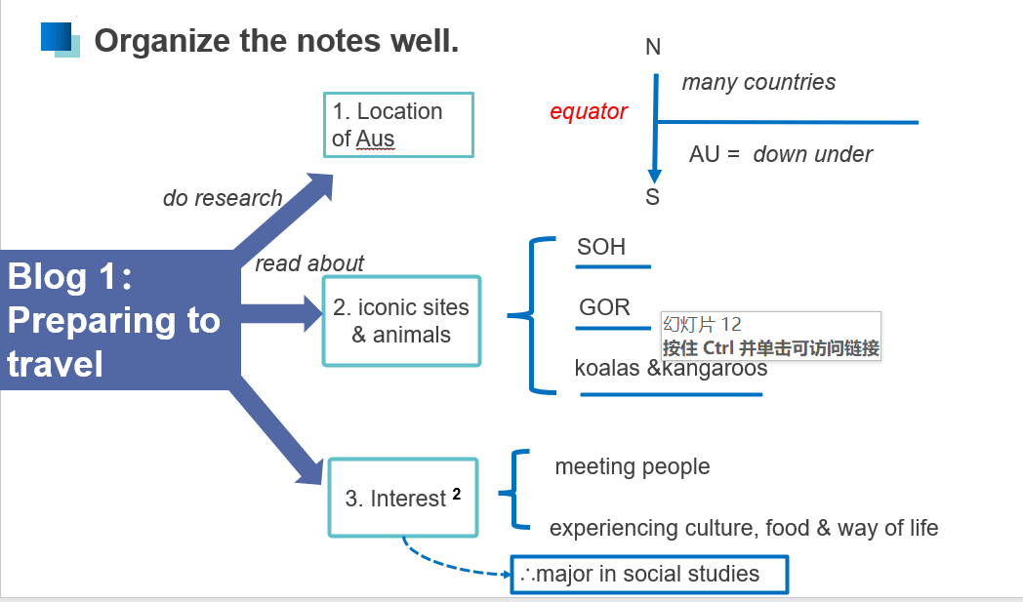
The teacher presents skills of note-taking and organizes the notes with students. Then, students read the rest of the blogs and organize their notes.
Students reread the blog entries and fill in the blanks to experience the iconic features of Australia (Example of travel routes and perspectives).
Justification: to practice reading a passage for details and keywords. Help students to fully understand the text to support Step 4.
Step 3. Post-reading
Activity 4. Group Discussion
After reading the whole passage and summarizing it, the teacher asks the students to discuss the following questions with their partners.
Q1. Why was Australian cuisine influenced by different cultures?
Q2. How does multiculturalism reflect in Australia?
Q3. How do you understand the sentence “There is nothing like Australia” ?
Q4. What’s the author’s feeling after experiencing Australia?
Justification: to foster students’ critical thinking and their ability to identify the facts & opinions.
Ⅵ. Homework
The students discuss what iconic Chinese attractions you would like to introduce to a foreigner and explain why. Then, write what you discuss within 100 words..
Justification: To inspire students to think and express themselves.

